All Course Resources + Notebooks

Throughout the course there will be various links to different resources, however, one will be your source of truth.

The course GitHub repo: <https://github.com/mrdbourke/tensorflow-deep-learning>

Inside you will find a "Course materials" table that contains all of the materials you'll need for the course, including:

* **Lessons in code & text:** all videos are based on these notebooks, refer to them for code and text-based explanations of different deep learning and TensorFlow concepts.
* **Lessons in code & text (from the videos):** notebooks containing the exact code we'll be writing together during the videos.
* **Slides:** all slides and images used to explain different concepts throughout the course.
* **Exercises & extra-curriculum:** each section comes with a series of challenges and extra resources to help you practice your skills and learn more.

But possibly the most important out of all of the above will be the GitHub Discussions tab: <https://github.com/mrdbourke/tensorflow-deep-learning/discussions>

If you have any questions, ideas, feedback or concerns, feel free to start a discussion thread, that way Daniel (the one writing this), Andrei and other students can read and offer help.

Again, there will be more resources listed throughout the course but the GitHub repo will be the one-stop-shop for everything.

Be sure to star it and add it to your bookmarks tab: <https://github.com/mrdbourke/tensorflow-deep-learning>

Happy Deep Learning!

- Daniel (@mrdbourke on Discord)

Resources for this lecture

* [Zero to Mastery TensorFlow Deep Learning on GitHub](javascript:void(0))

Fullscreen

Go to Previous lecture

3. Exercise: Meet The Community

Go to Next lecture

5. What is deep learning?

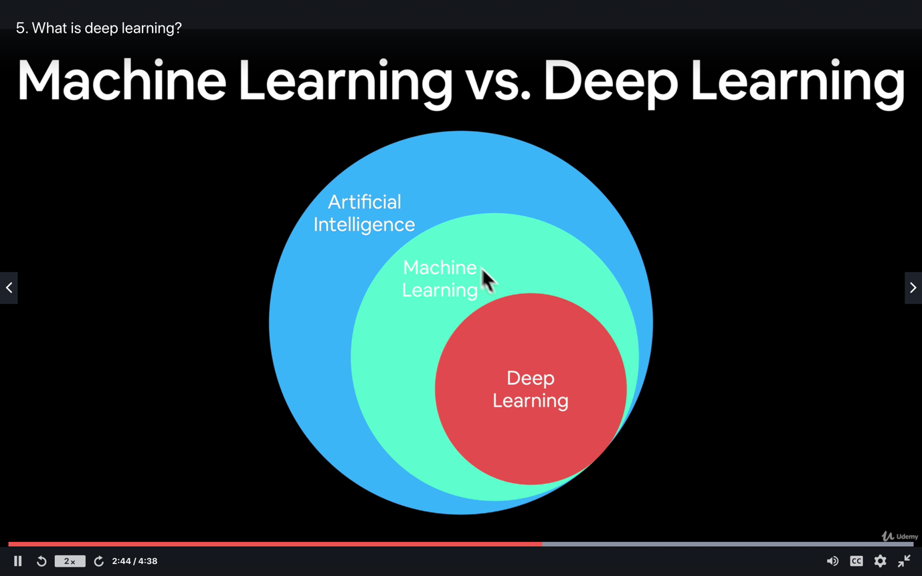

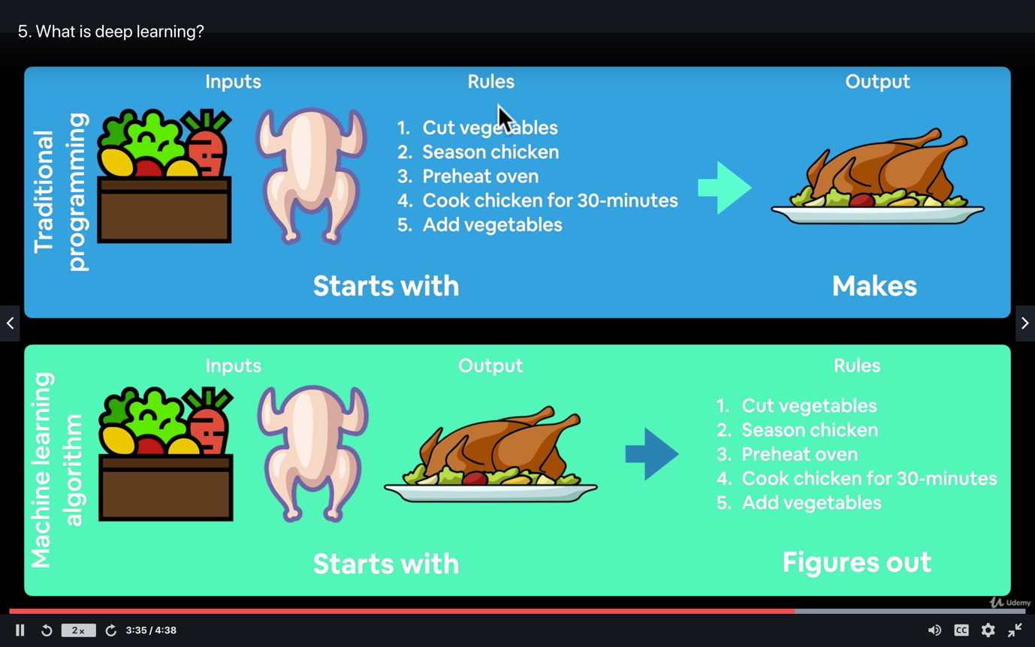

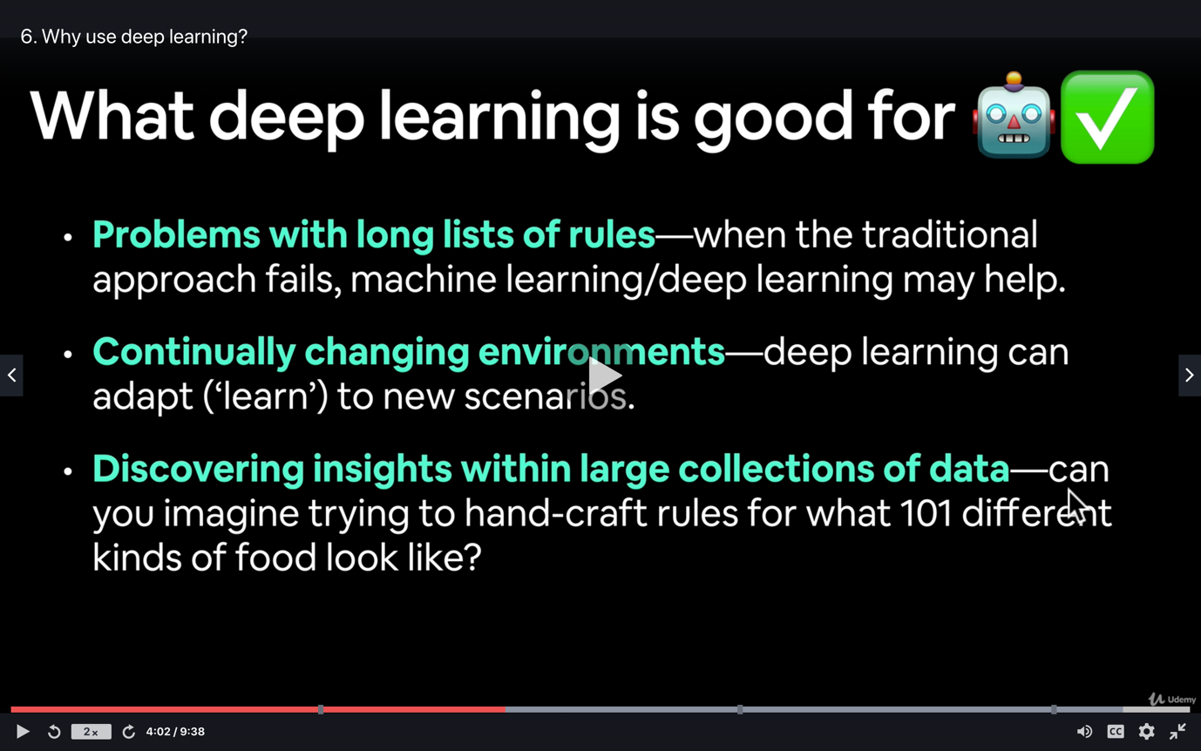

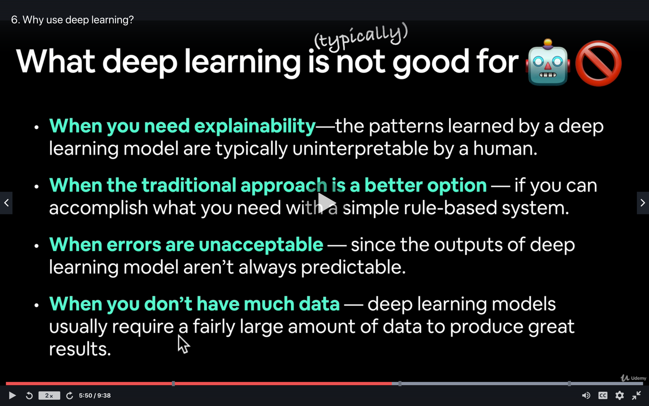

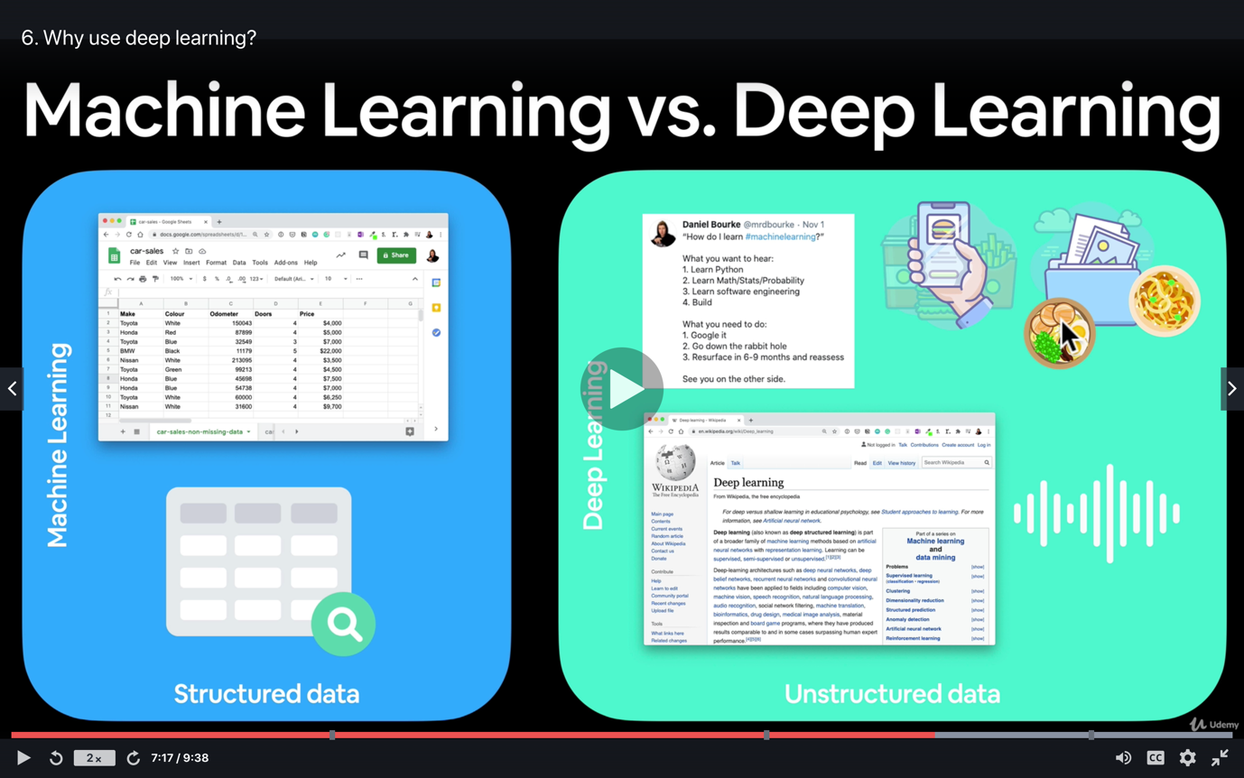

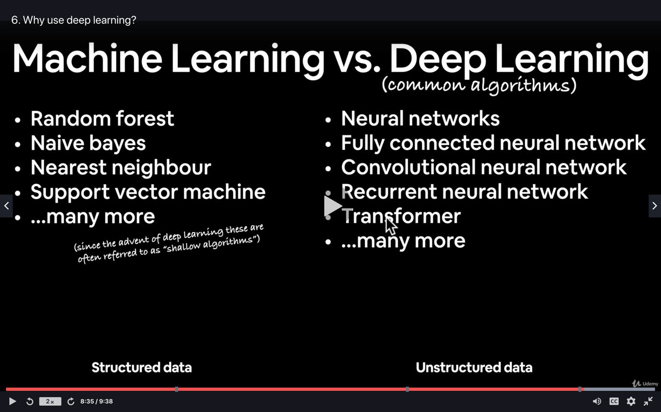

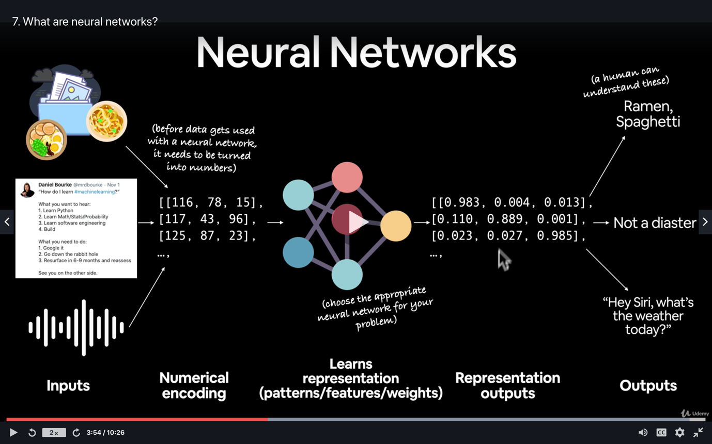

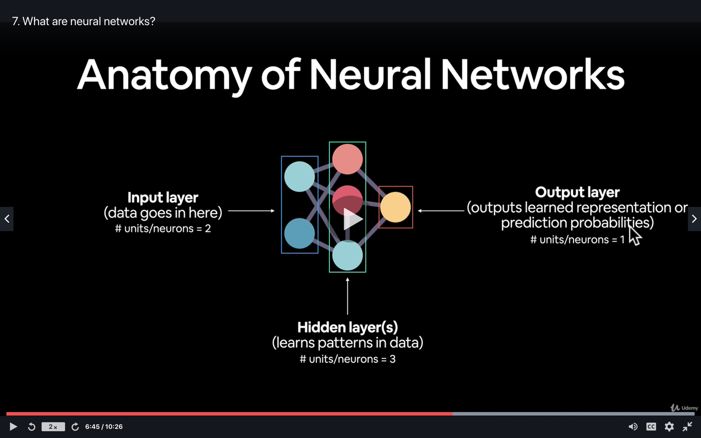

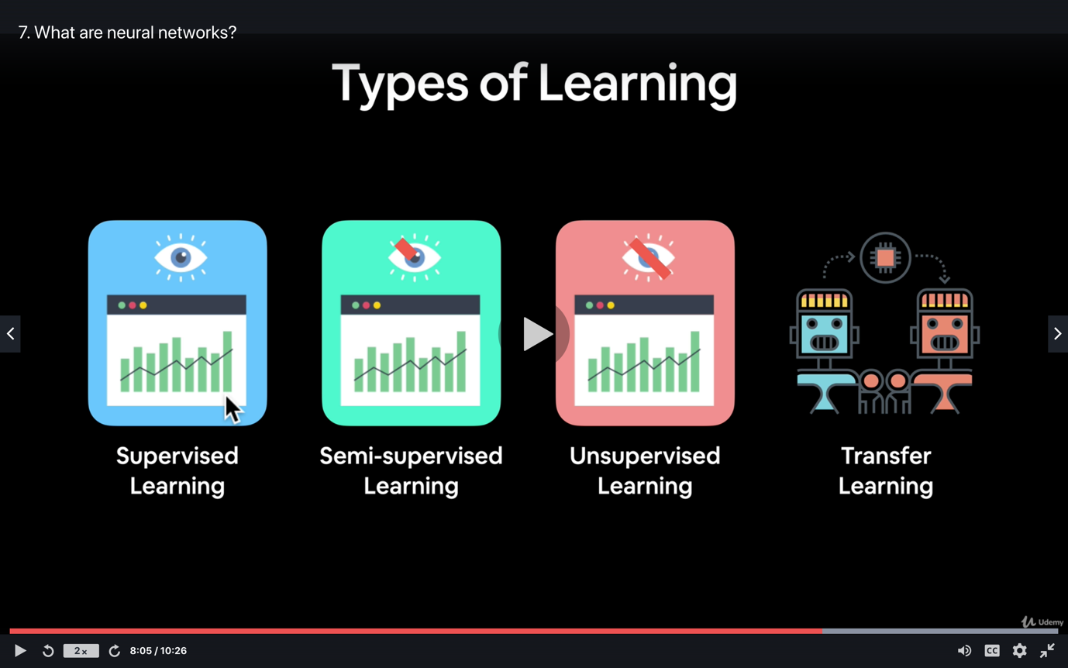

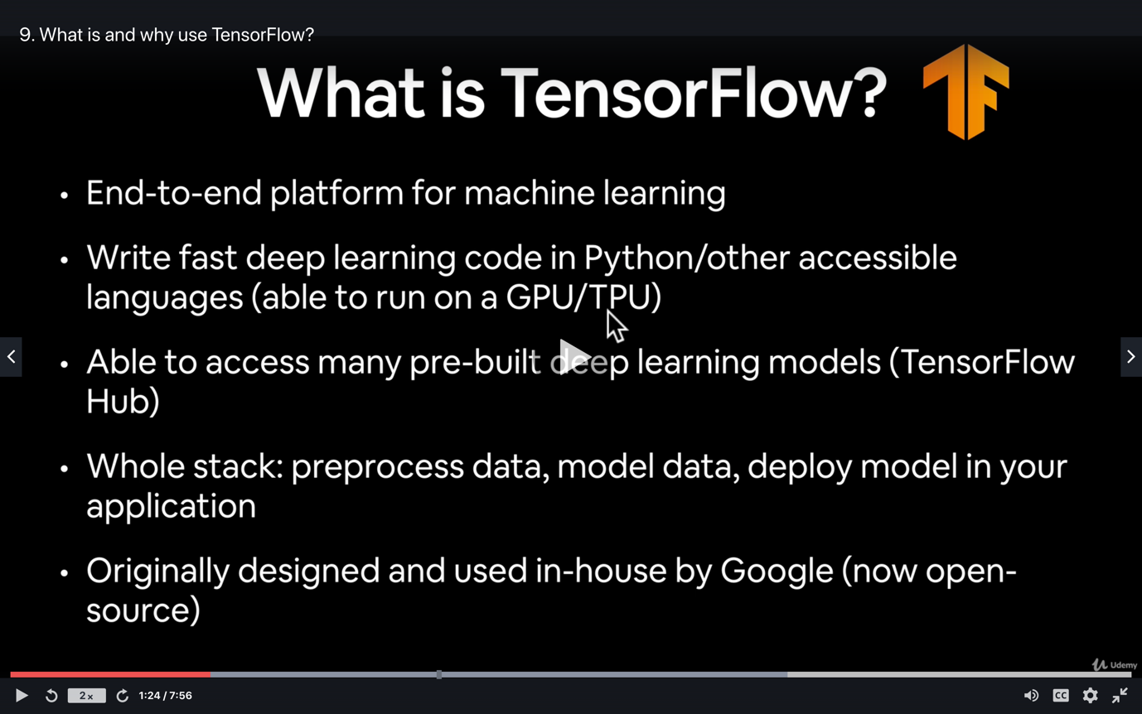

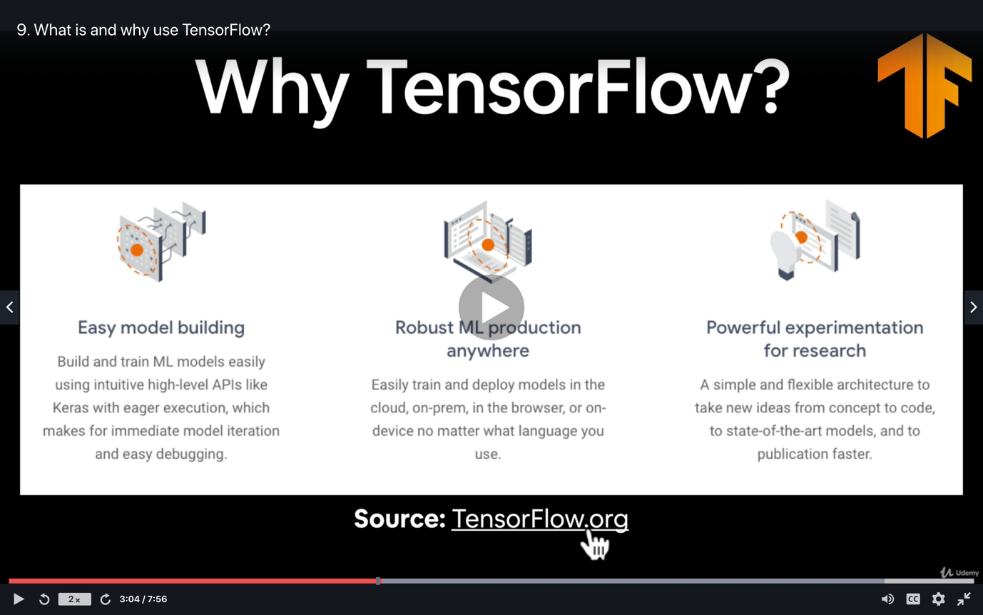

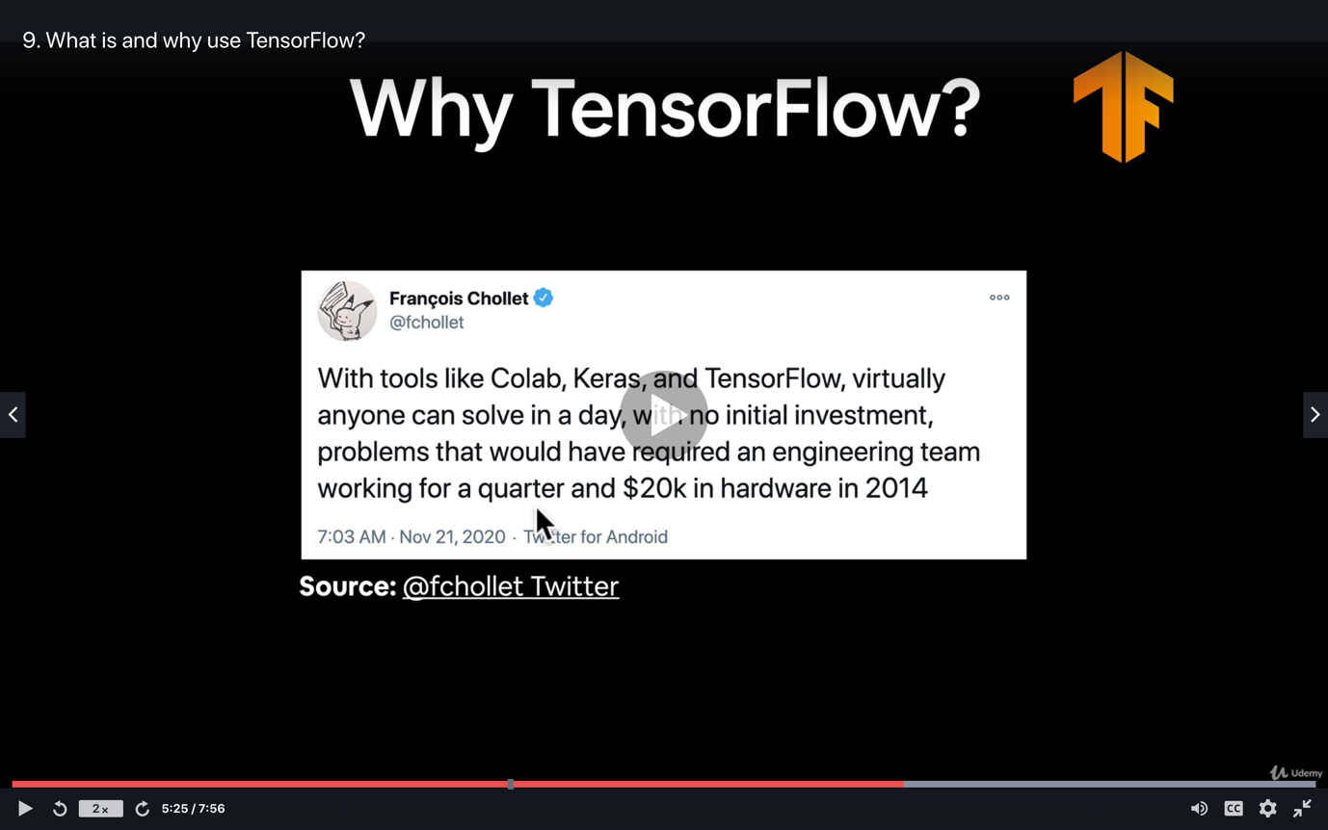

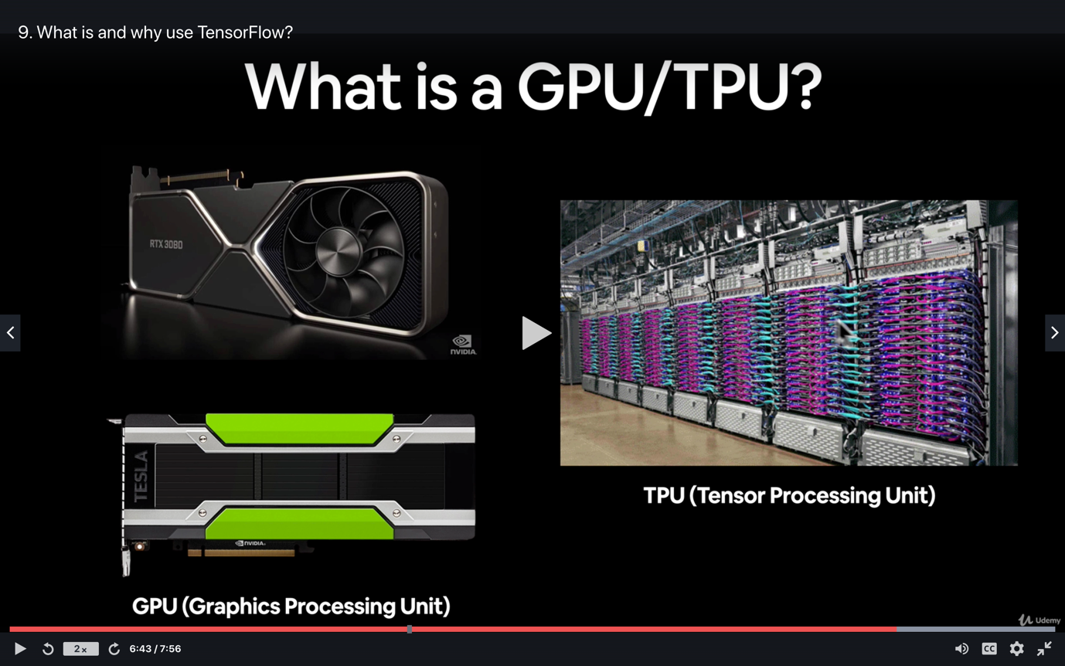

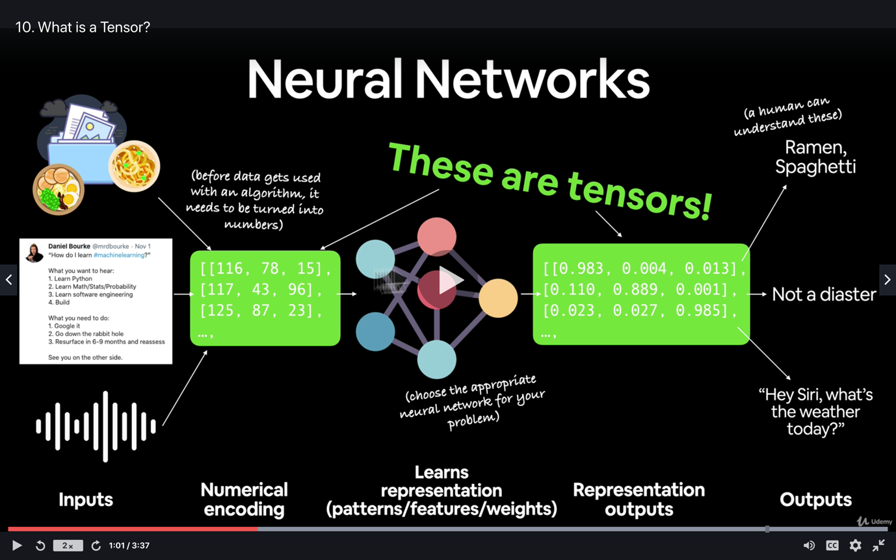

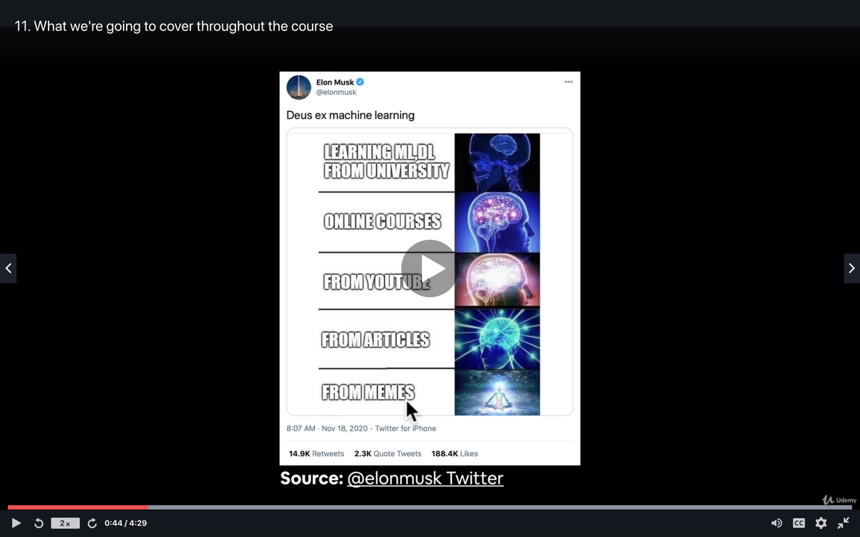

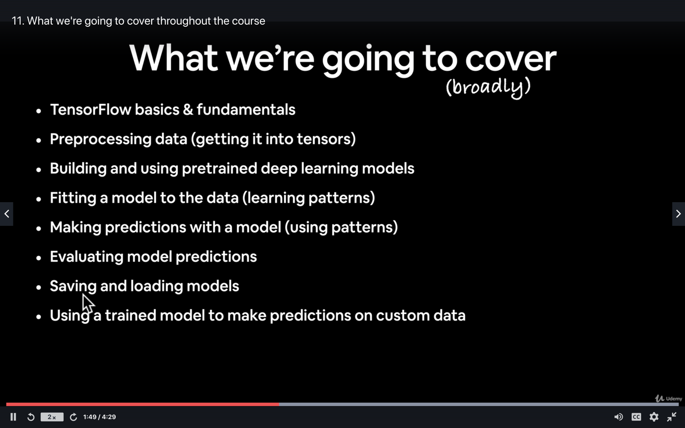

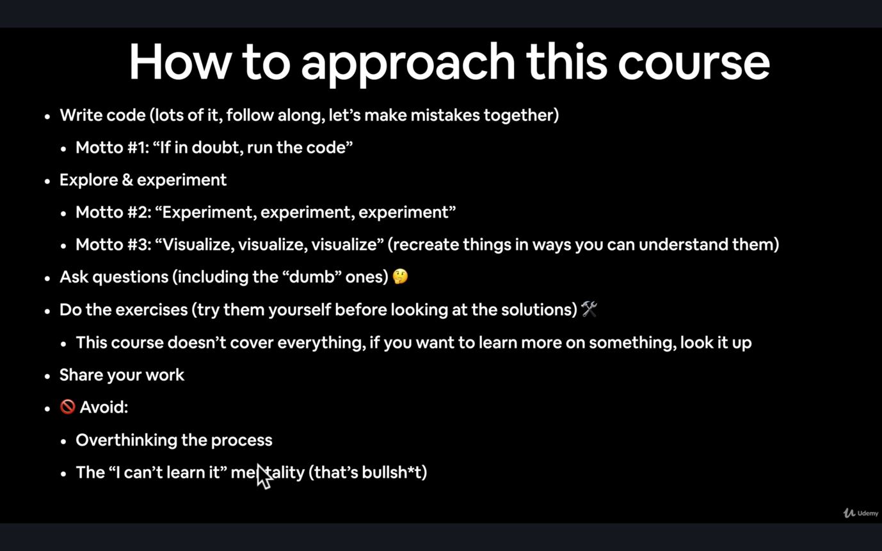

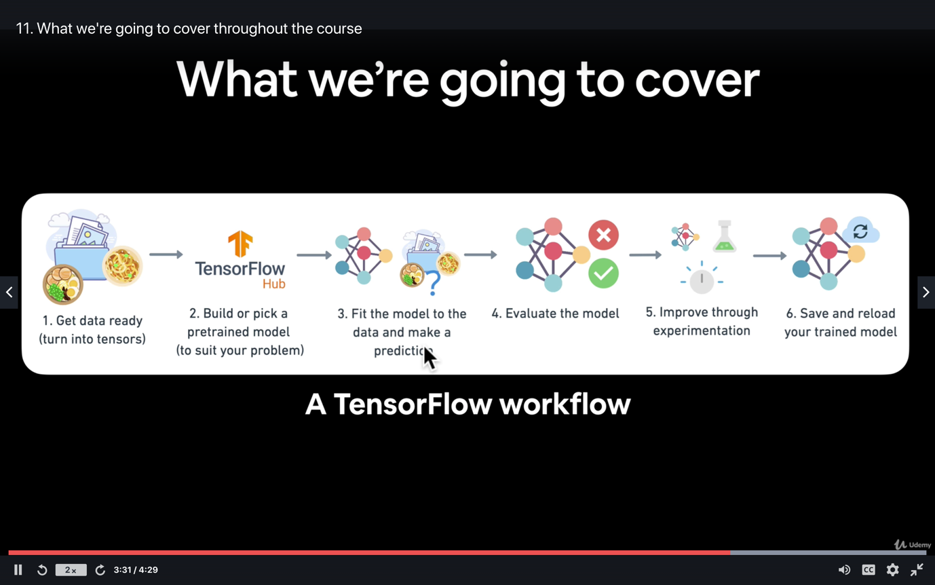

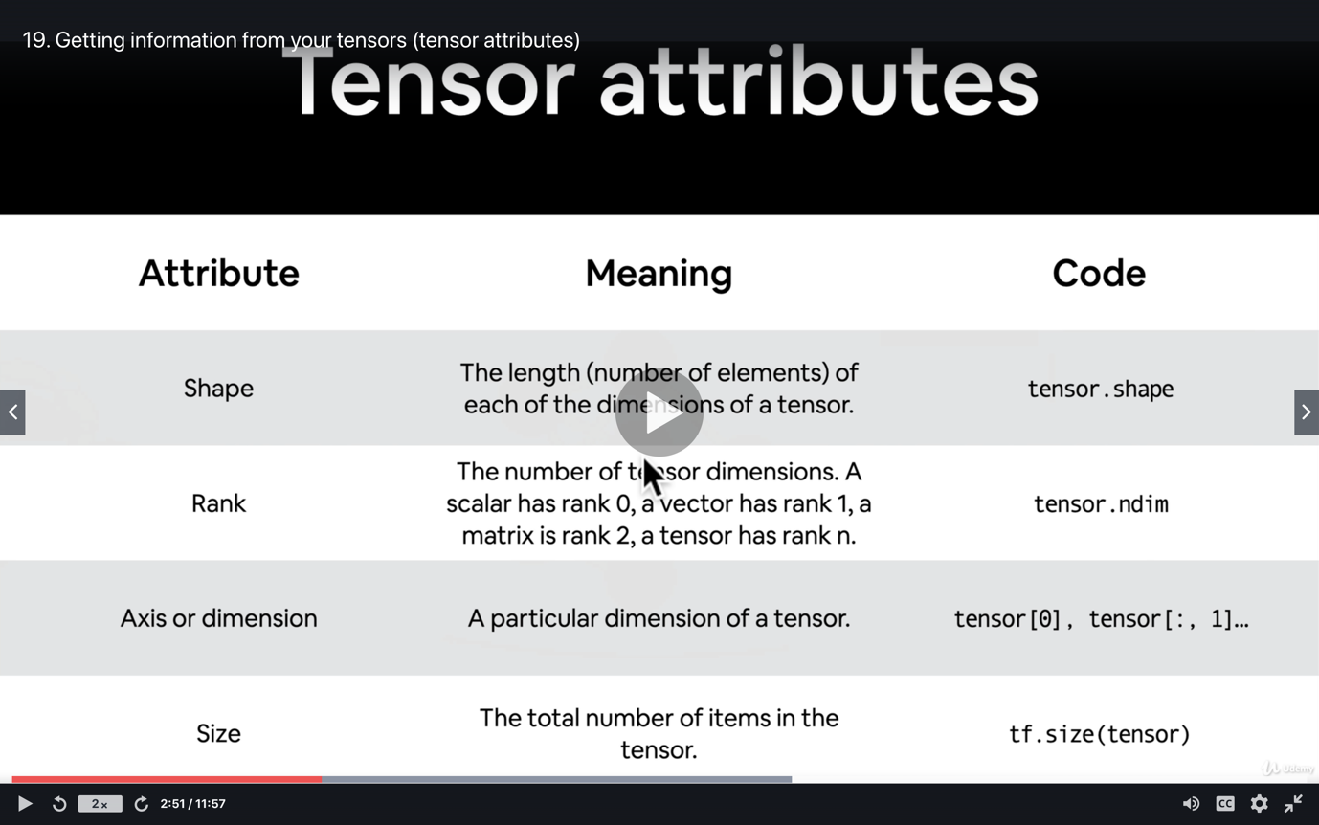

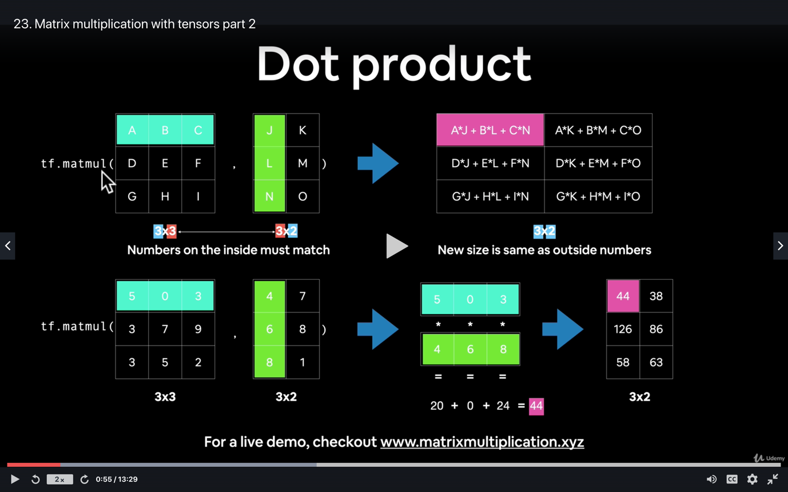

TensorFlow Fundamentals challenge, exercises & extra-curriculum

Massive effort on making it through the first section!

By now you should have a high-level overview of what deep learning and neural networks are and what kind of problems they can be used for.

And you should also be familiar with creating and manipulating tensors in TensorFlow. Because as you'll see later on, tensors are a fundamental component of representing and finding patterns in data.

Before moving onto the next section, it's time to practice your skills!

In the [course GitHub repo](https://github.com/mrdbourke/tensorflow-deep-learning) under “course materials”, you'll find a series of exercises and extra-curriculum suggestions.

By going through these, you'll cement your foundational knowledge of deep learning and TensorFlow and be ready to start building neural networks of your own.

See the link below for more.

* [TensorFlow and Deep Learning Fundamentals Exercises & Extra-curriculum](https://github.com/mrdbourke/tensorflow-deep-learning#-00-tensorflow-fundamentals-exercises)

And remember, if you have any questions, be sure to [add them to the discussions page](https://github.com/mrdbourke/tensorflow-deep-learning/discussions).

**Challenge:** What are 3 of your favourite use cases for deep learning (you can use examples from the videos or feel free to look some up)?

Send a message with your answer(s) to the #machinelearning-datascience channel on Discord and mention my name (@mrdbourke), I’d love to hear them!

See you in the next module!

- Daniel

Web: [www.mrdbourke.com](http://www.mrdbourke.com/)

YouTube: <https://dbourke.link/youtube>

Fullscreen

Go to Previous lecture

33. Making sure our tensor operations run really f…

Go to Next lecture

35. Python + Machine Learning Monthly

Python + Machine Learning Monthly

Every month, I accumulate all of the best resources and articles, as well as free resources around the web for Python Developers. If you want to stay up to date with the industry and make sure you don't miss any important news, you can check out the monthly newsletter here. [**It's completely free every month**](https://zerotomastery.io/blog/?tag=PM&utm_source=udemy&utm_medium=coursecontent#monthly)!

Ps, there is also the Machine Learning Monthly and Web Developer Monthly if you are interested which you can find [**here**](https://zerotomastery.io/blog/?utm_source=udemy&utm_medium=coursecontent#monthly)**.**

Fullscreen

LinkedIn Endorsements

If you are looking to improve your LinkedIn profile and have others endorse your skills, we have a private ZTM[**LinkedIn group here**](https://www.linkedin.com/groups/12121940/)**.** LinkedIn allows you to have recruiters message you with lots of job opportunities. You can **join the group by clicking on "LinkedIn Group"** and then go ahead and endorse some of the member's skills (other people will do the same for you as they join).  
  
If you have any questions, reach out in our private Discord chat community in the **#job-hunting** channel!  
  
**UPDATE!!!** **Zero to Mastery is officially a recognized school!**What does this mean for you? It means that you can add it as an educational institution on LinkedIn as part of your profile to wow those employers *(as your education history)*.[**Check it out here**](https://e2.udemymail.com/ls/click?upn=ZF3sOyS2SxEPIoSZT6Aoc2QMwvQmXWe-2BAGLtZe1ftiUWm8HNINAC-2BglZIfi-2BX1cWRmBh1iMVnSWgHj9-2BpNbf1TpoTrTy-2BIt-2Ffav2-2BMNaCgXckTgGpdBkSM62EmpqkzL5-2Fkf-2BsyLov4bPbjrfsKSV9w76g1b-2F-2FIU-2Bg4BzbrHypNf6CwI6sOox8a0EzoIoEXto9X-2Be0fQVMTLOpSyMpsDOmQ-3D-3DQsXR_ATi1EBgLbEzaDPXXV2zwwQllcpxXTbiSWkLFf3MnoERIav-2FAOa66O5Xp7F-2FUsXnV87MEnYCyCHeGYzttSTgmLIrd2NTSgDnZ7zxqiS946KWMNNN3UbF-2FwcYqaNK6U5bv3dhORS7PdmSyZvHujas6KpW-2FD-2BLAoReUd6lGq7Z9GRFQr4WpafOBiXeCHwuRz26uCxkTG5XhPNGRjdAQ1J-2Fo2LoCgnPsP-2BEKdfSdNM8q-2BWKRZaV0agaZpi2ulYwOEOCKX2m3Dh6C3ztdNZbFeRCWPwM-2BbtQAzvXlLsuG4Sr3xHWd9WGfGSIMFccpephTxlxBIC5sq1s7lEhtajvVmPCG0lVER71vBf2SRM8l8vJpl3XGoLOXQrZvNu9Swa9fDot4gfj5sahuOGID7tXDMlpp-2B3p2t-2Fv4Lk0Y-2BrEfTxarU-2FM-3D). To add it to your profile:

*Step 1: Go to personal LinkedIn profile*

*Step 2: Scroll down to the Education section*

*Step 3: Click the****+***

*Step 4: Type in****Zero To Mastery Academy***

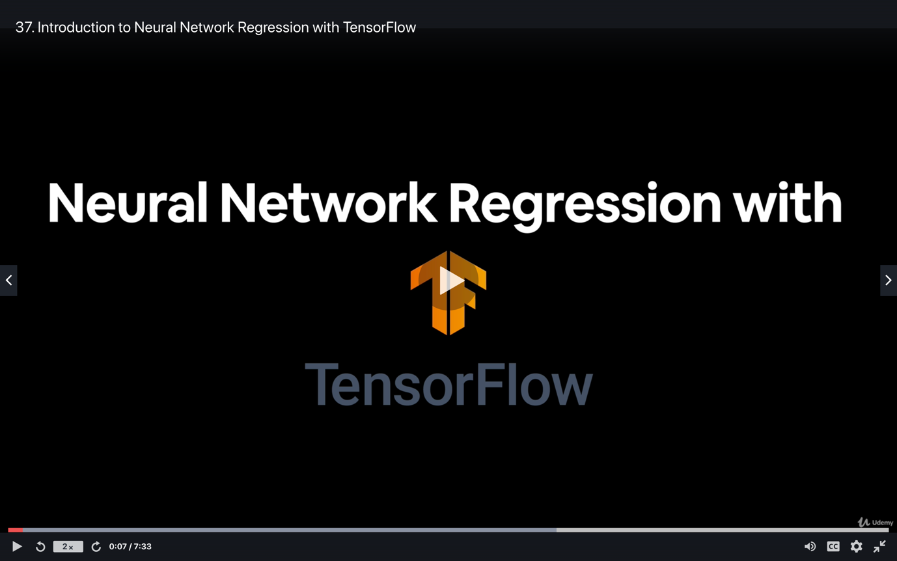

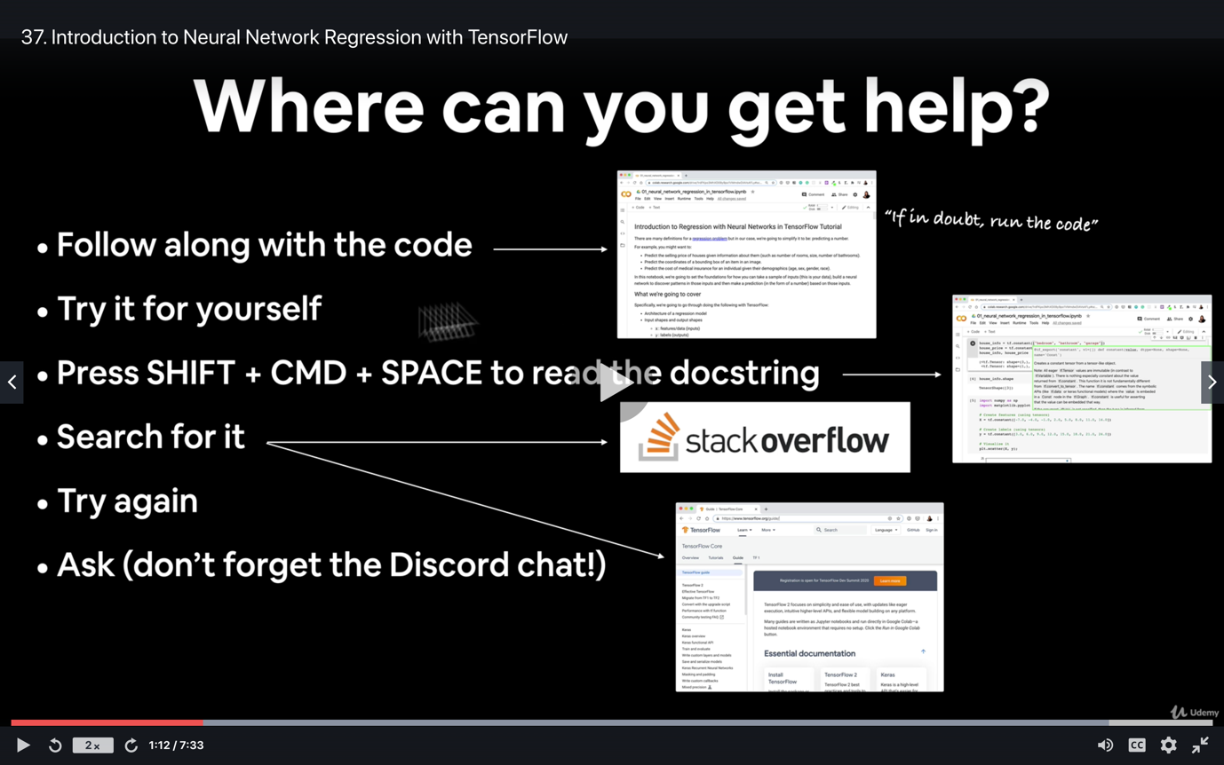

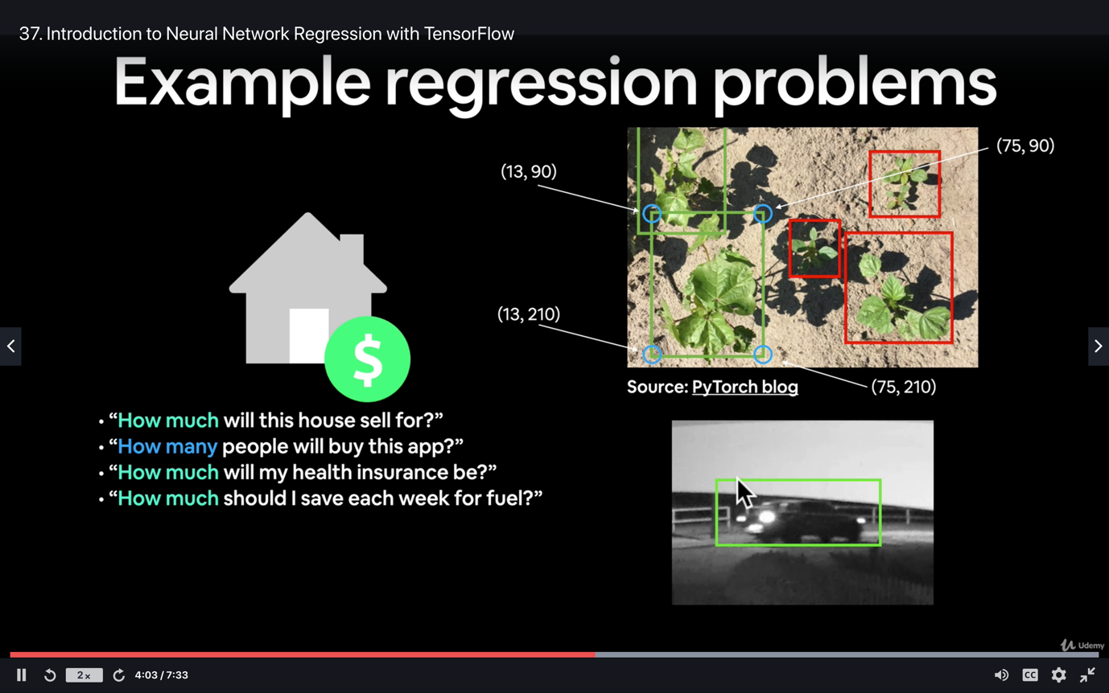

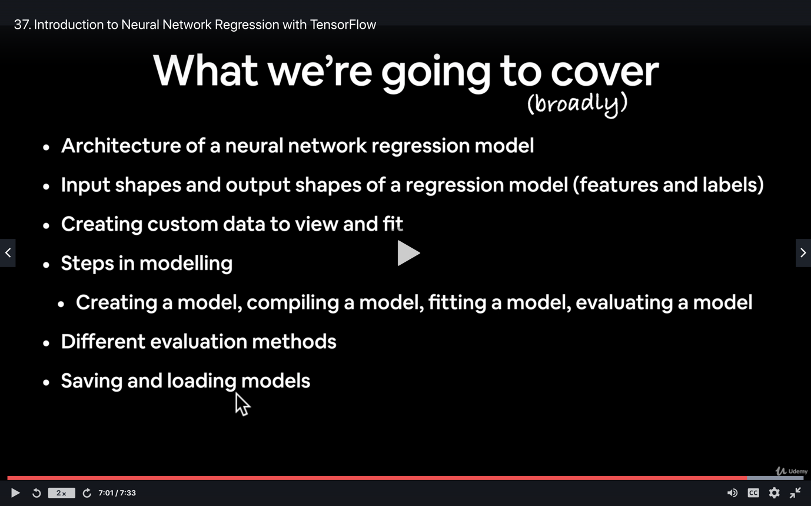

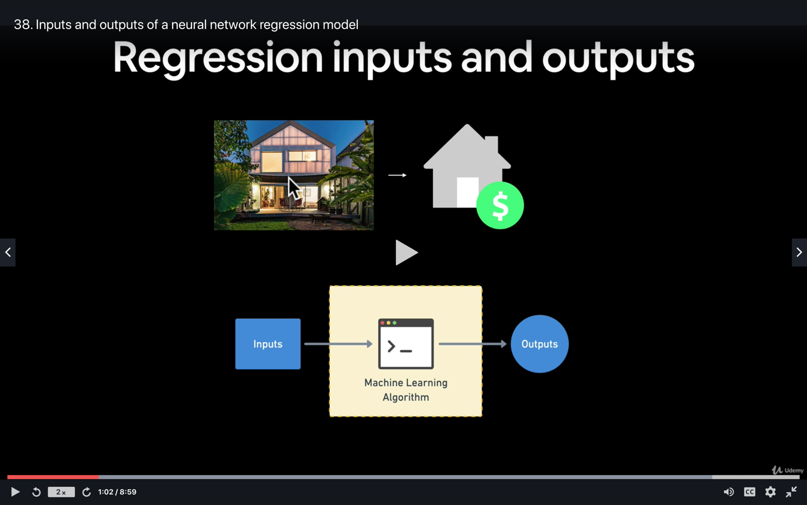

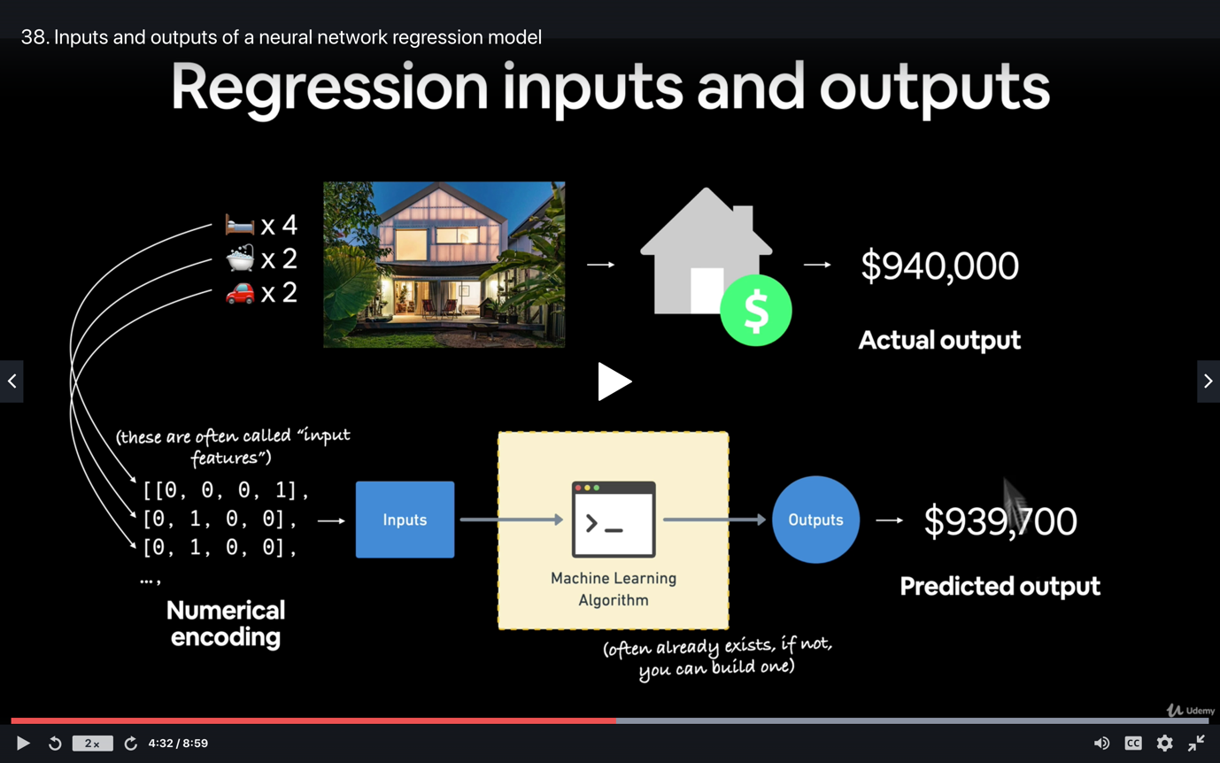

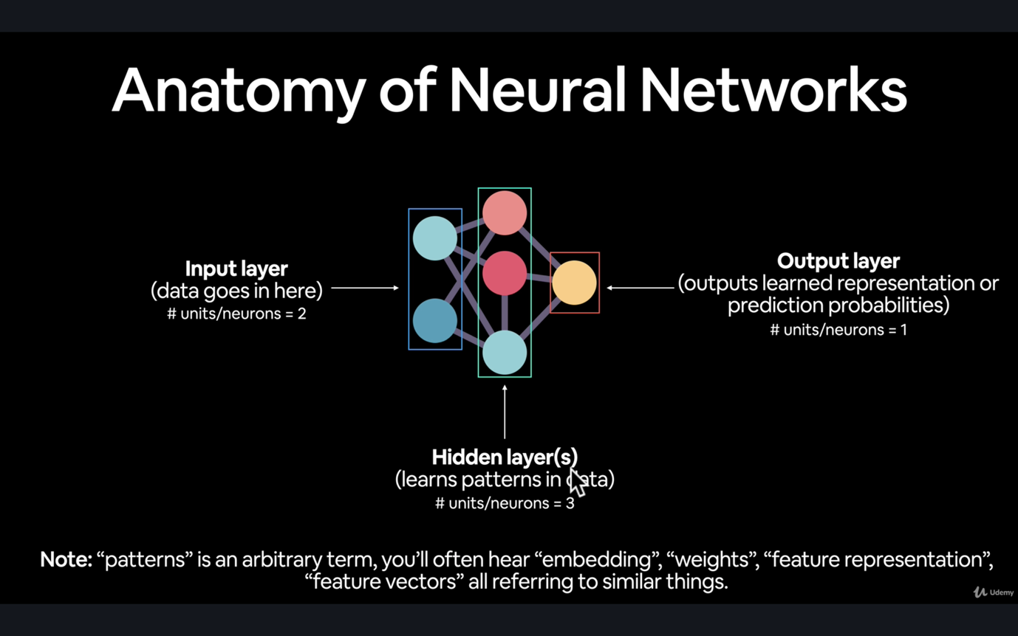

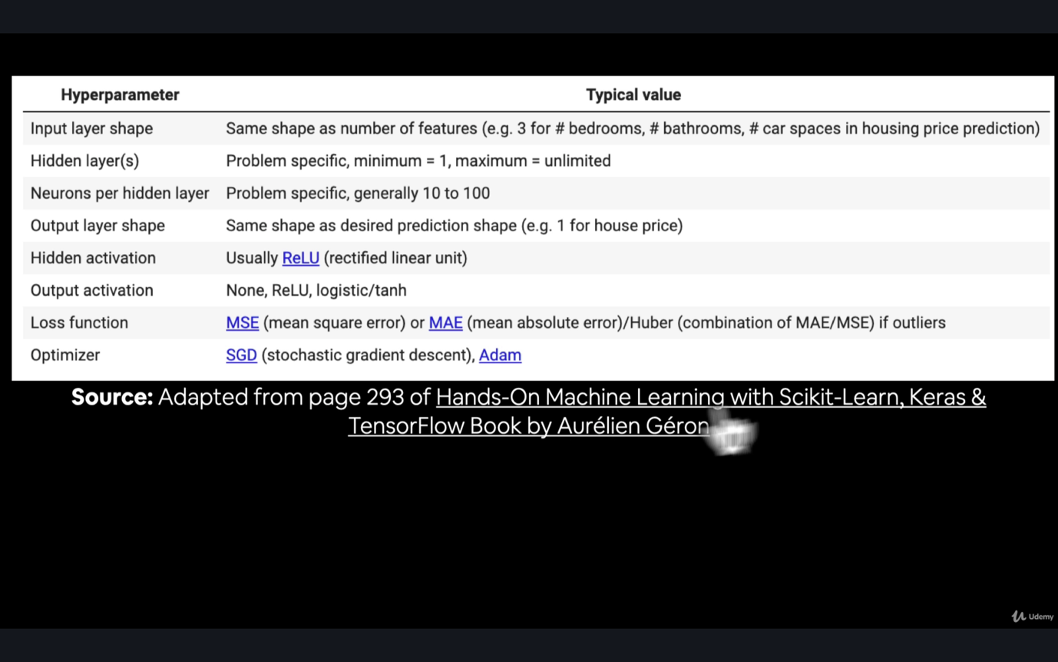

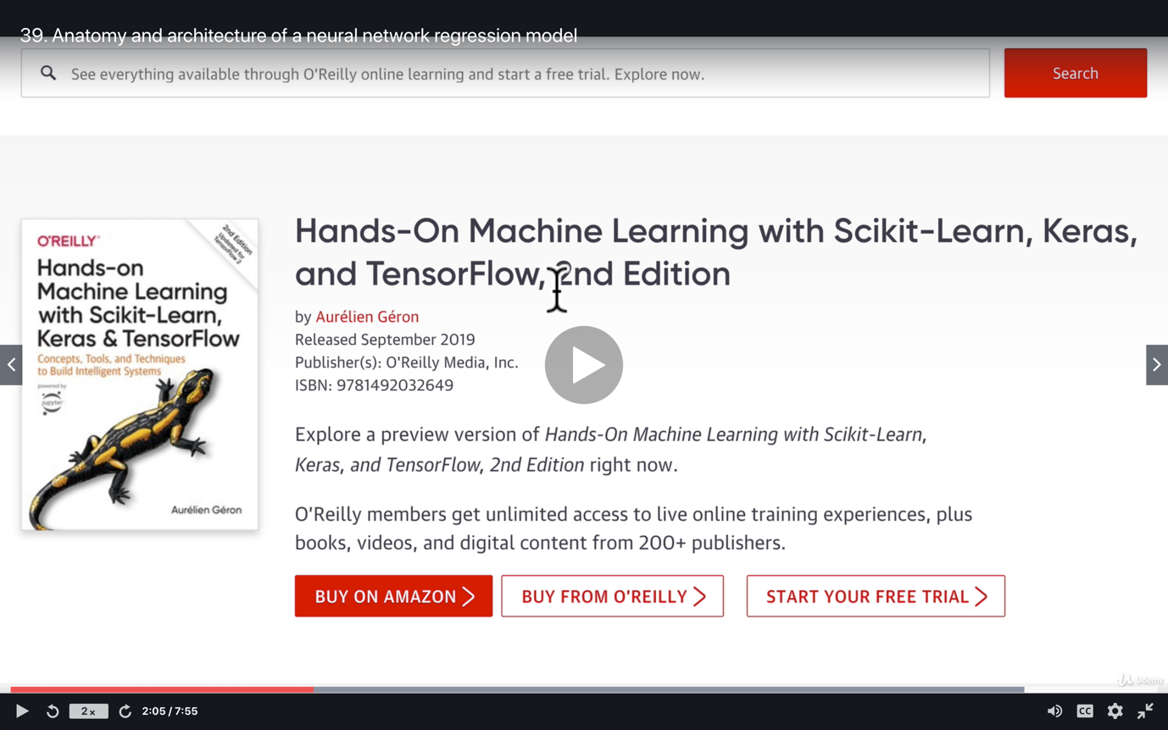

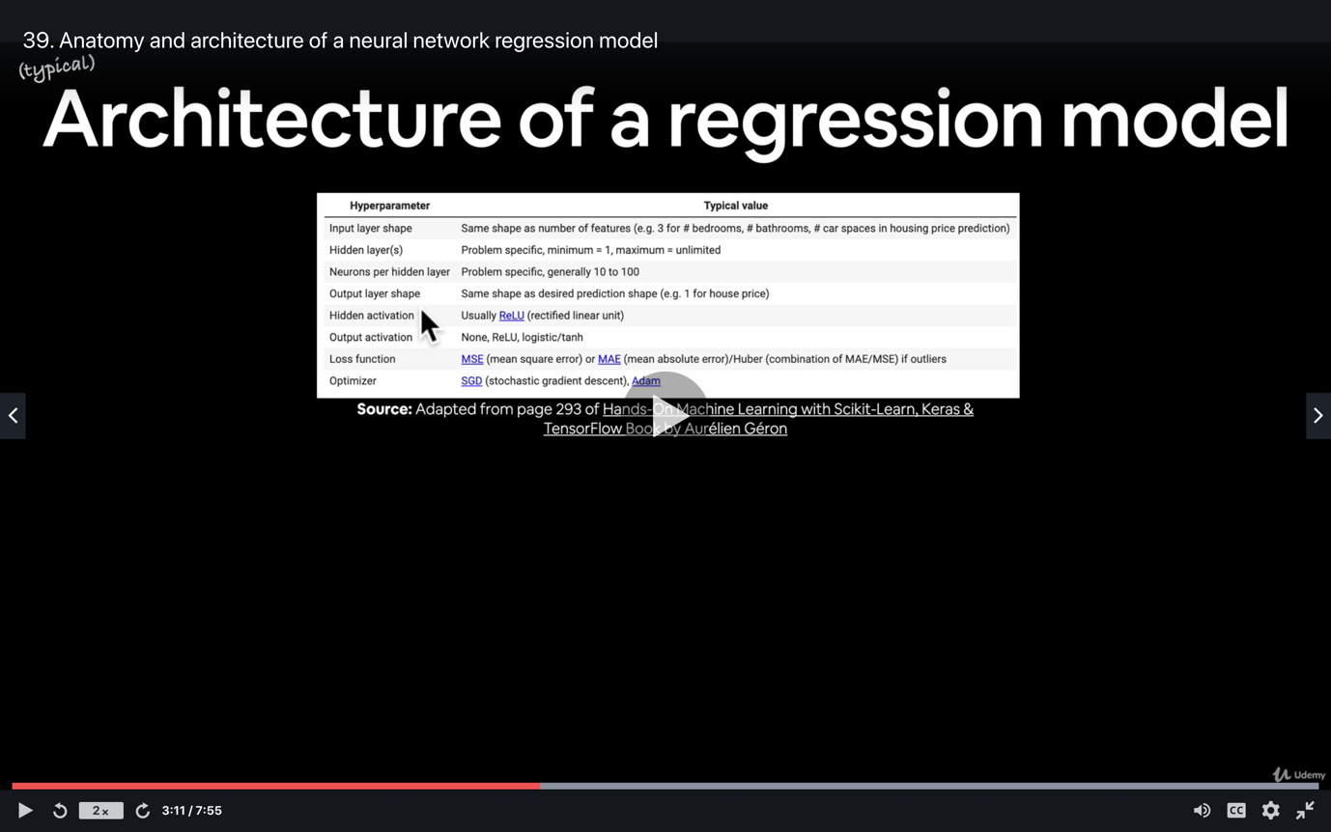

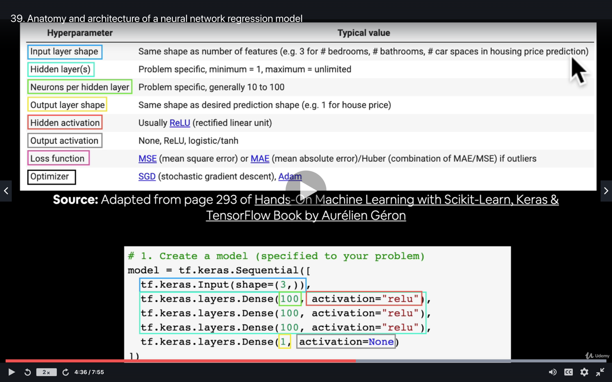

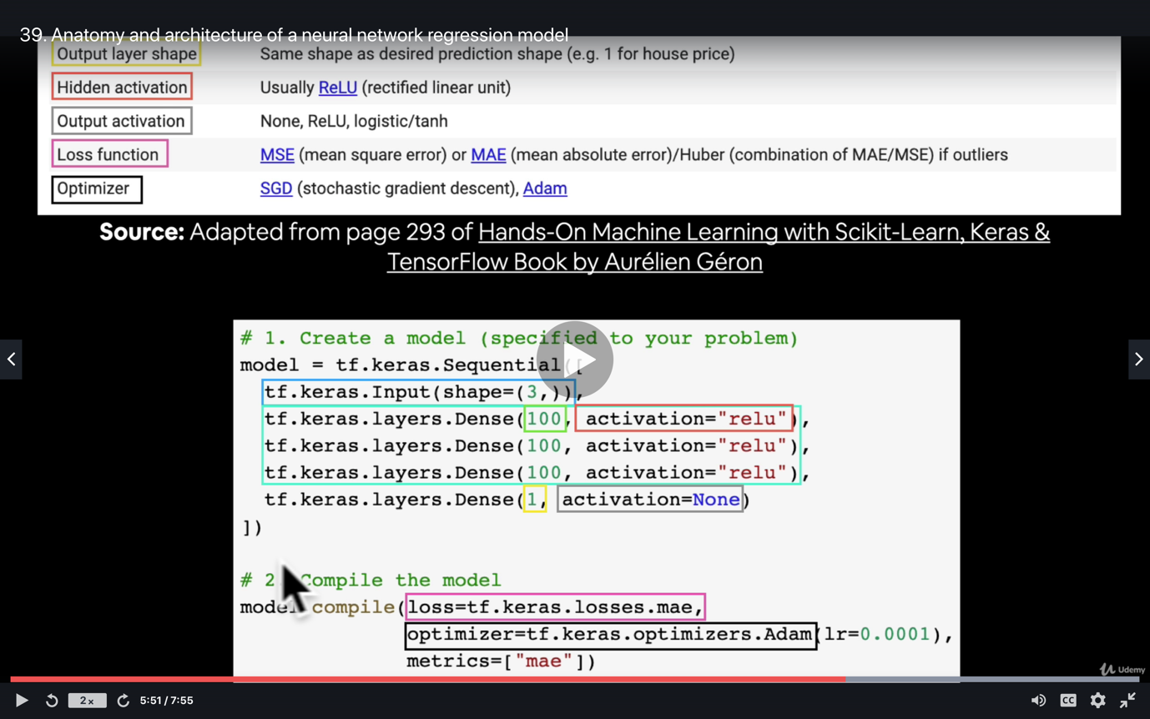

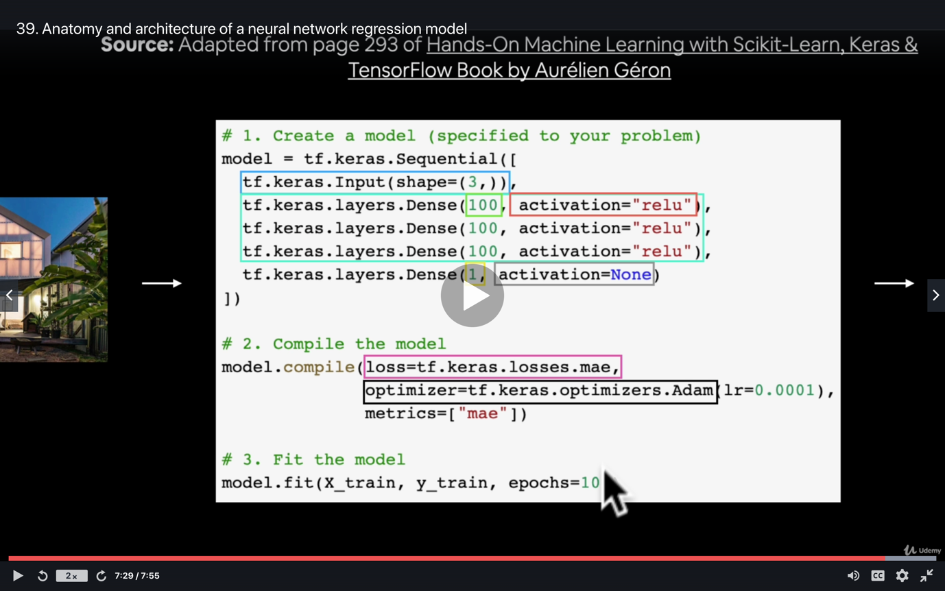

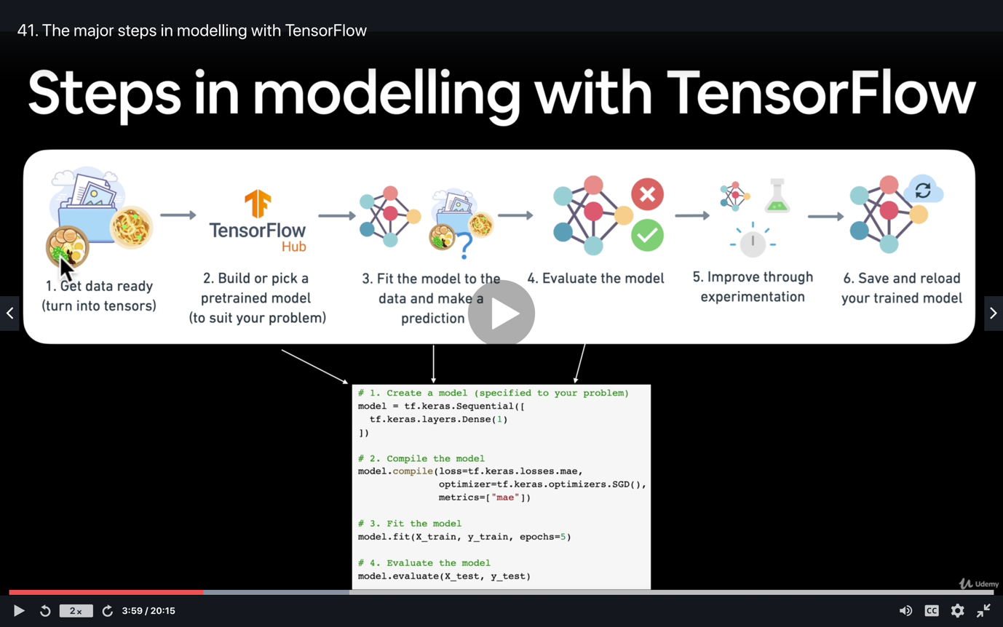

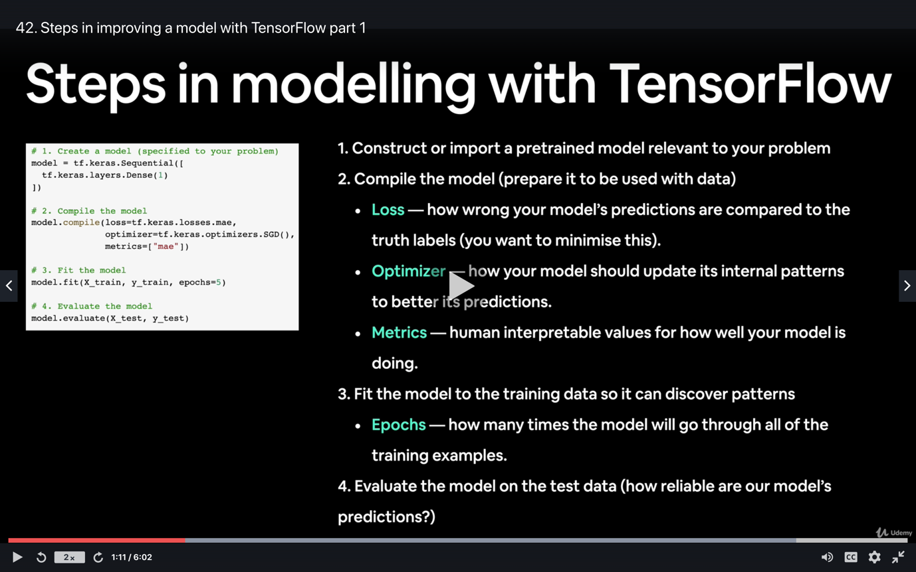

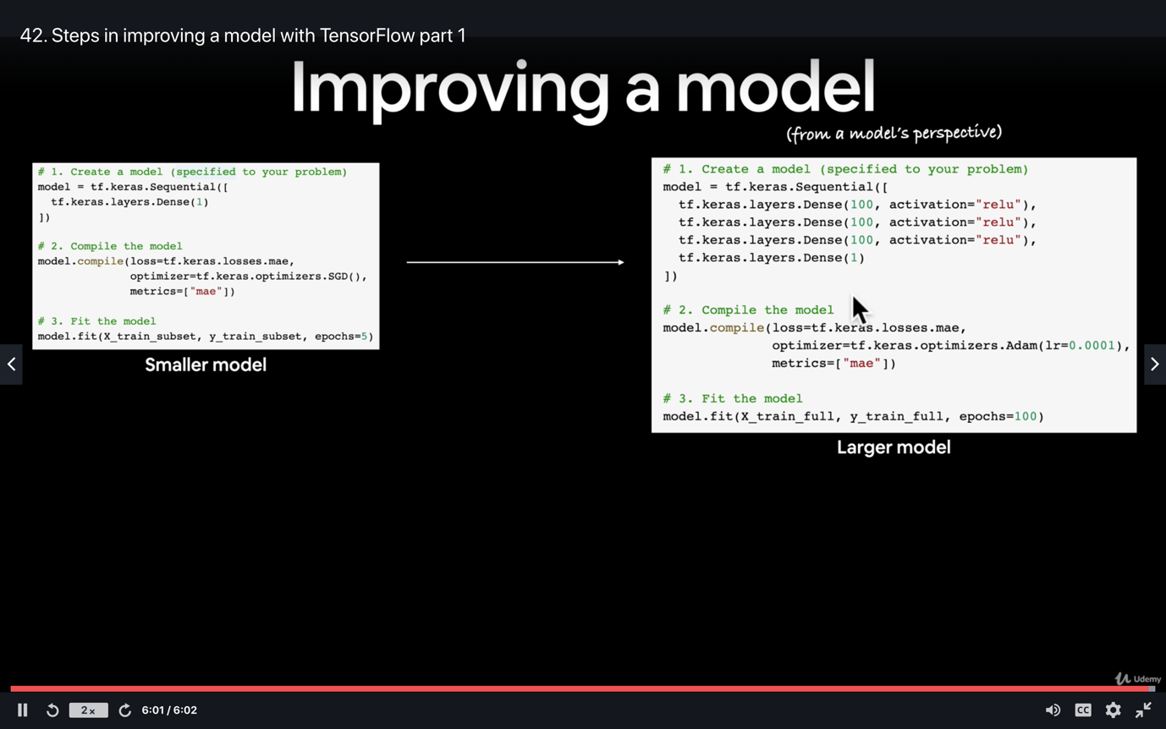

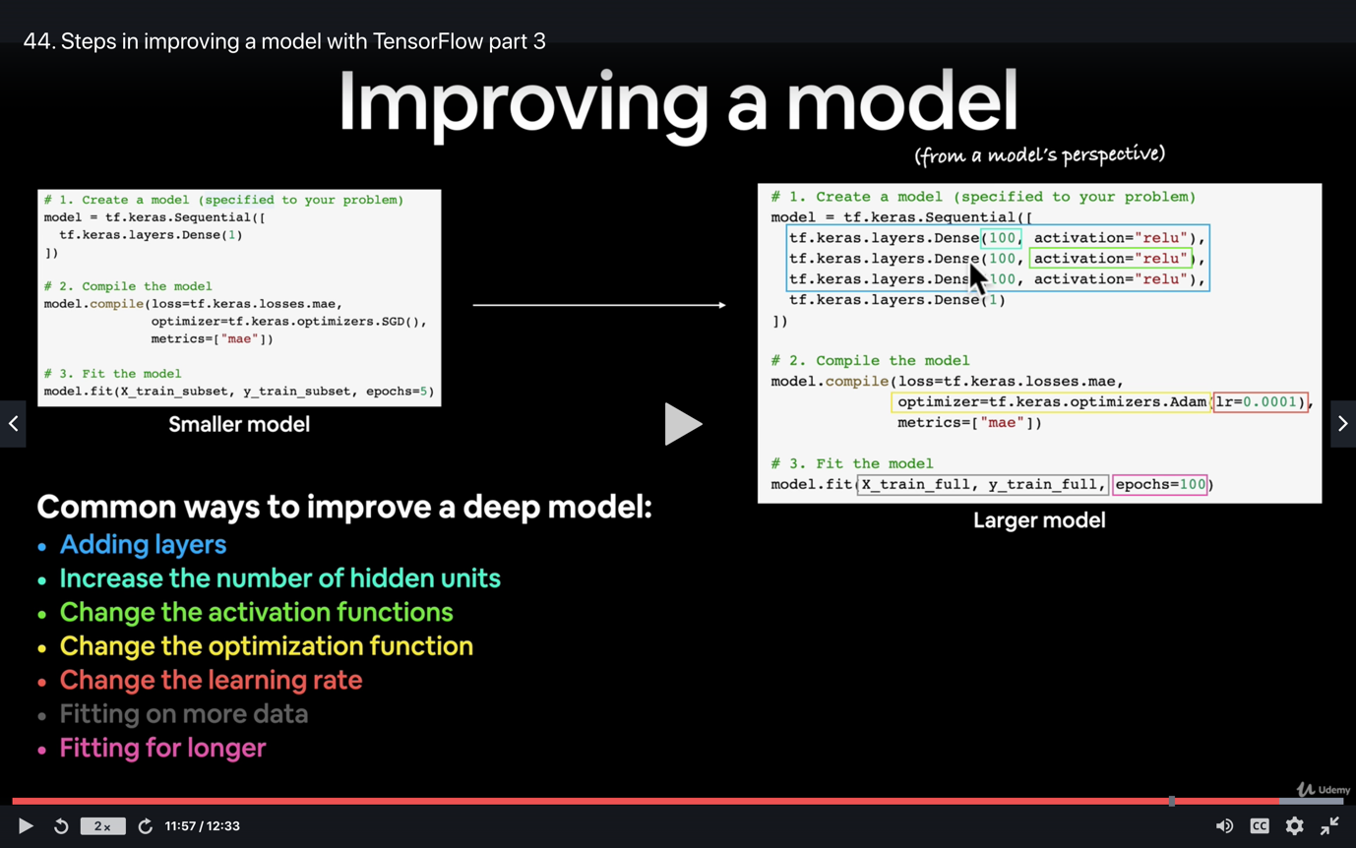

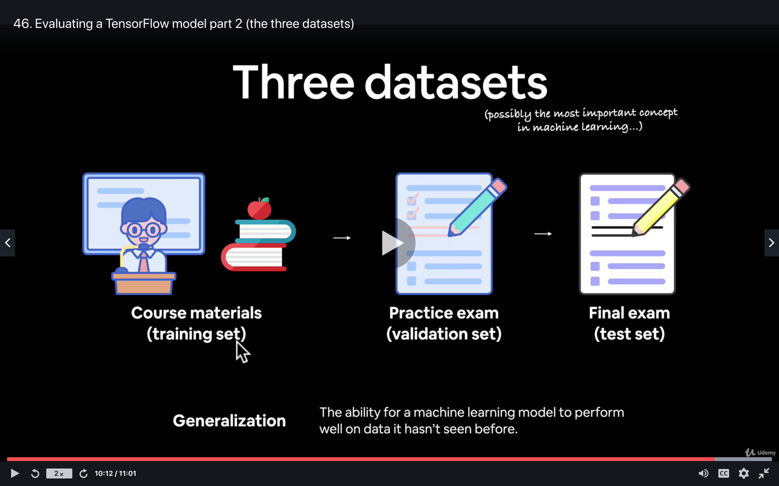

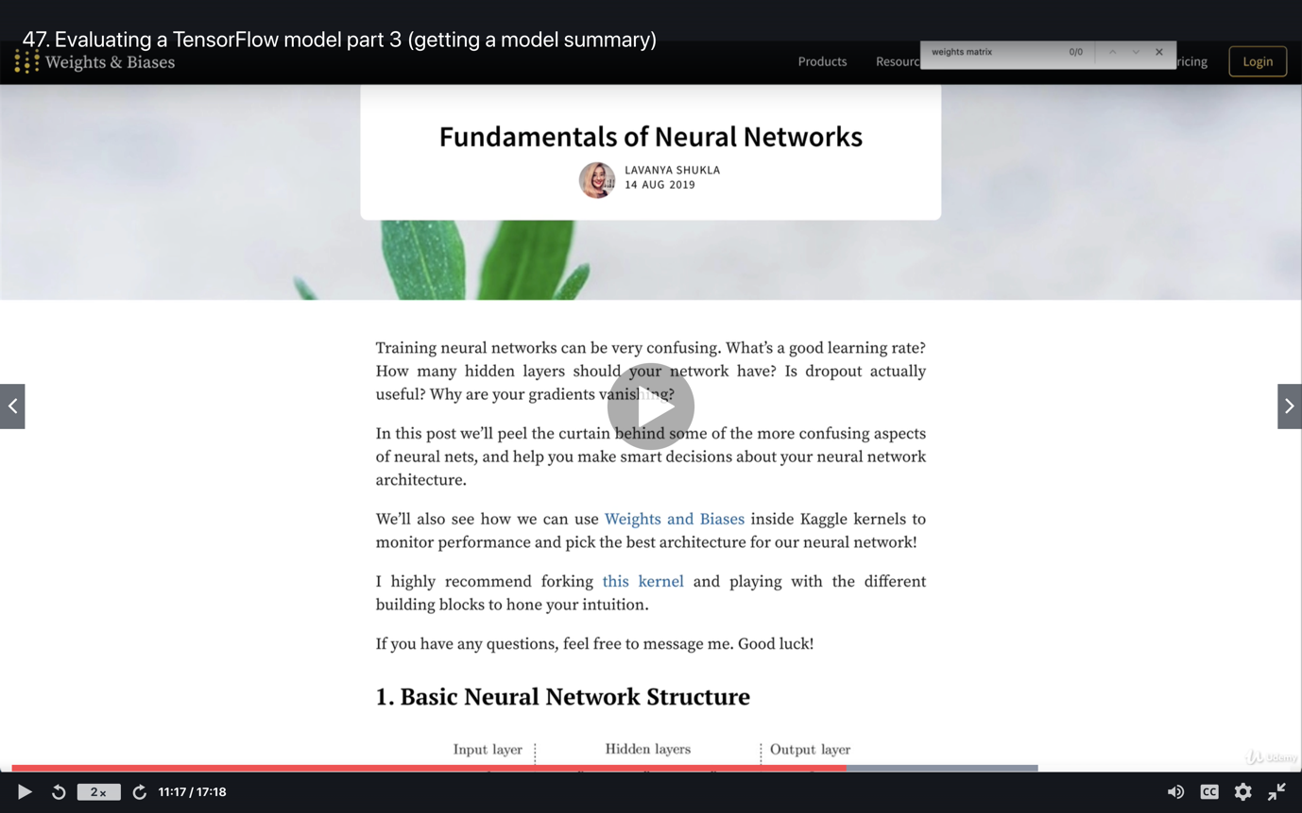

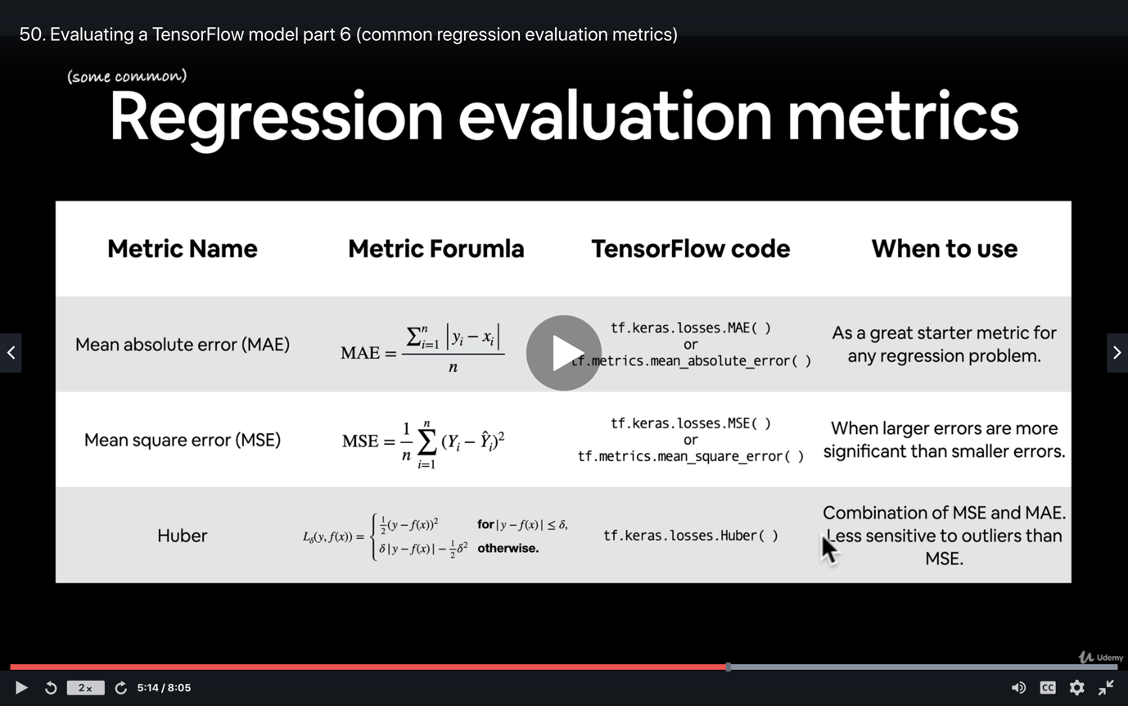

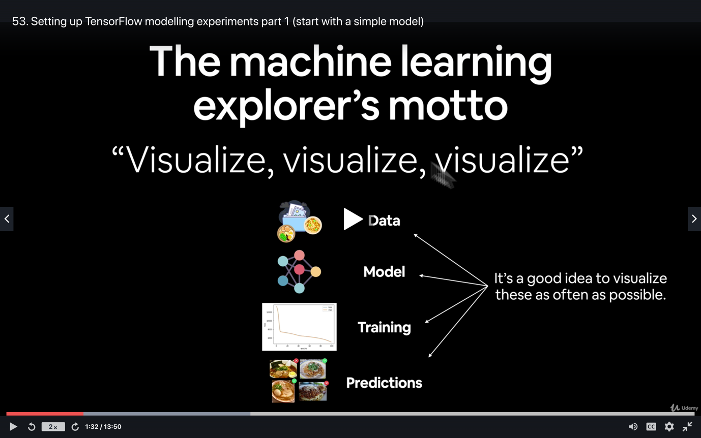

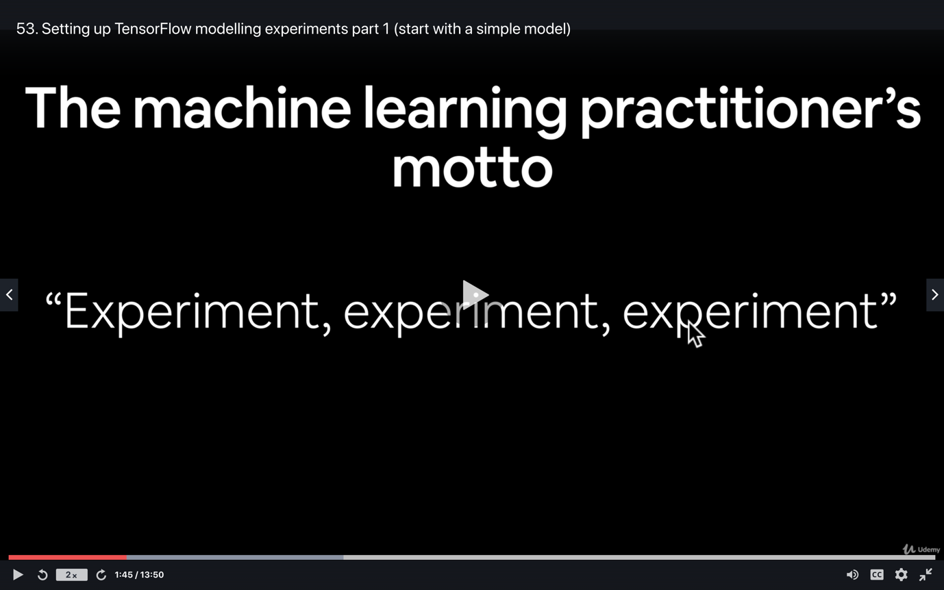

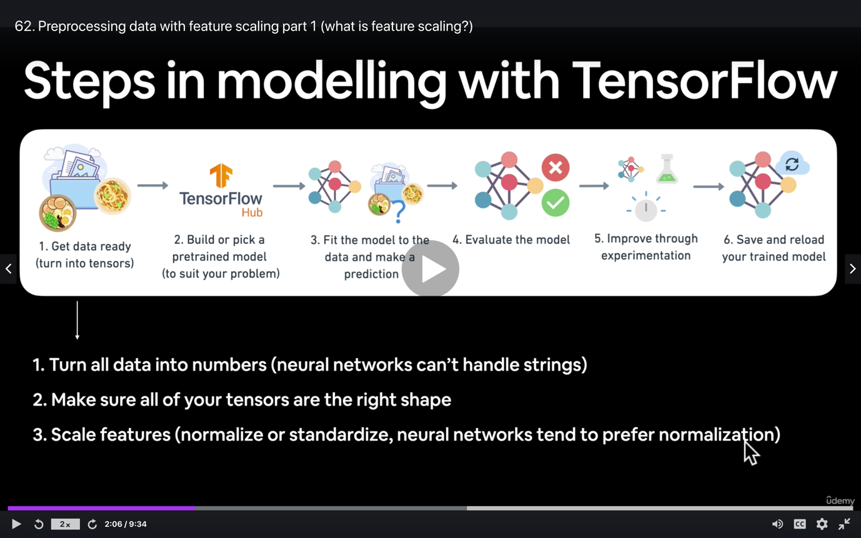

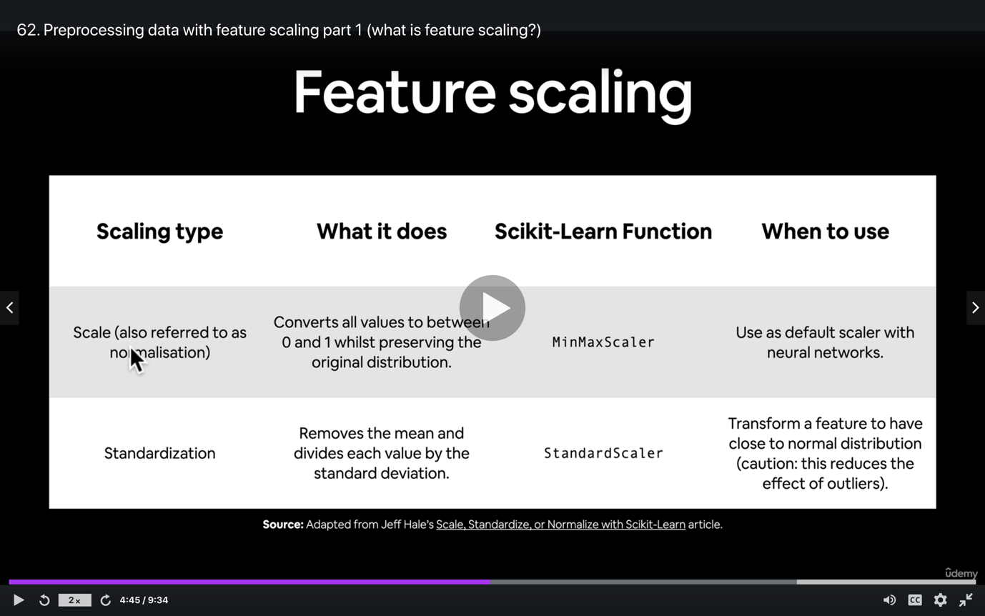

**4: Neural network classification in TensorFlow**

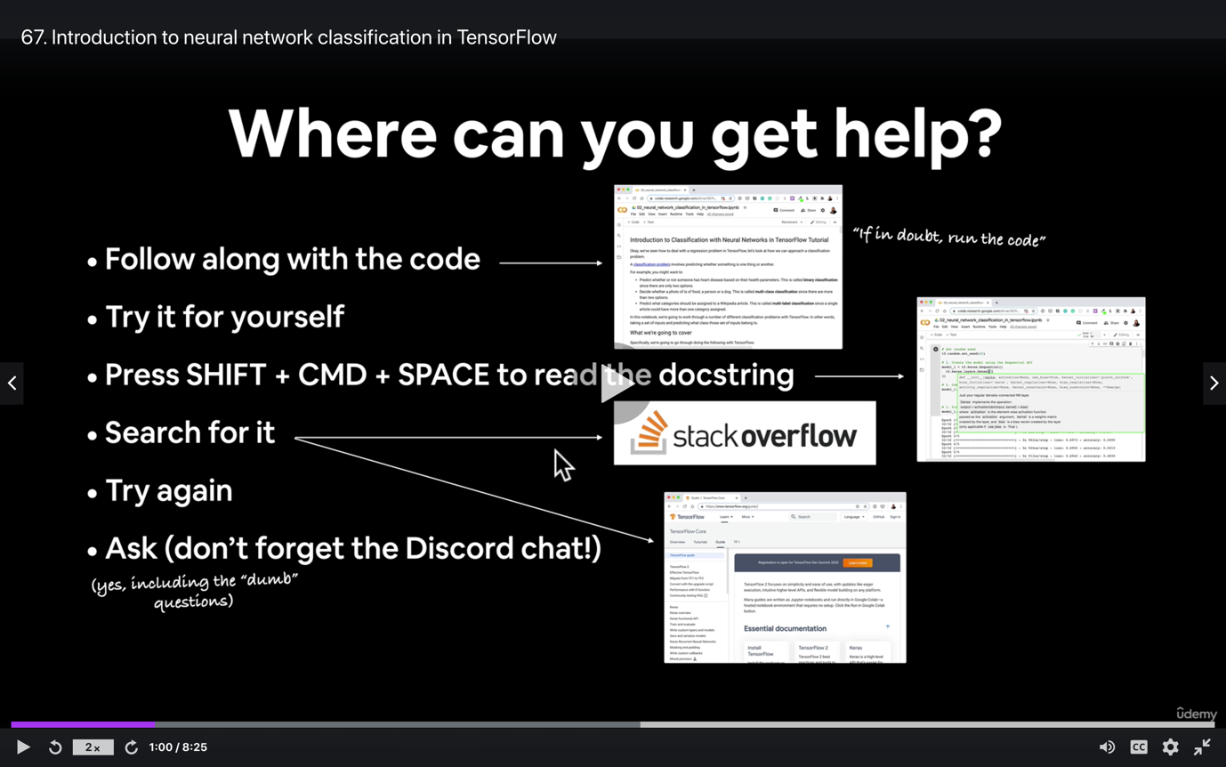

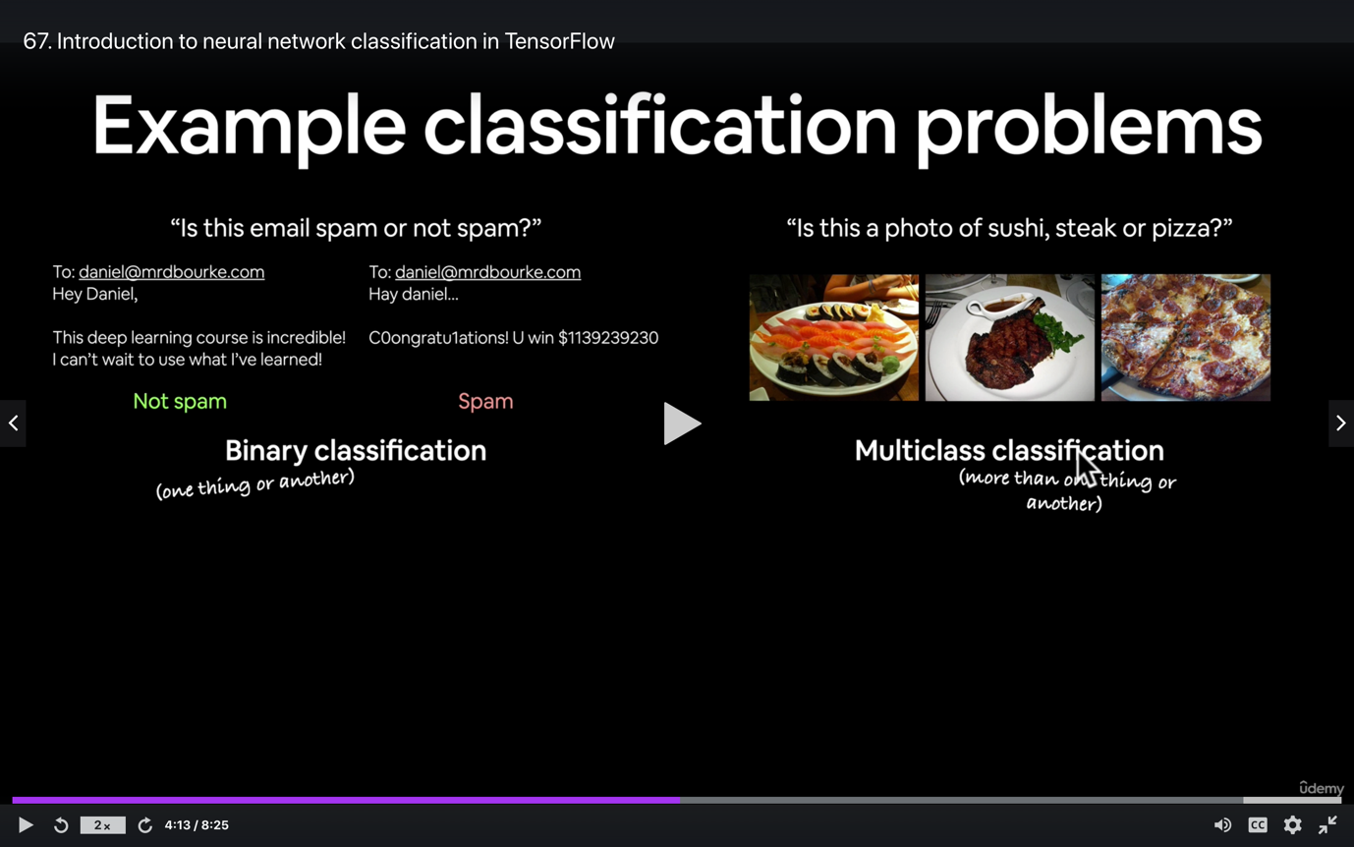

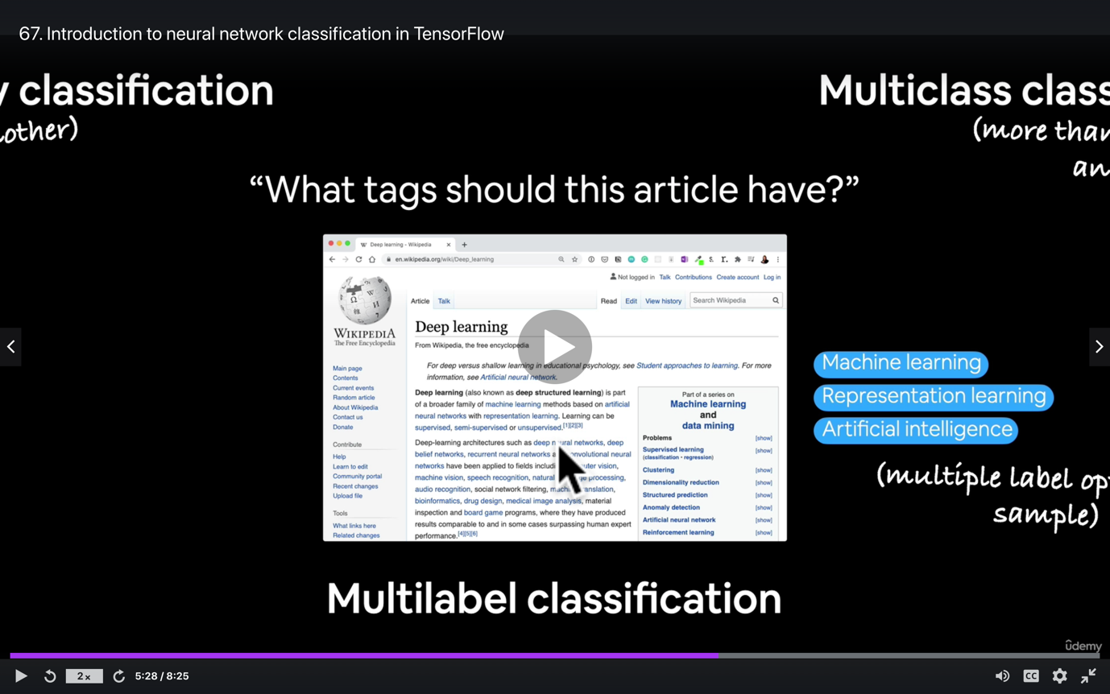

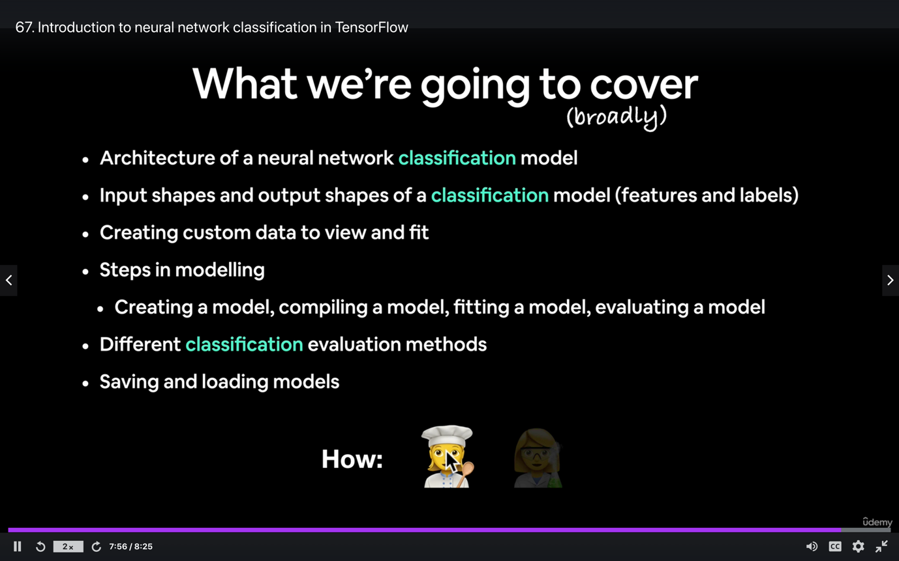

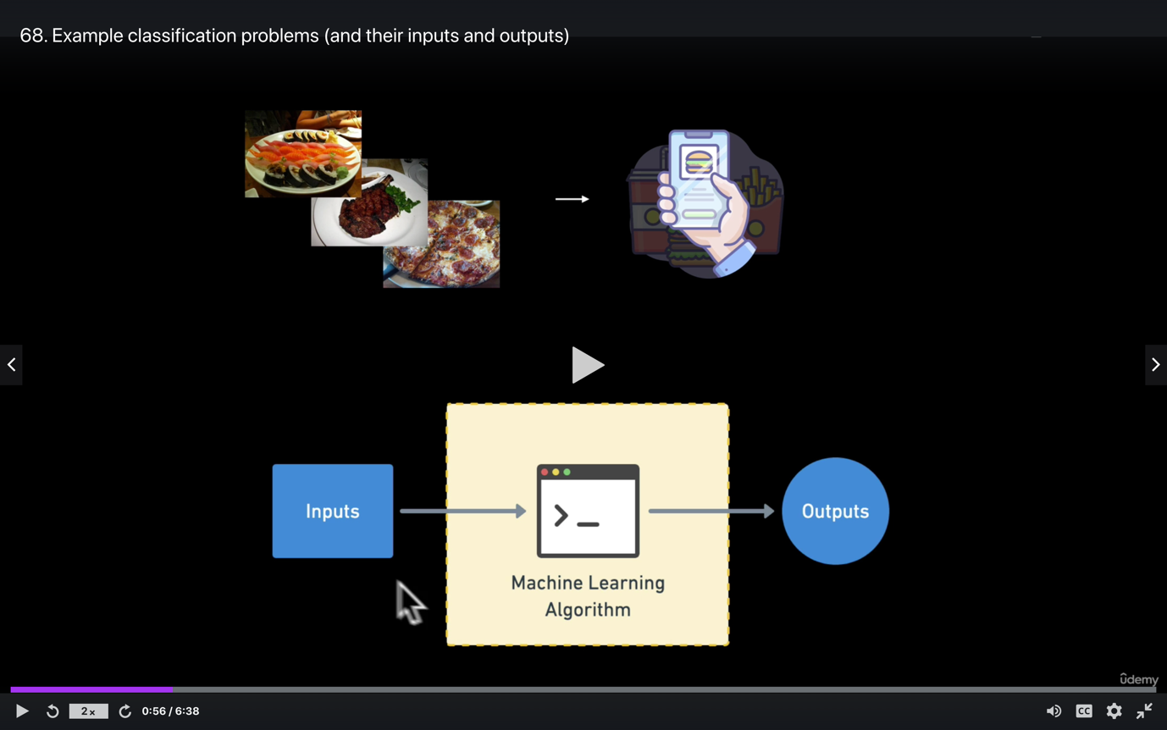

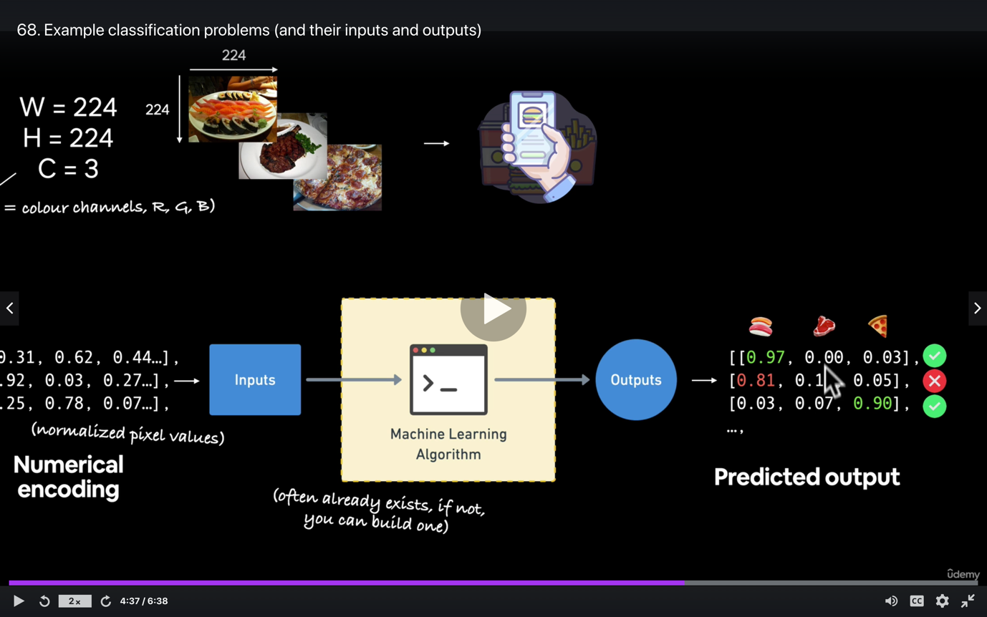

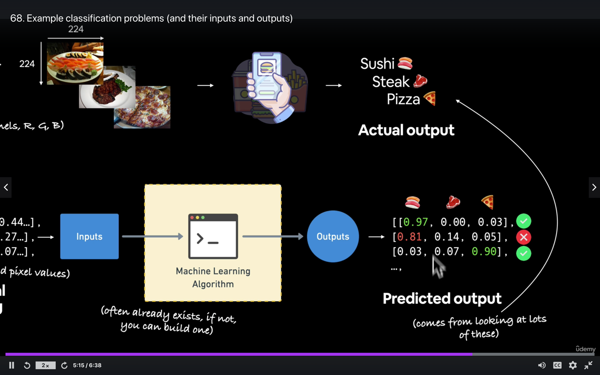

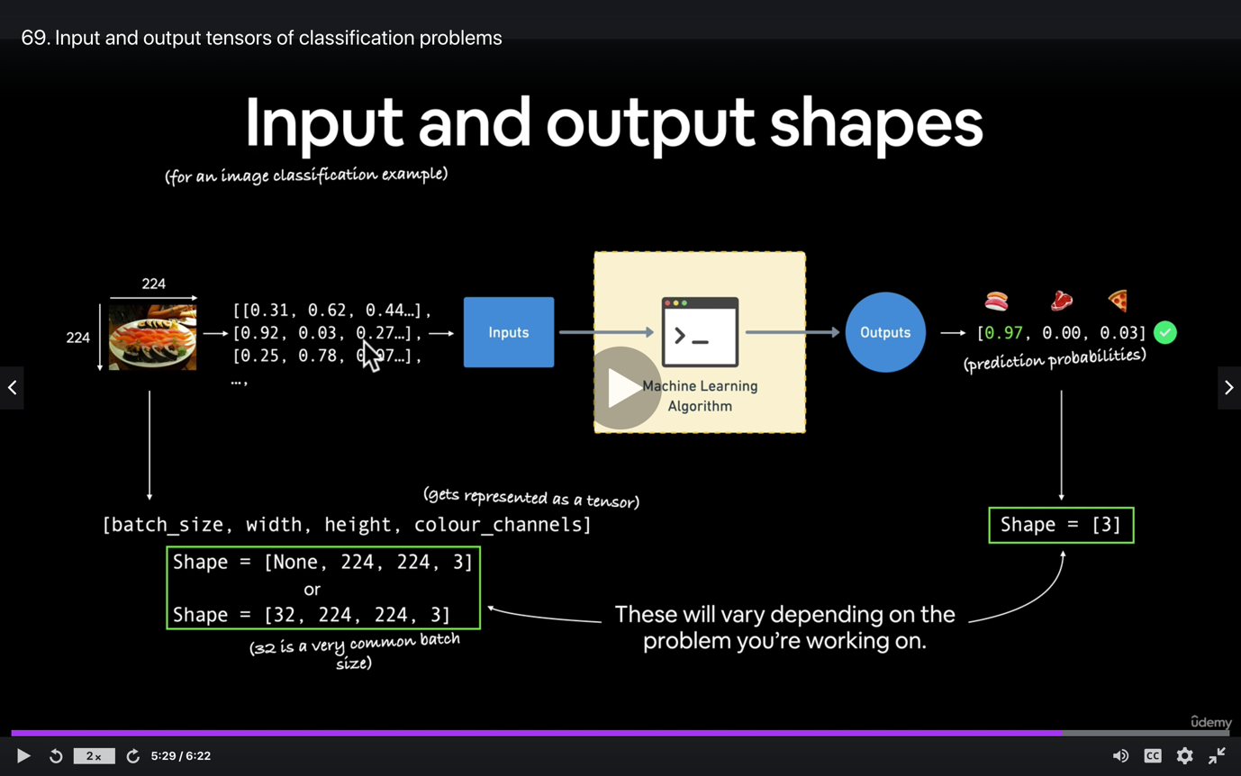

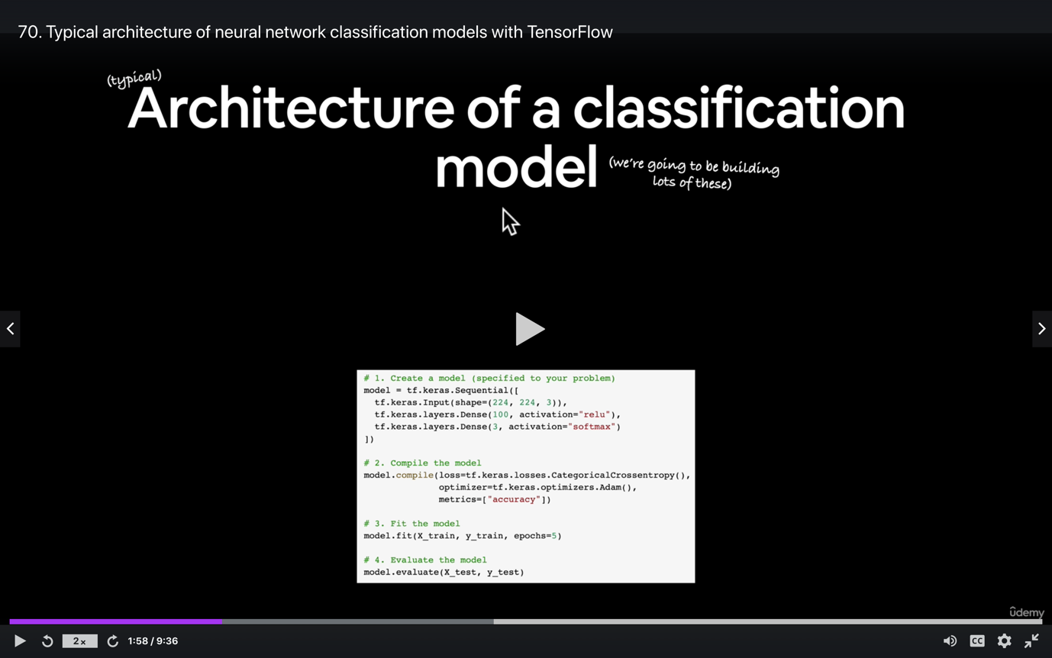

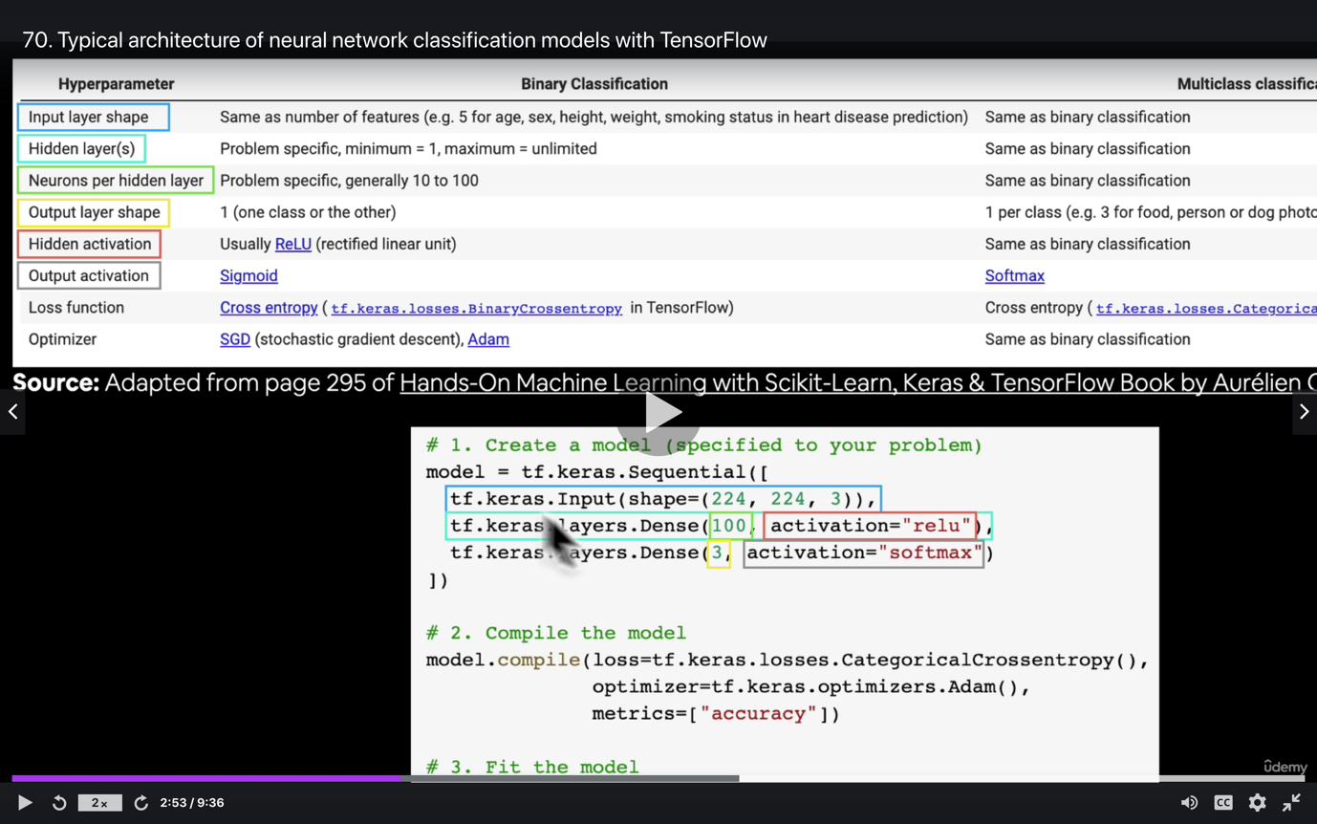

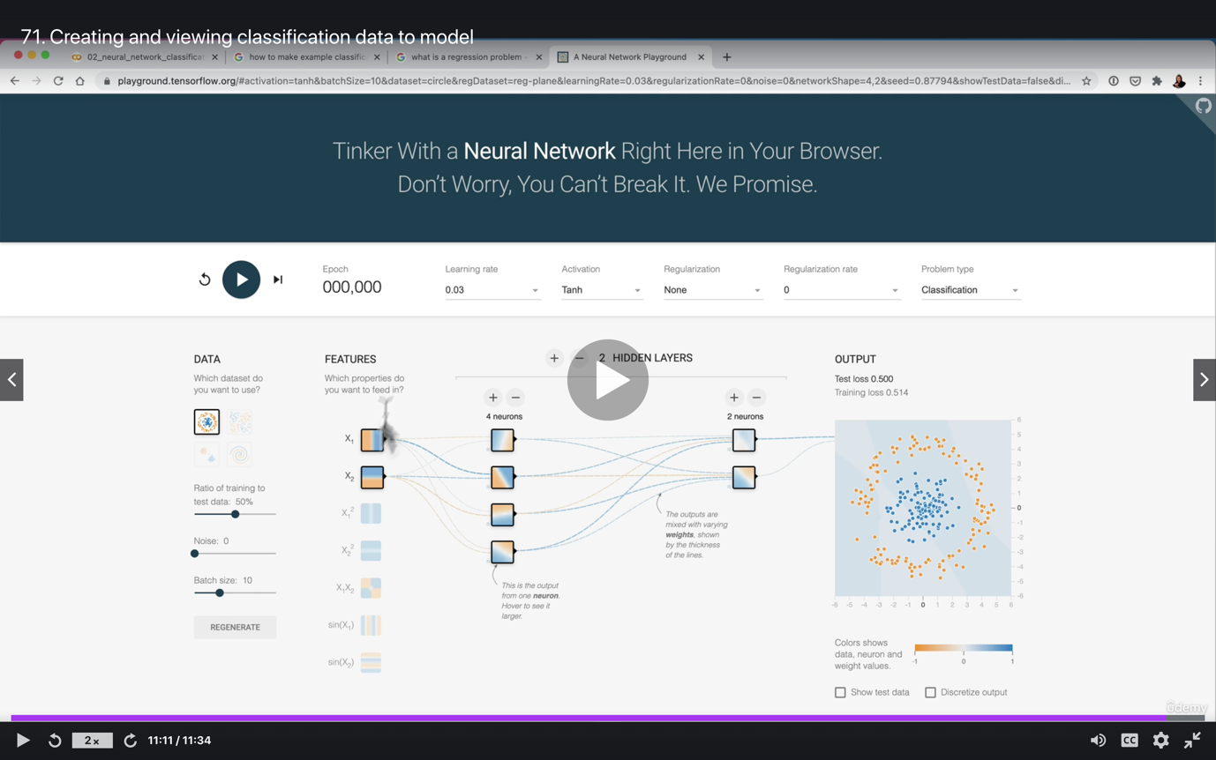

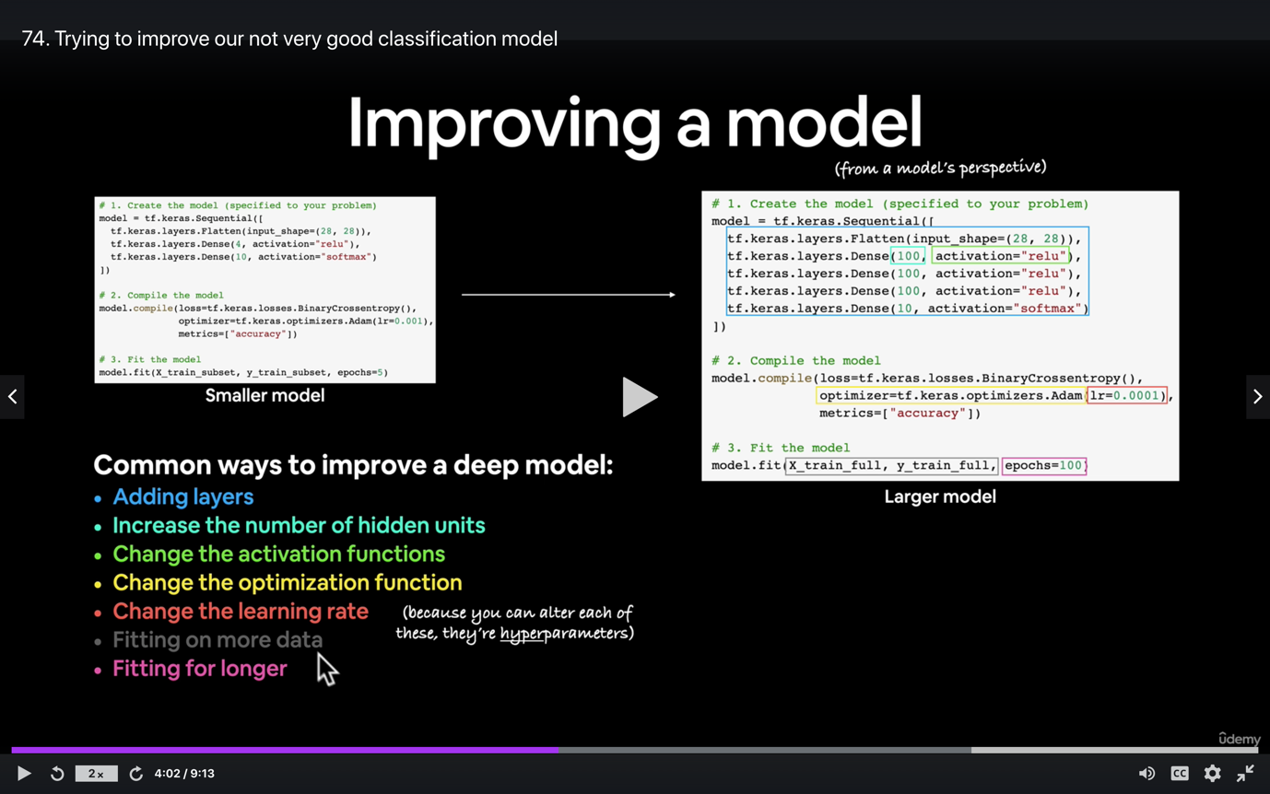

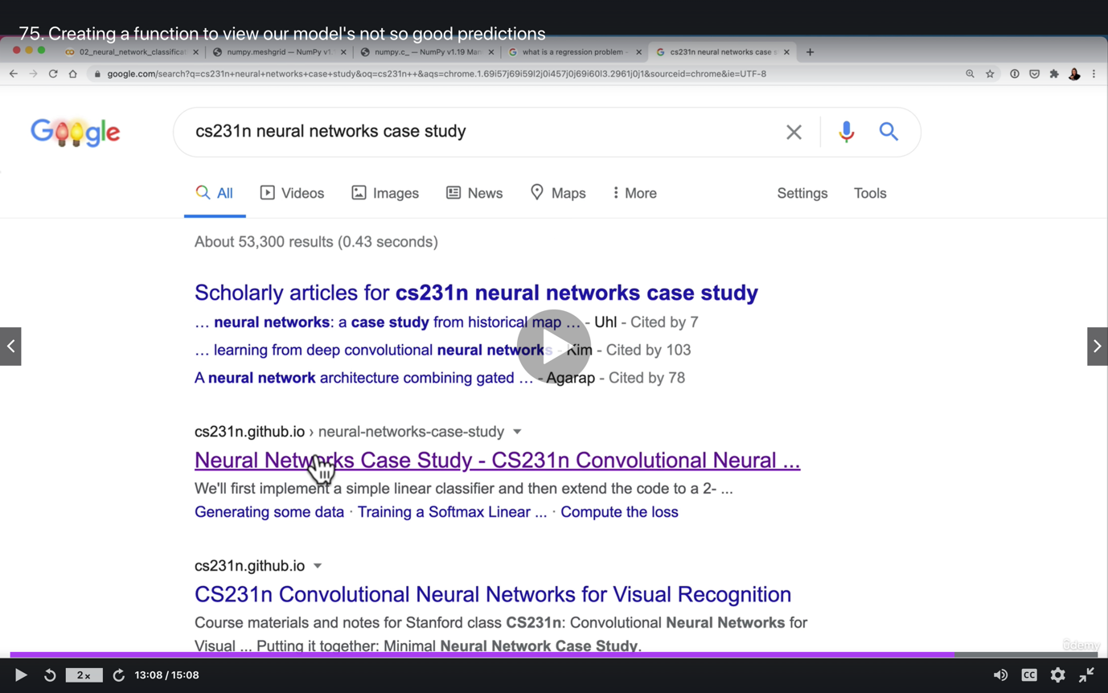

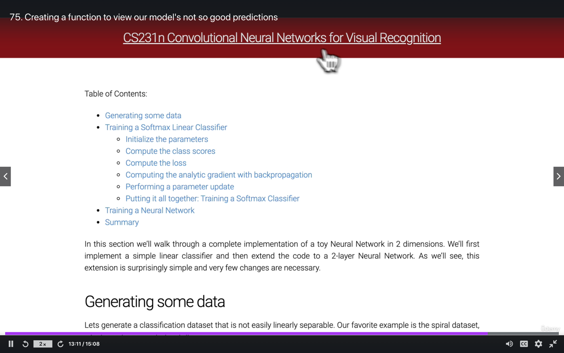

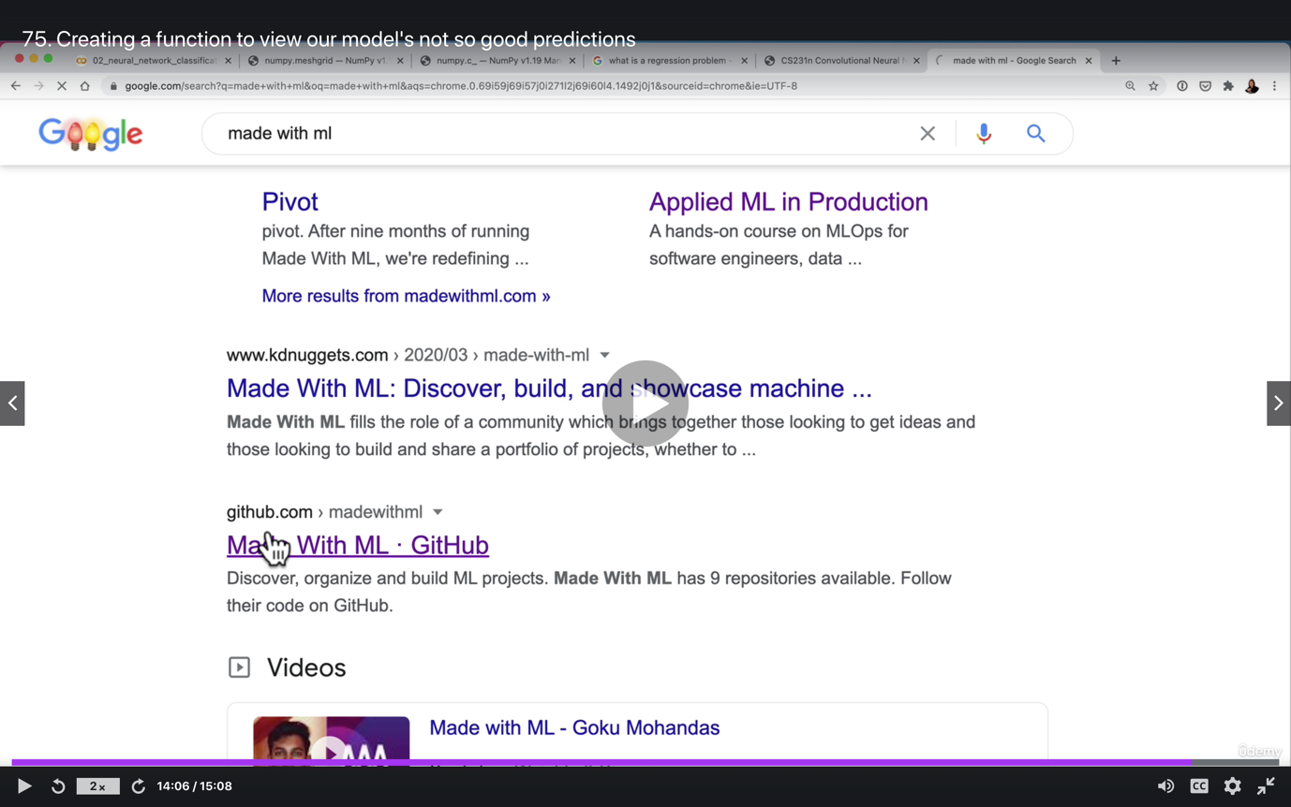

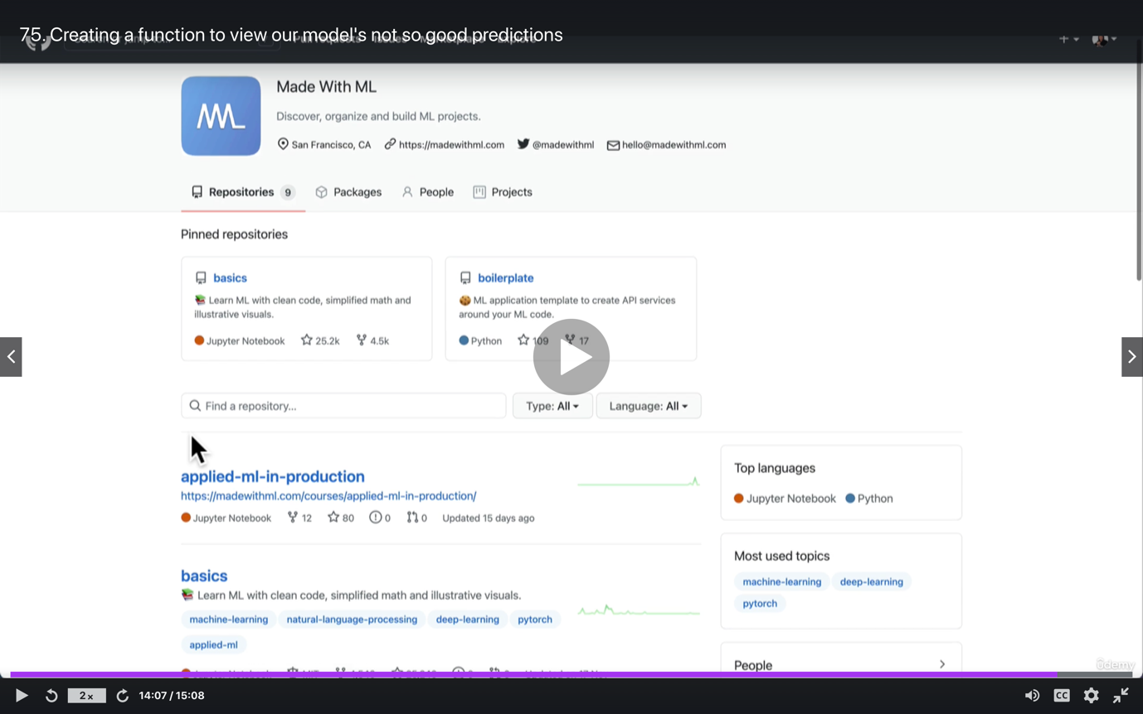

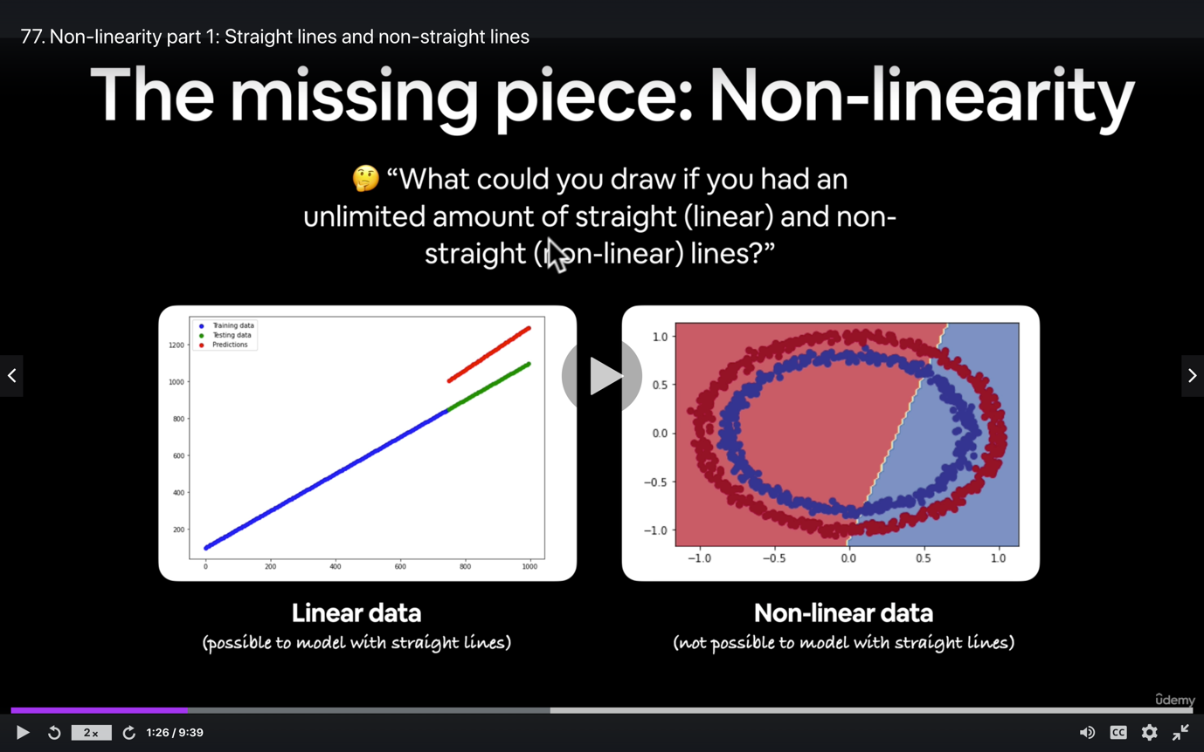

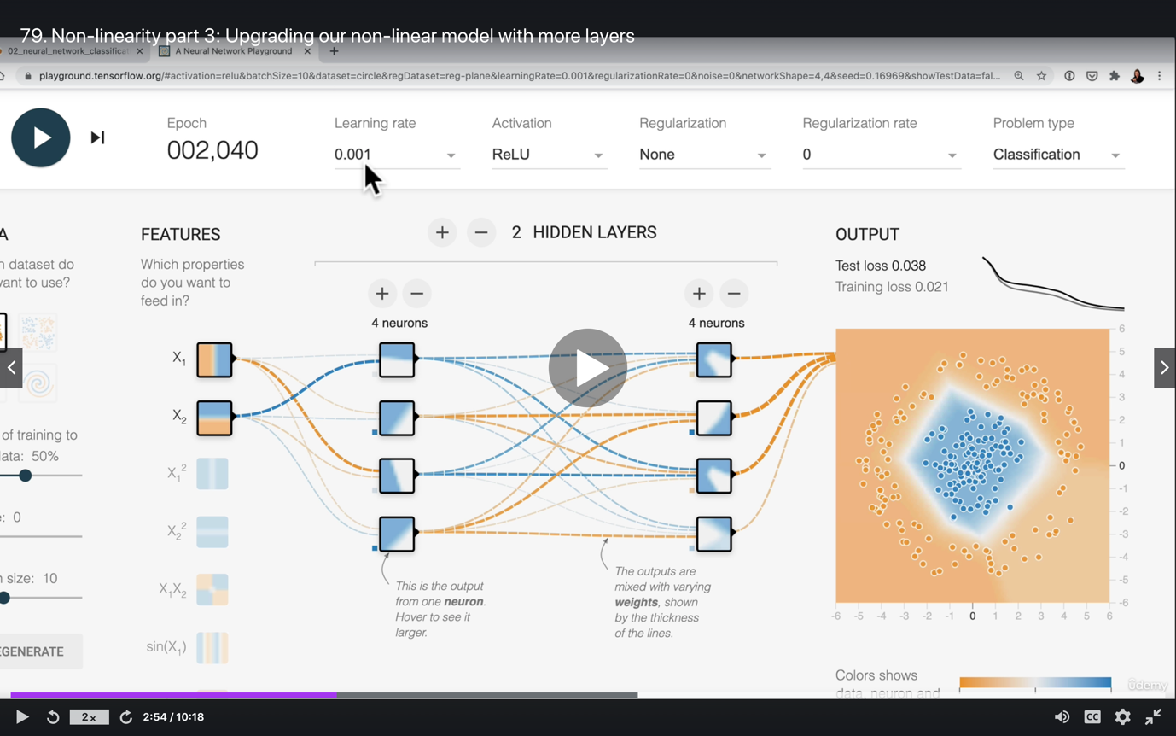

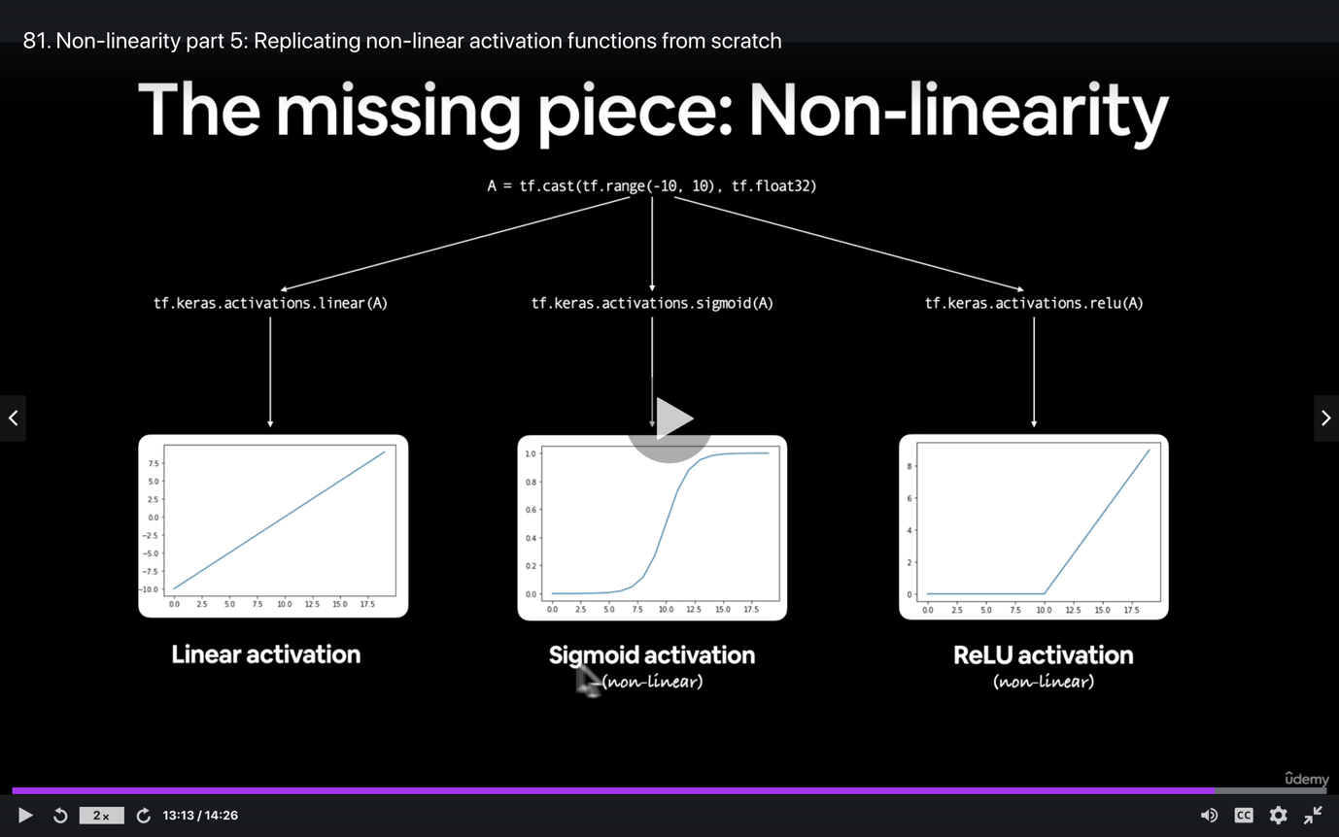

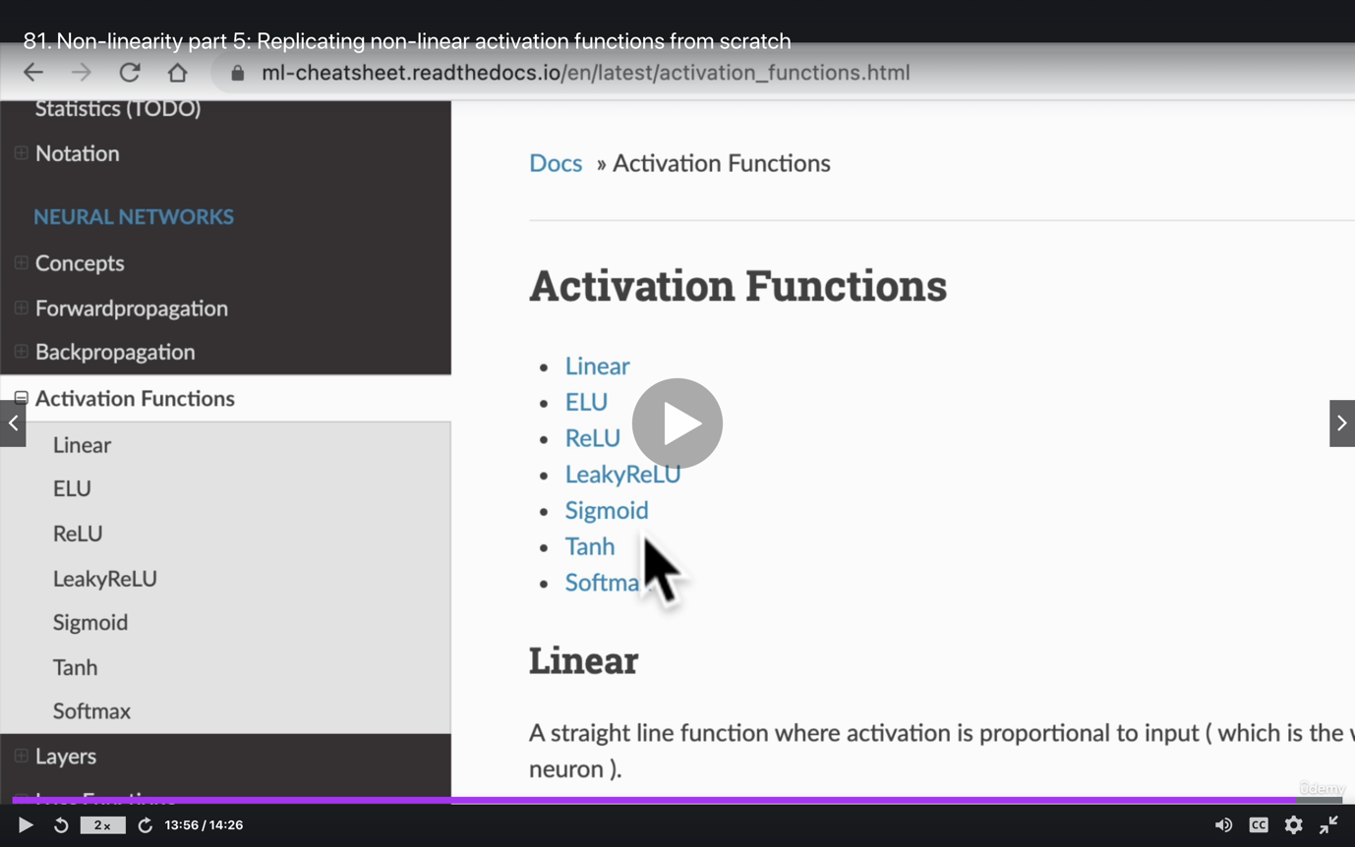

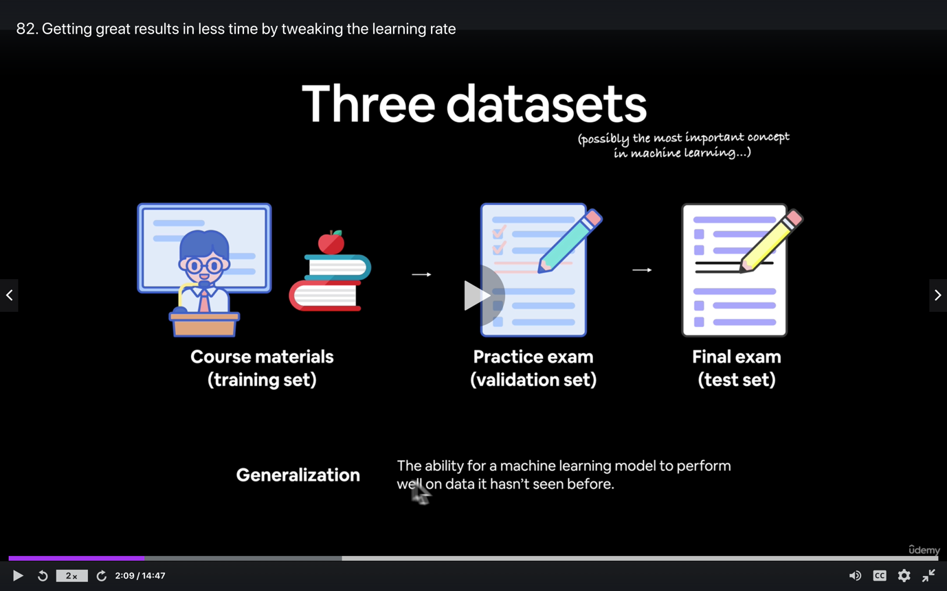

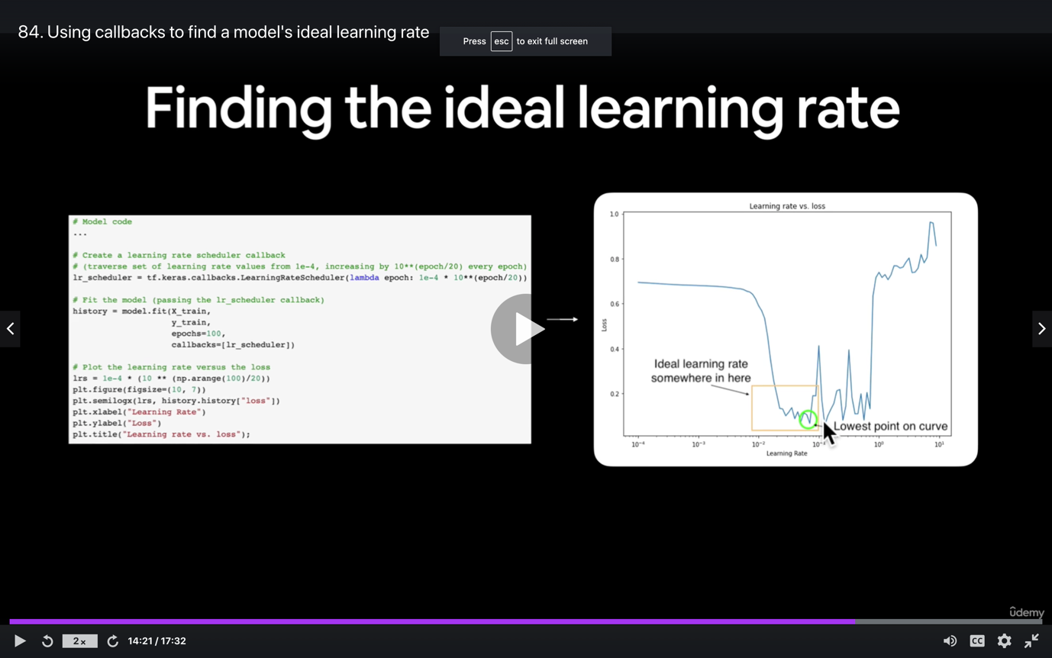

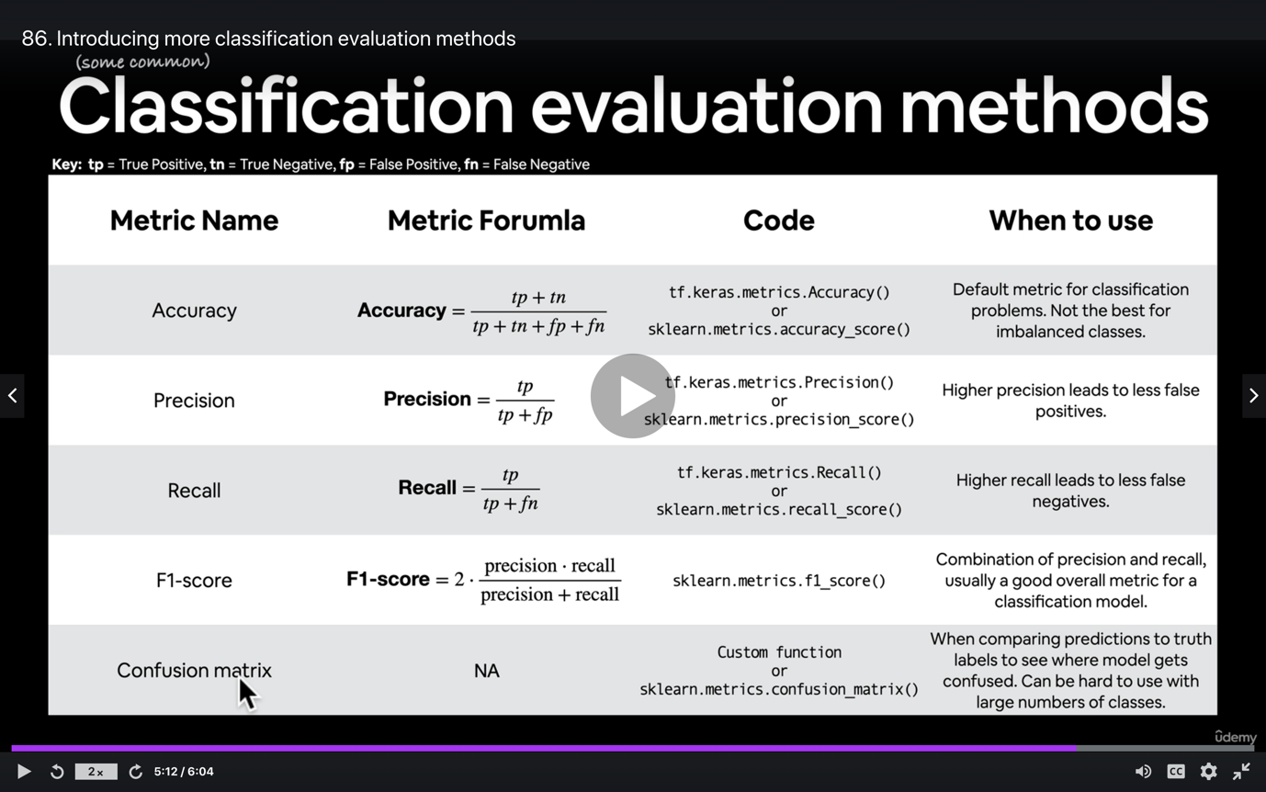

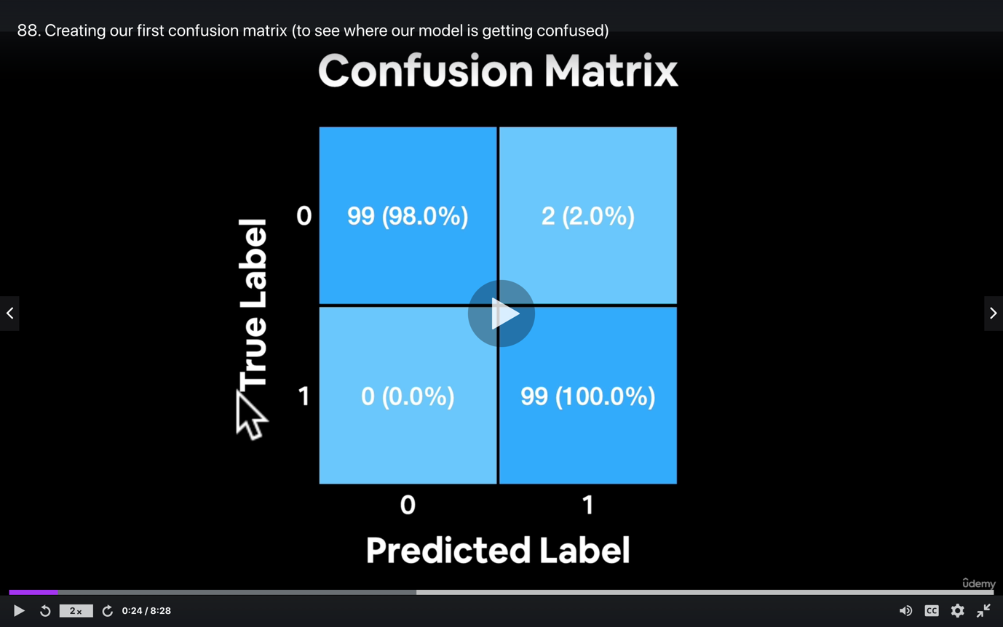

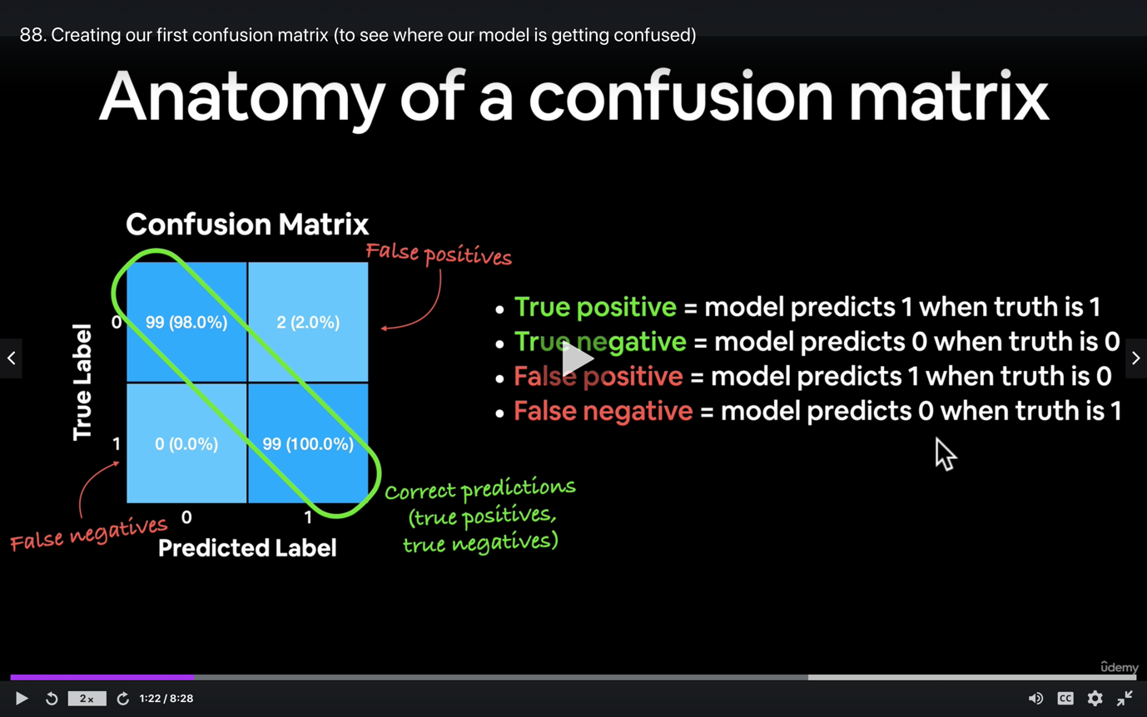

Multiclass classification:

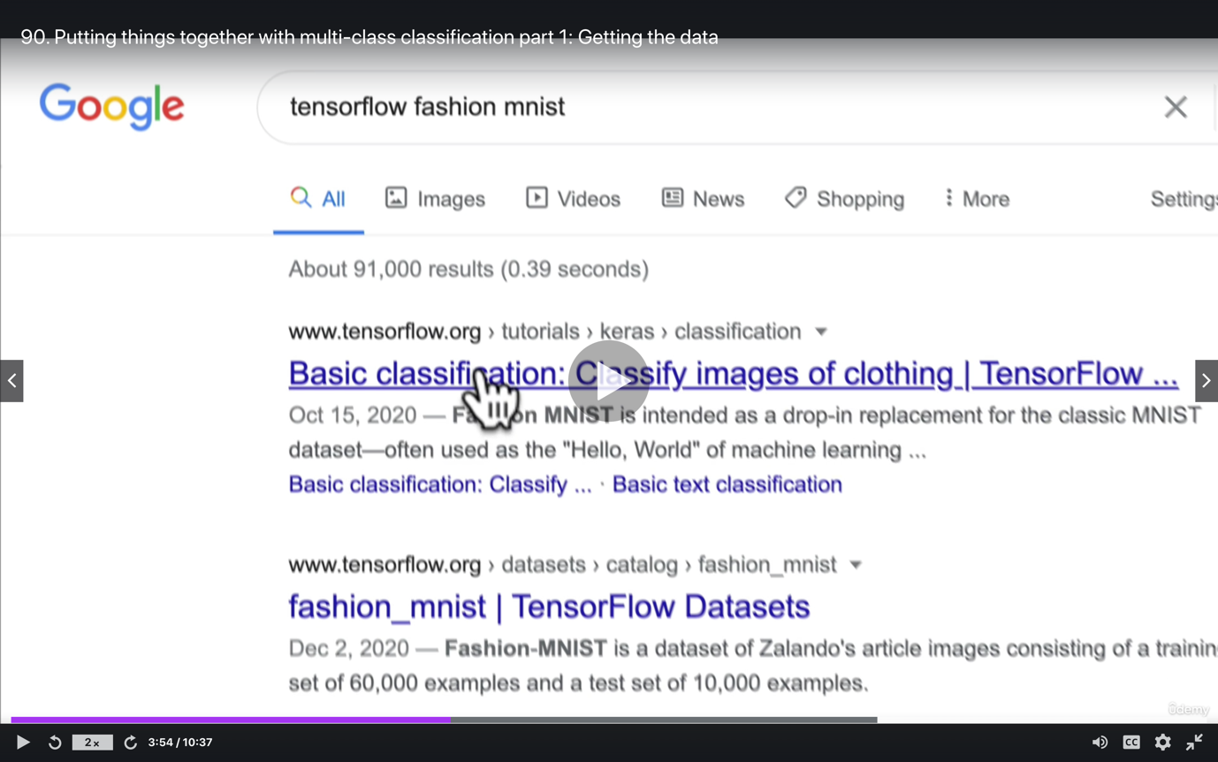

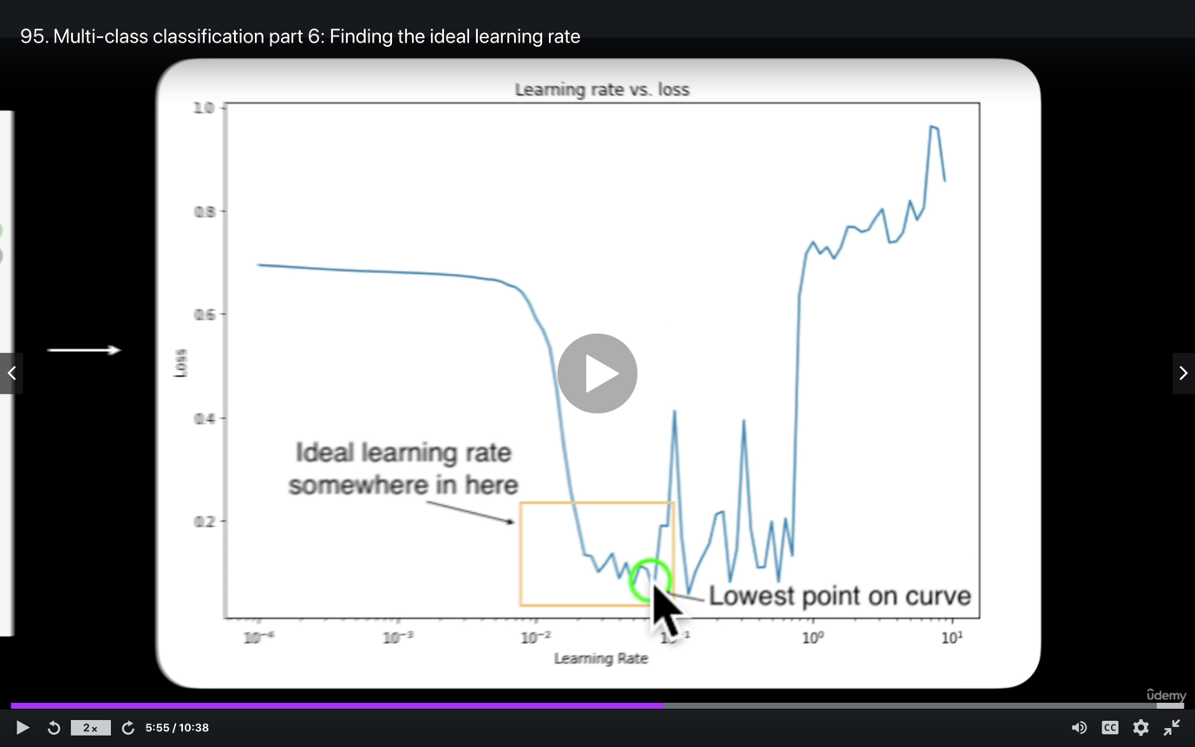

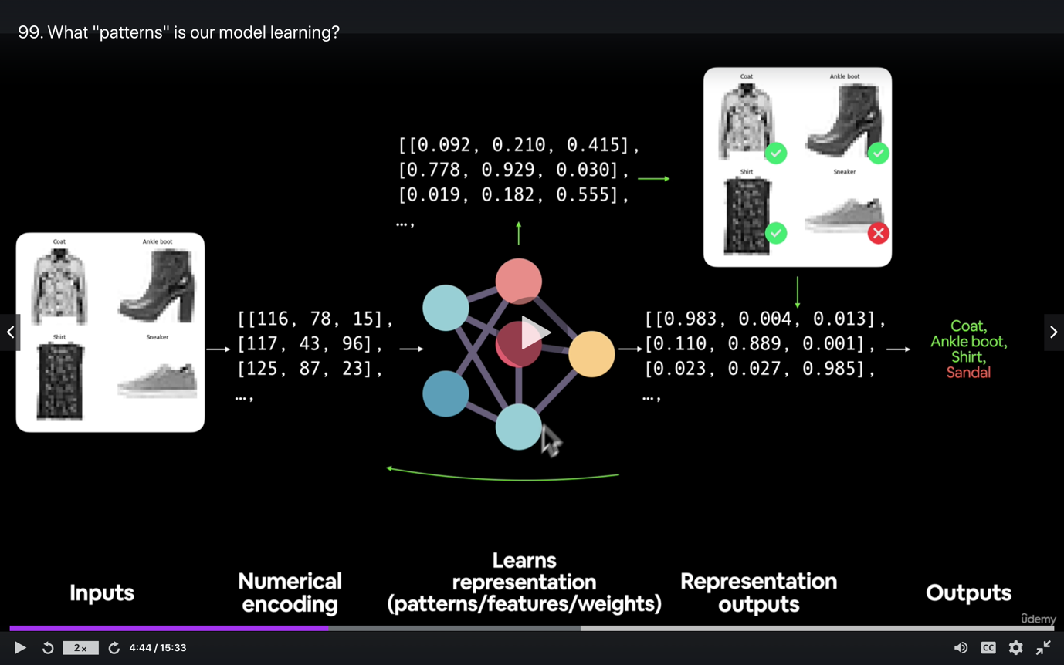

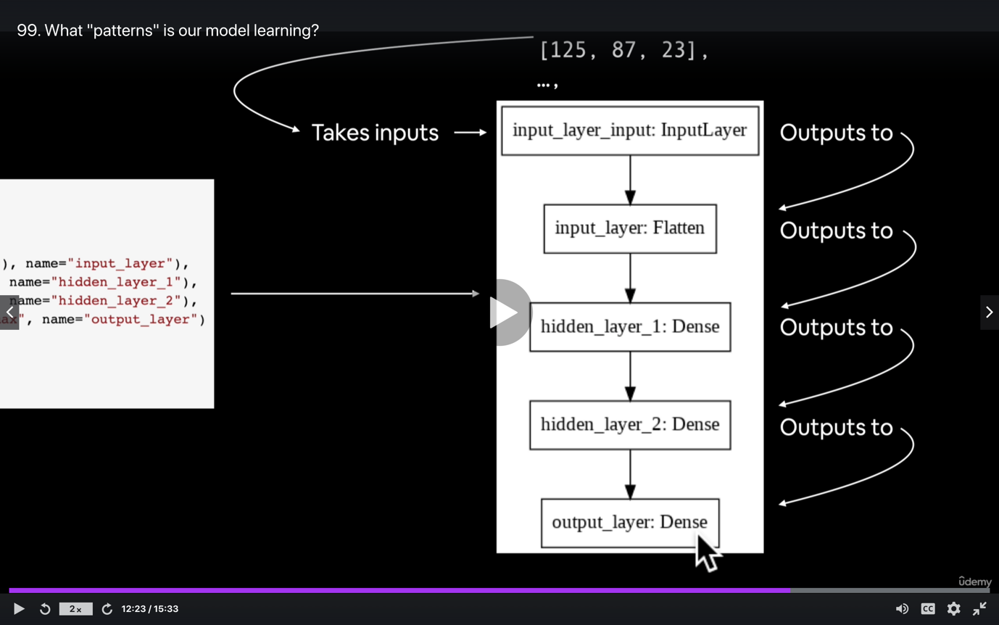

**5: Computer Vision and Convolutional Neural Networks in TensorFlow**

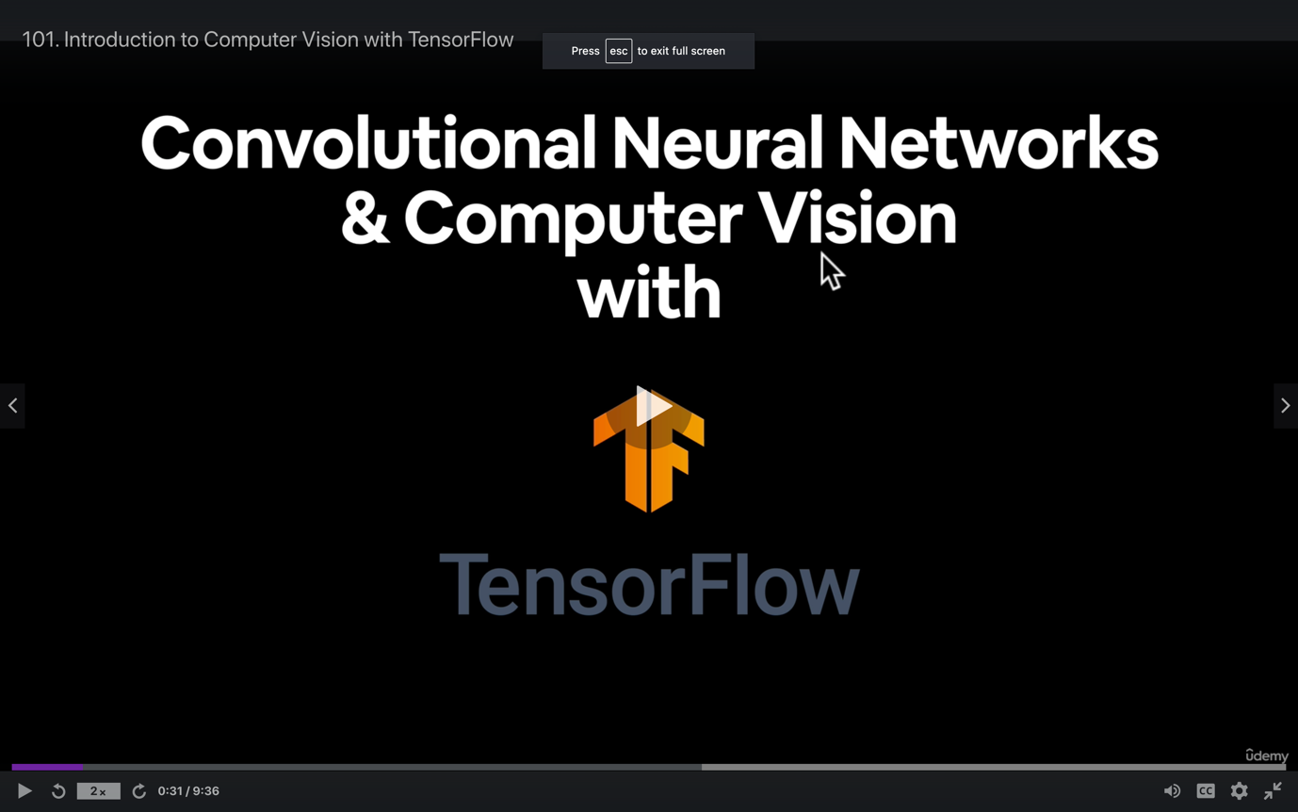

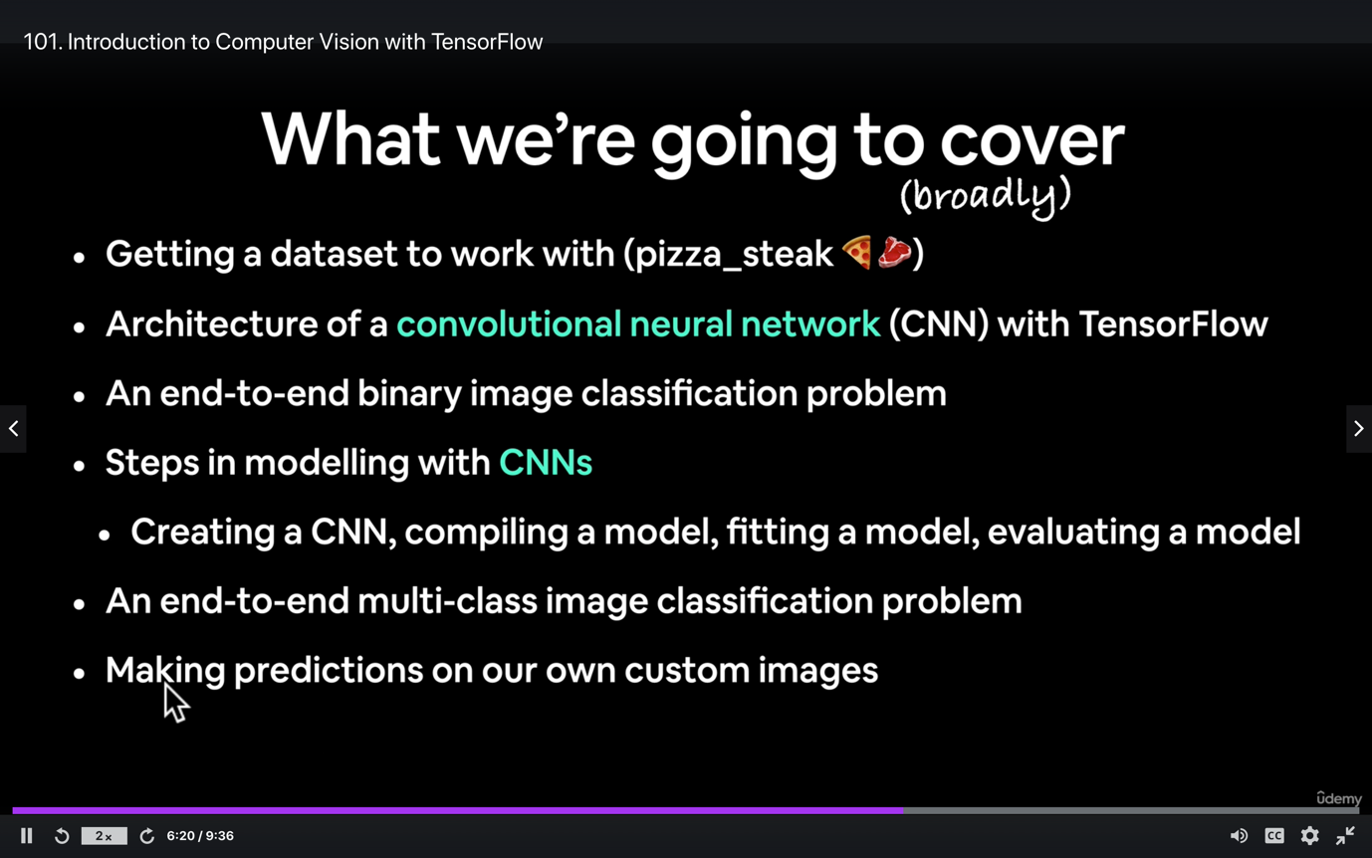

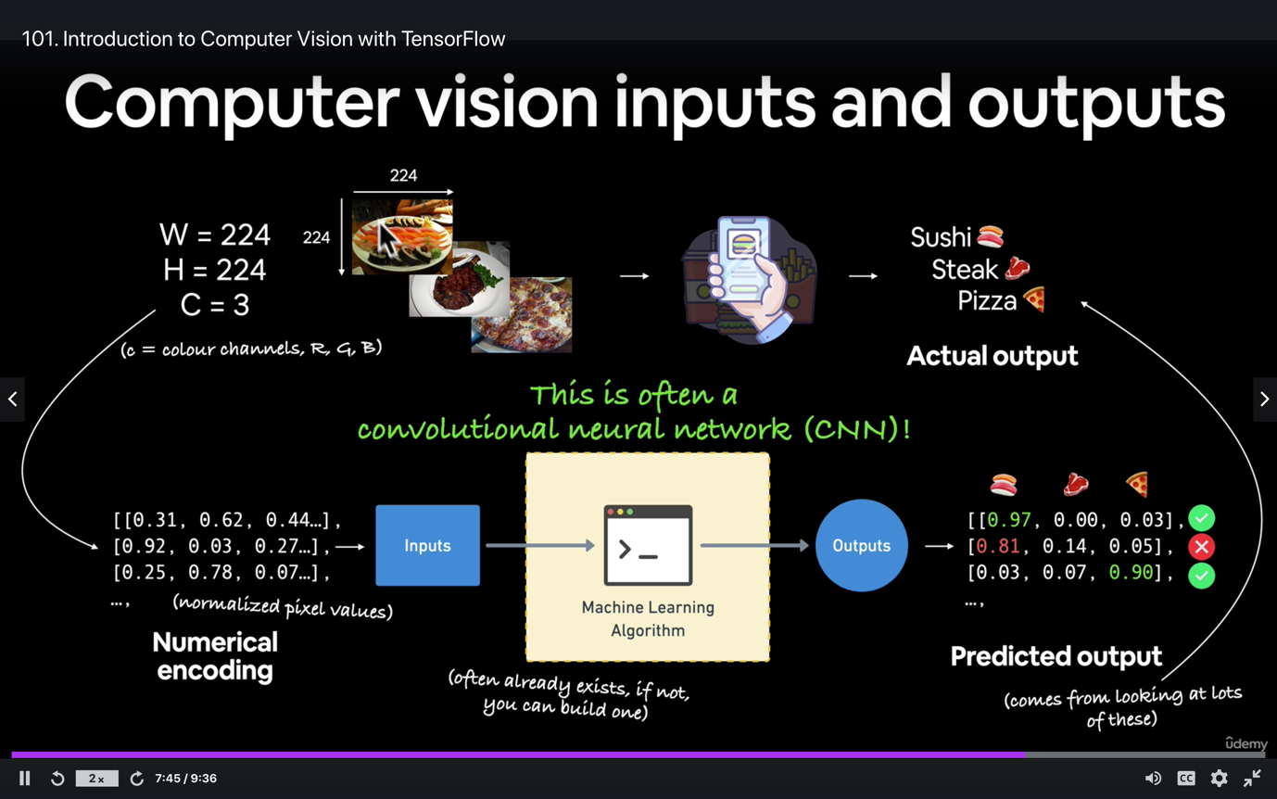

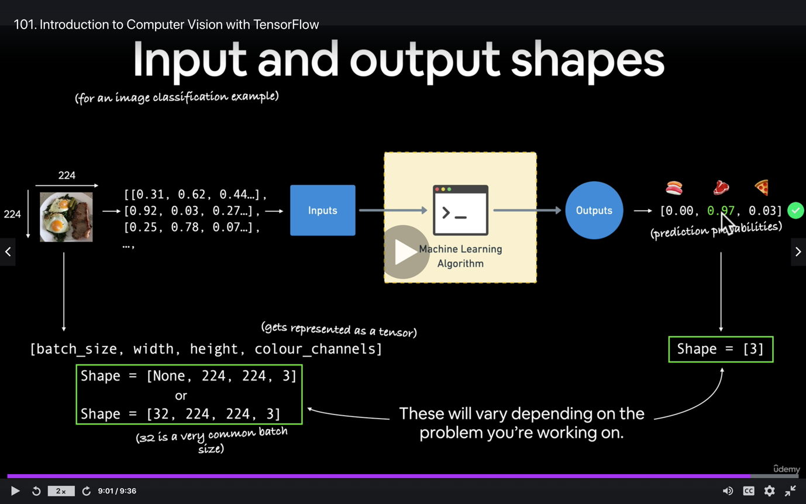

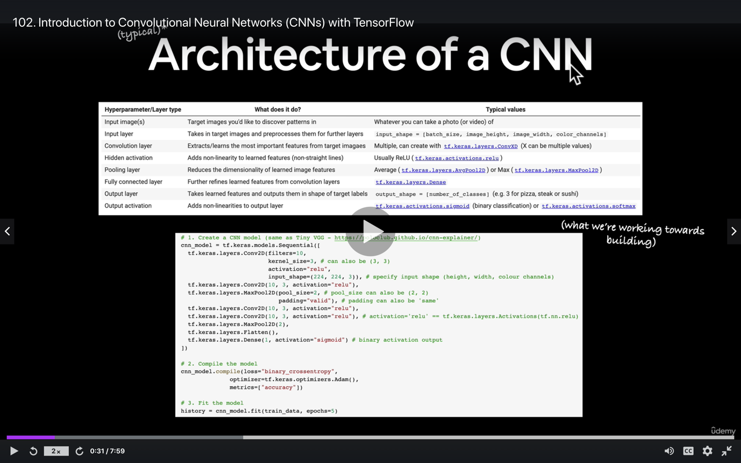

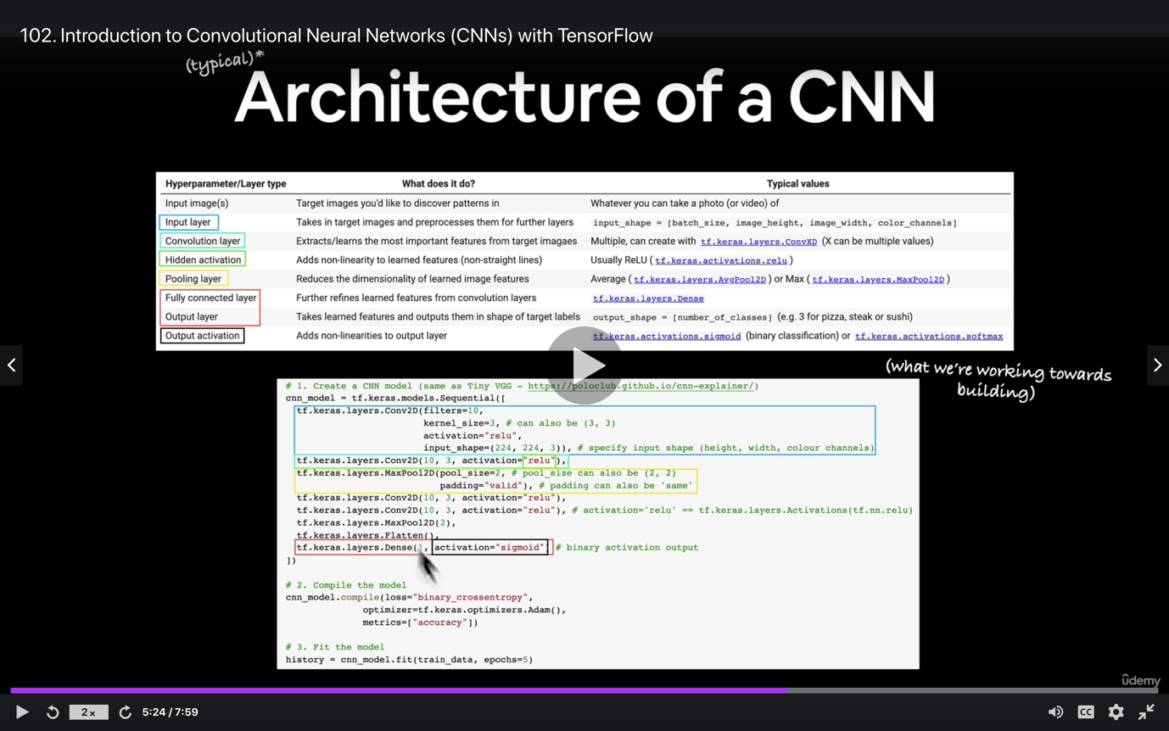

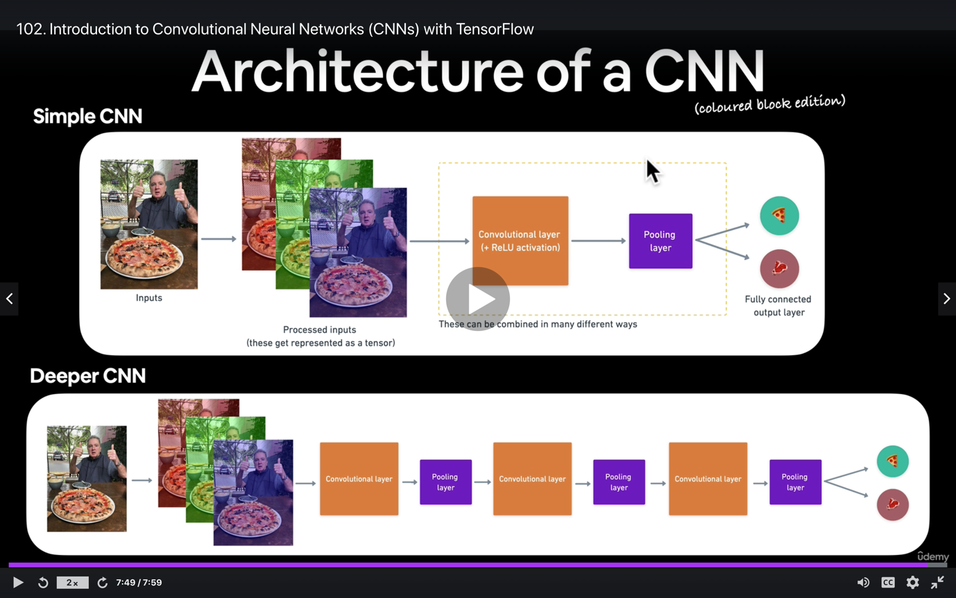

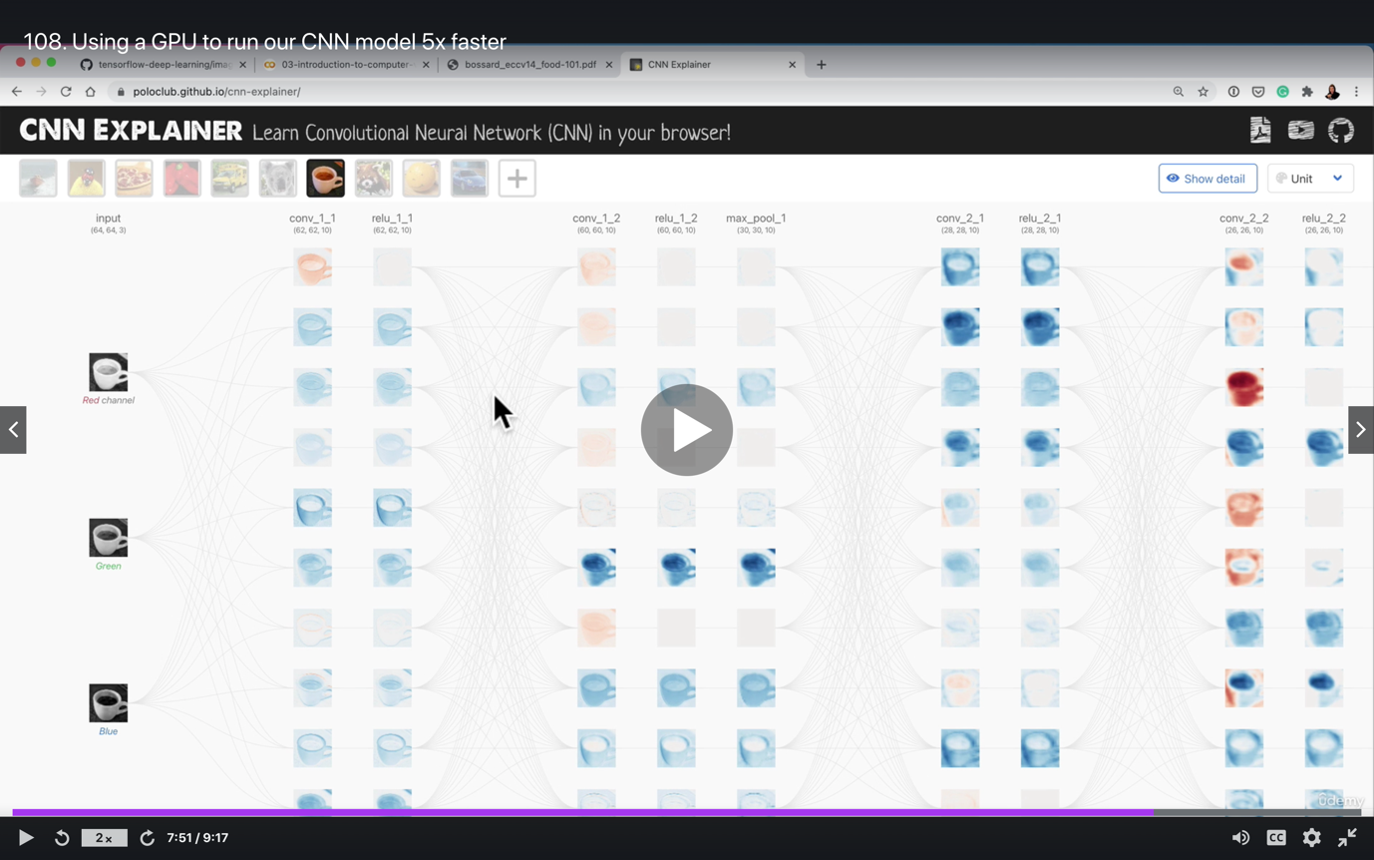

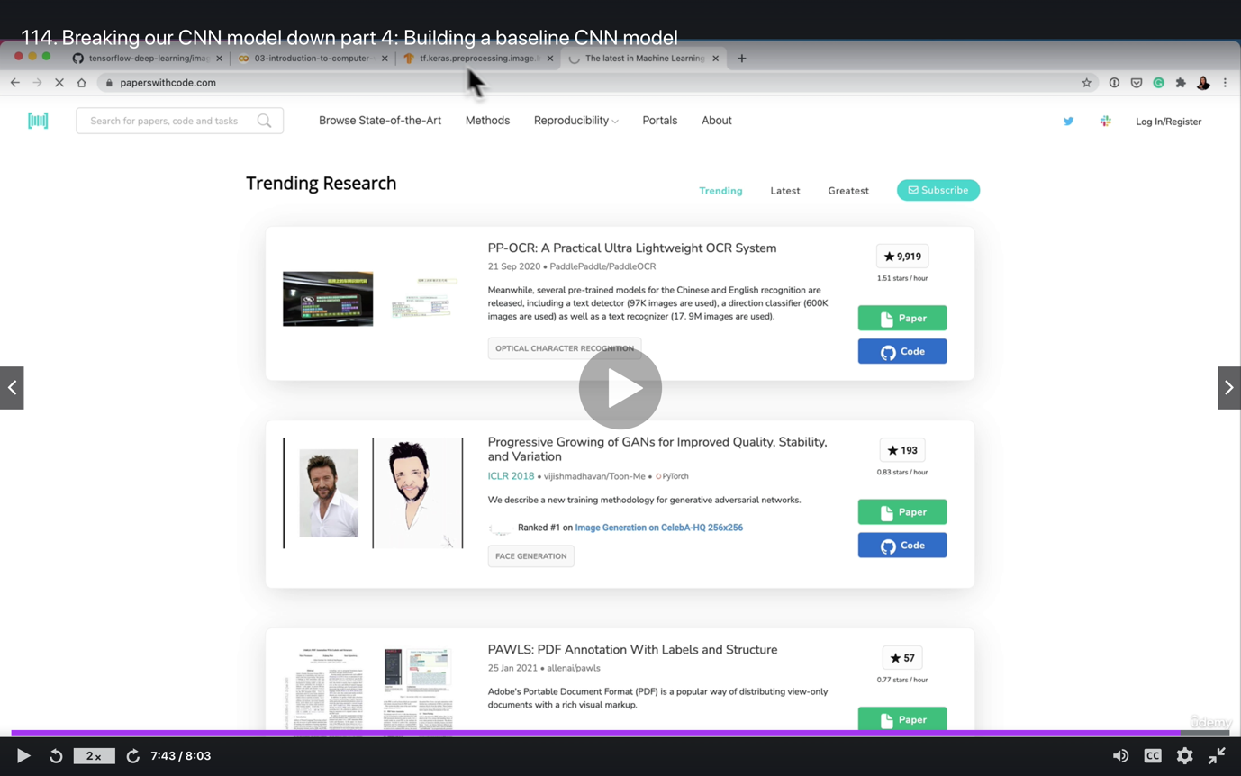

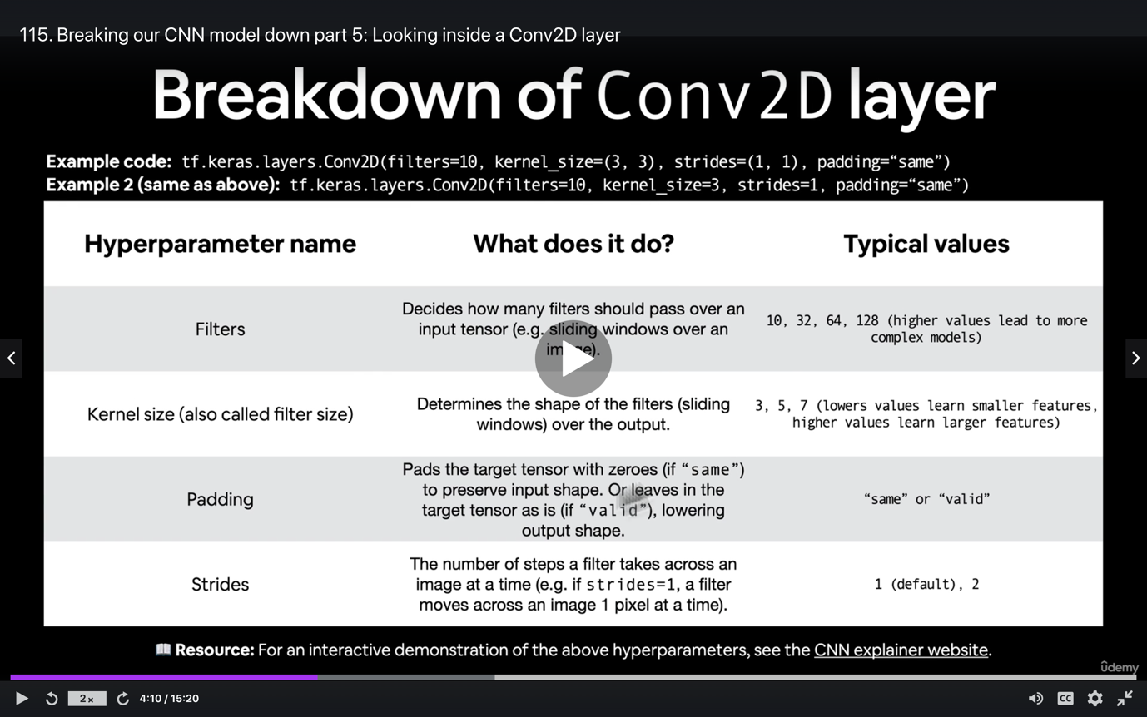

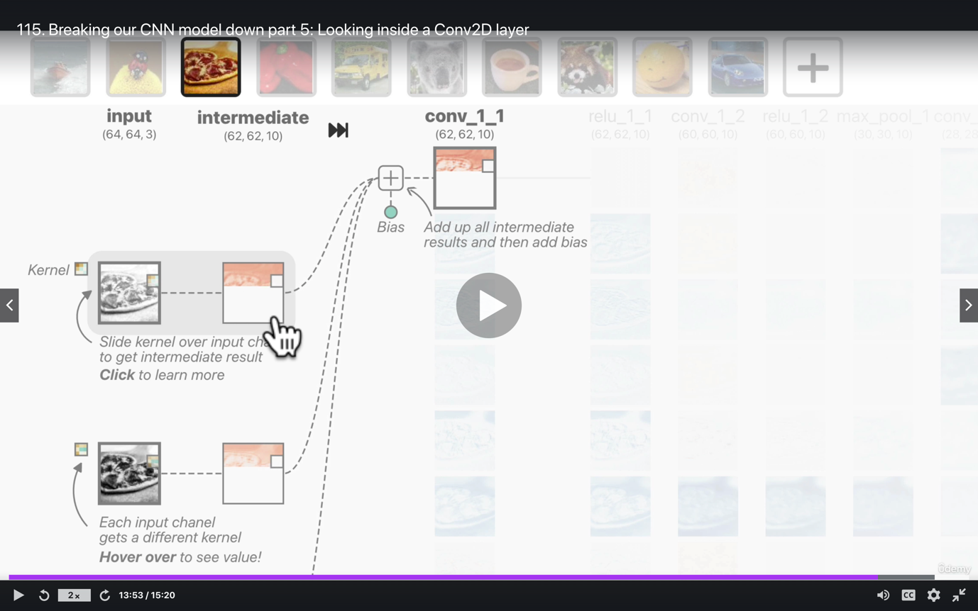

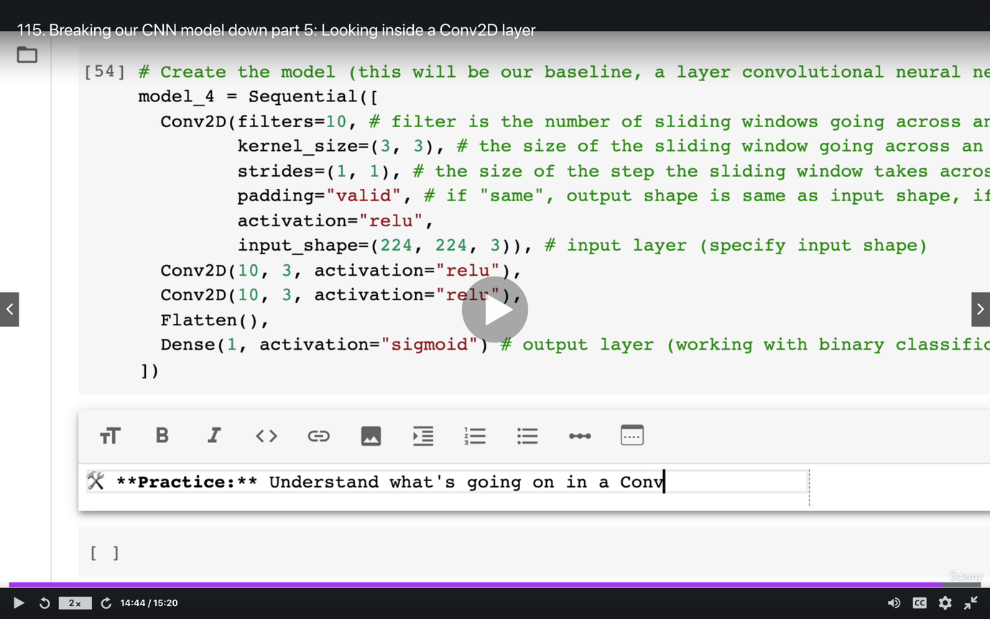

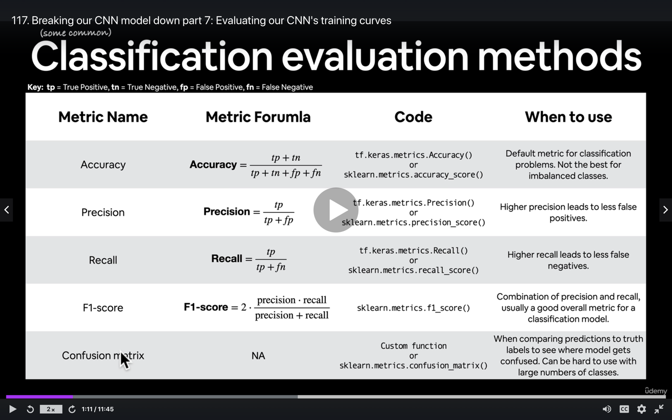

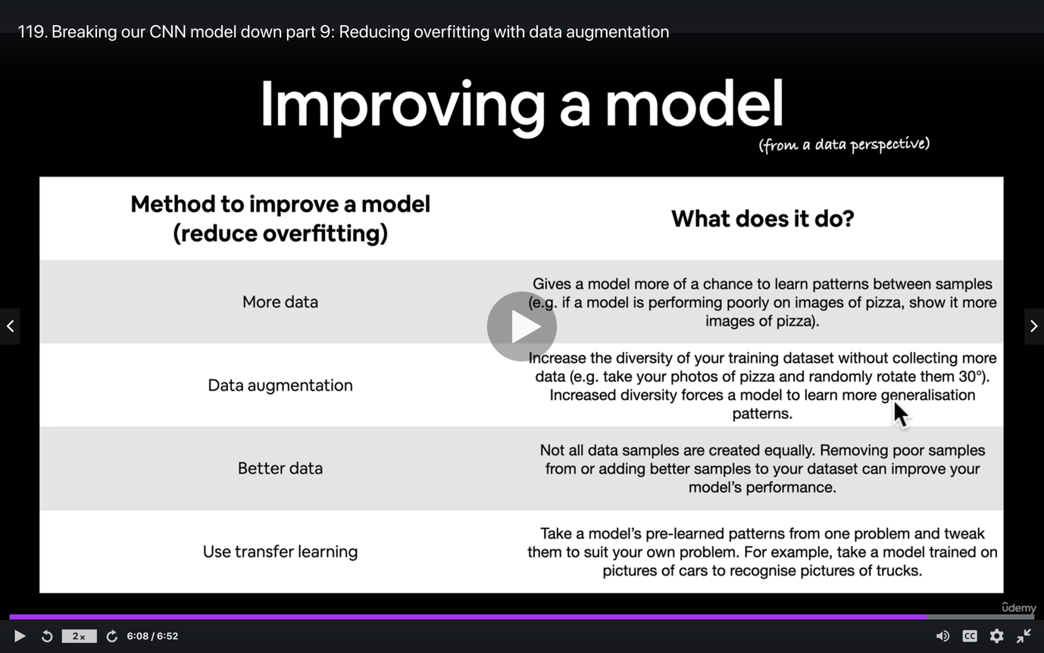

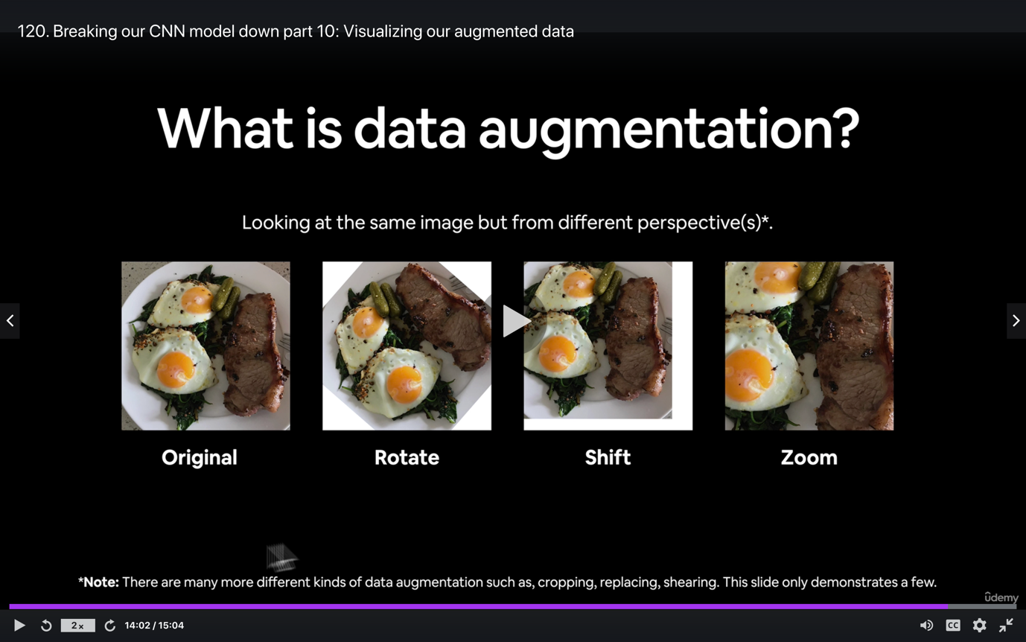

**Section 6: Transfer Learning in TensorFlow Part 1: Feature extraction**

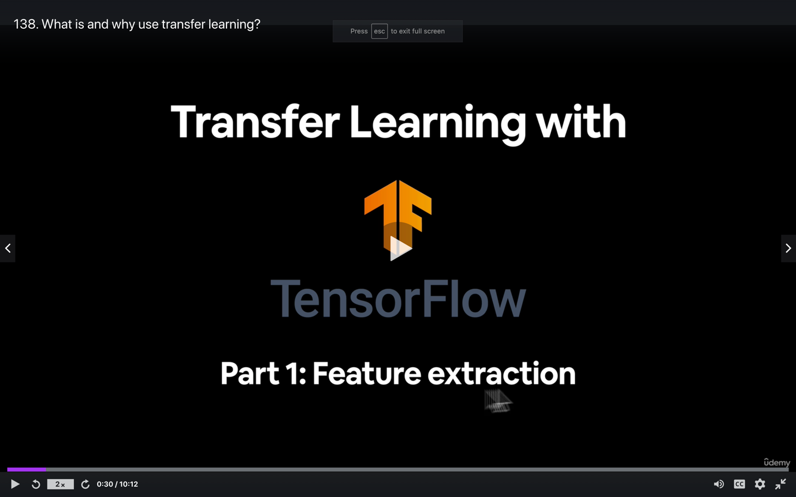

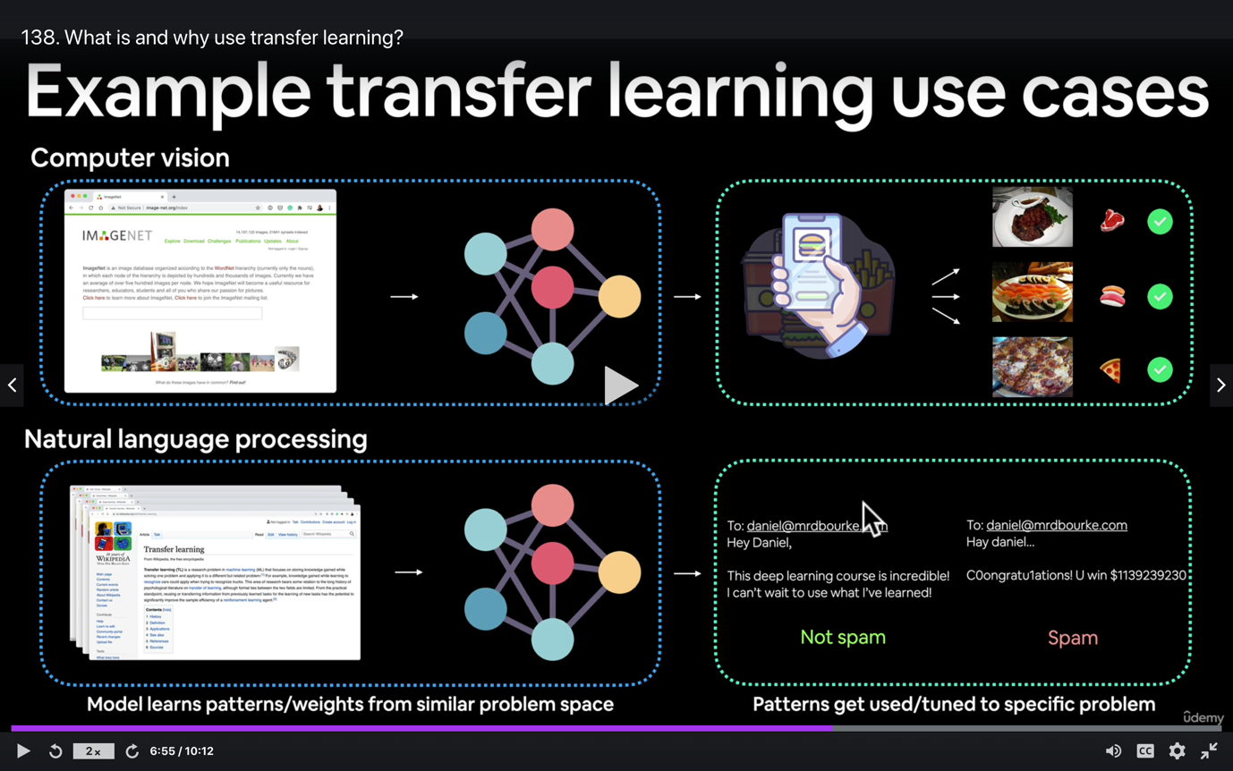

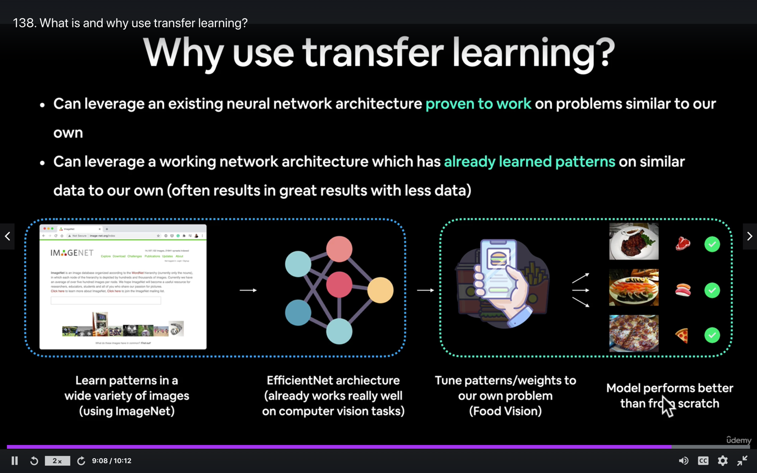

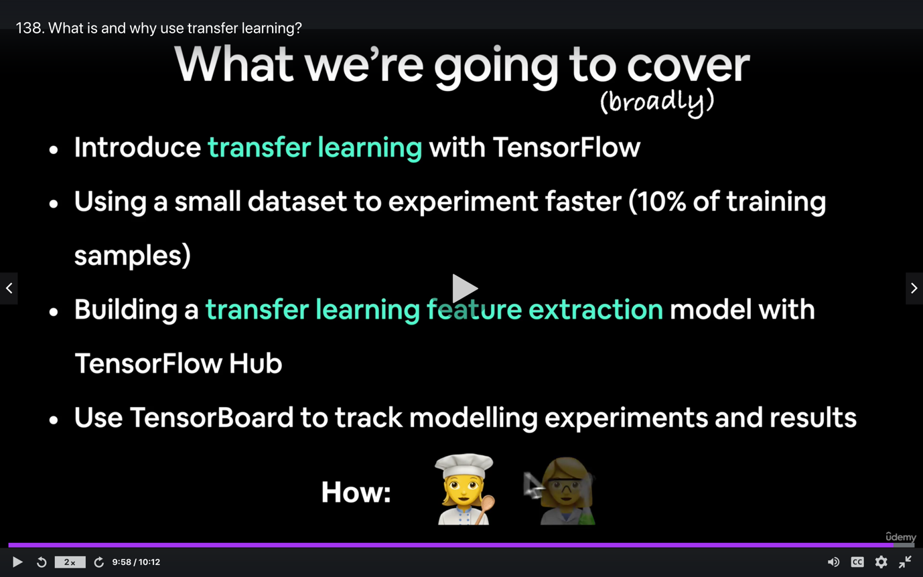

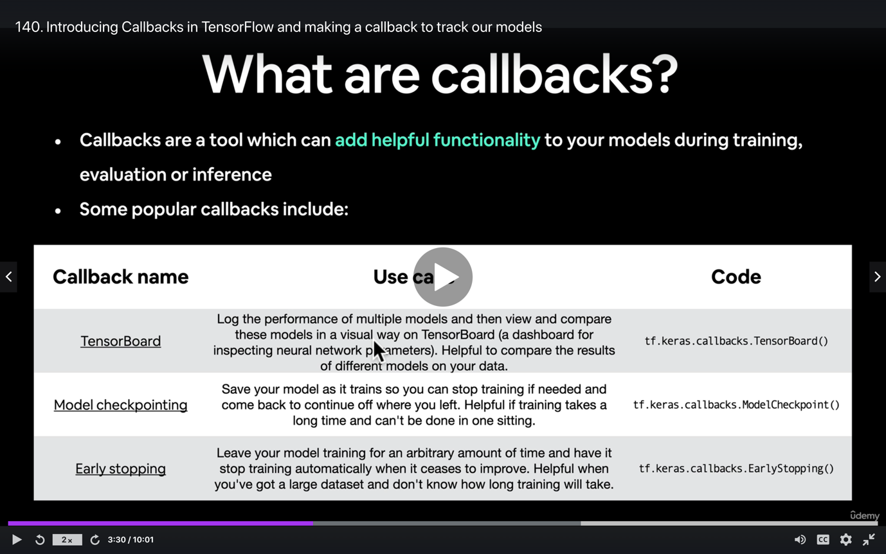

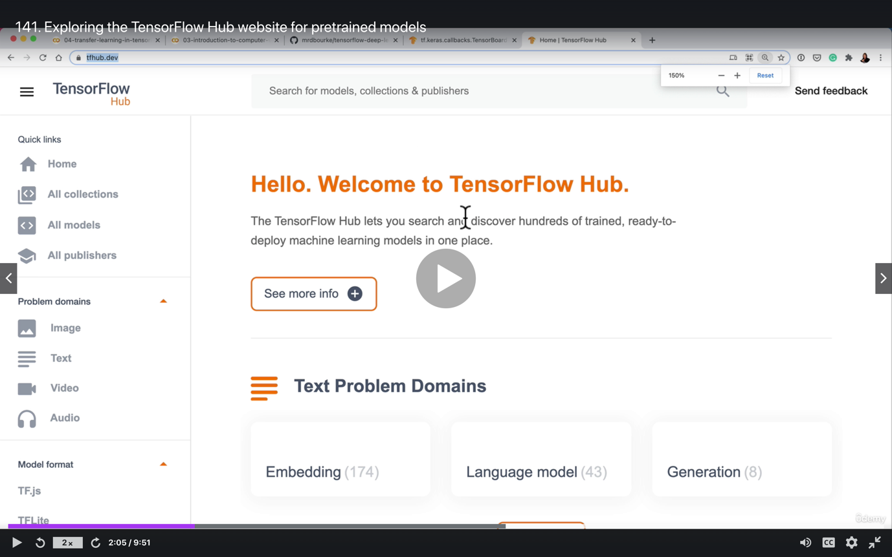

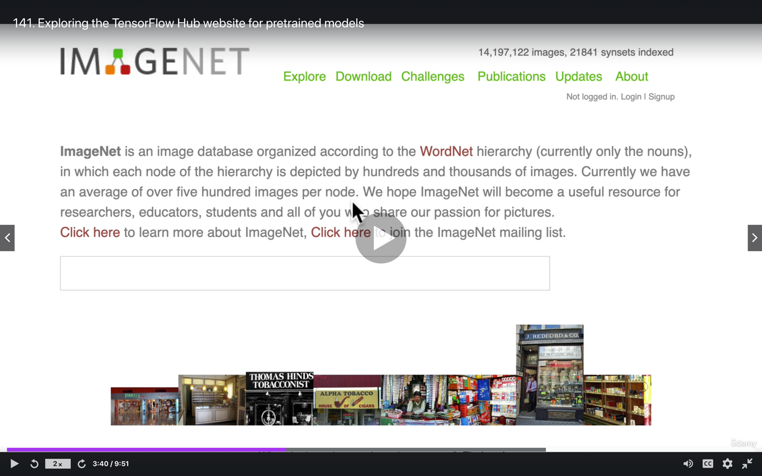

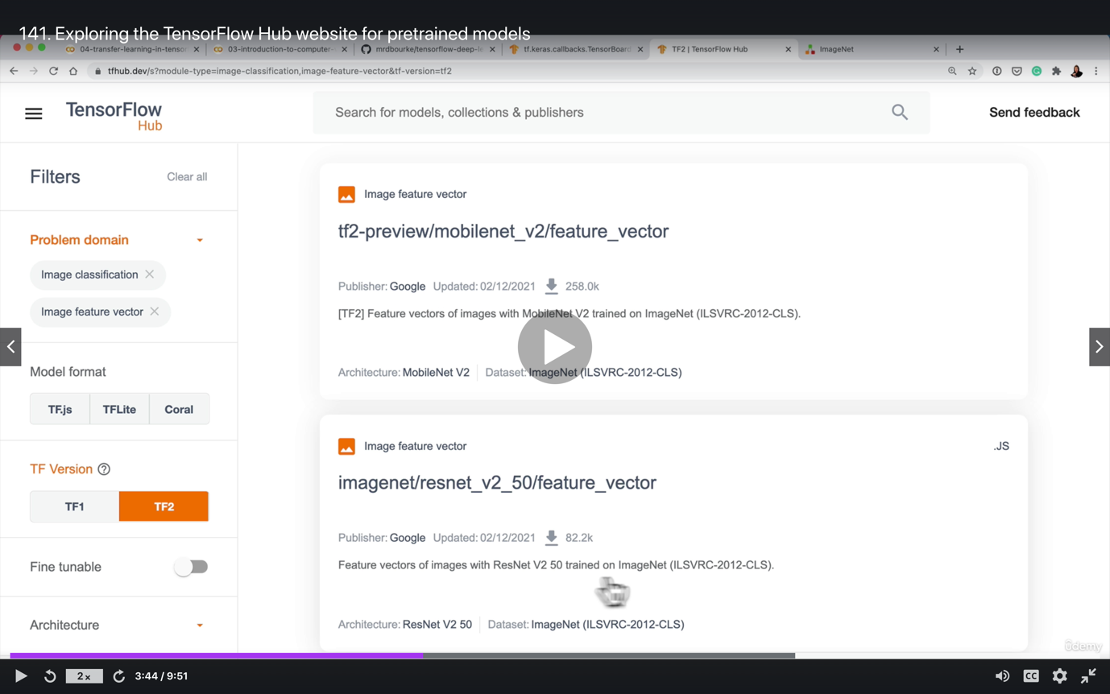

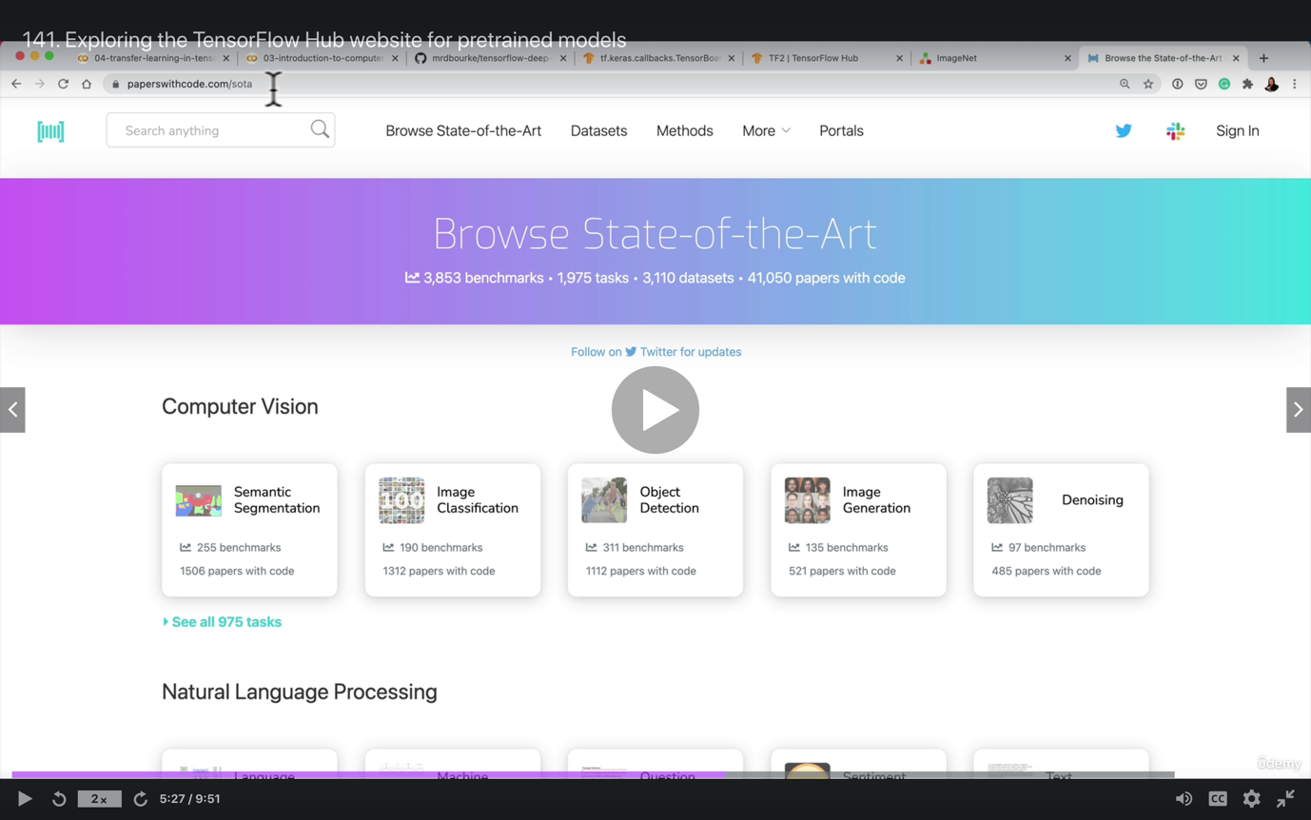

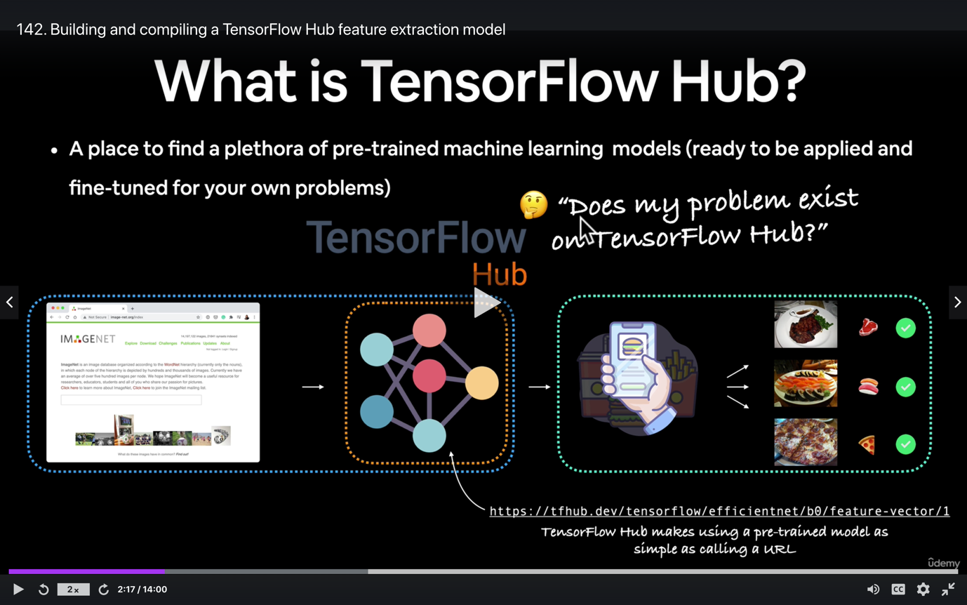

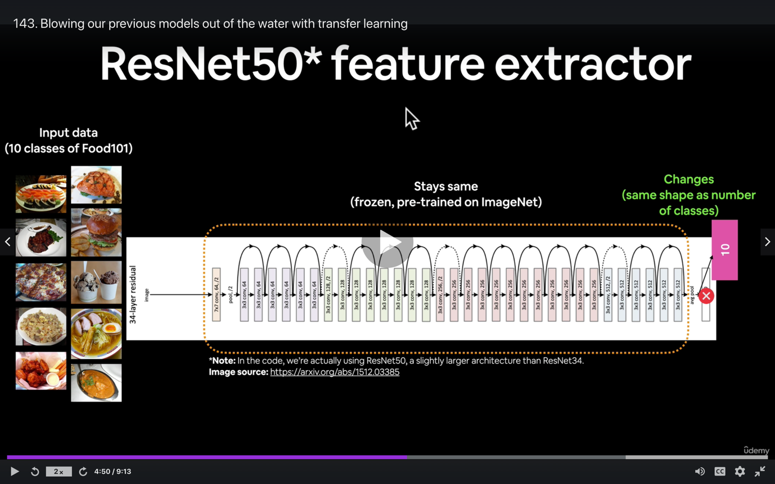

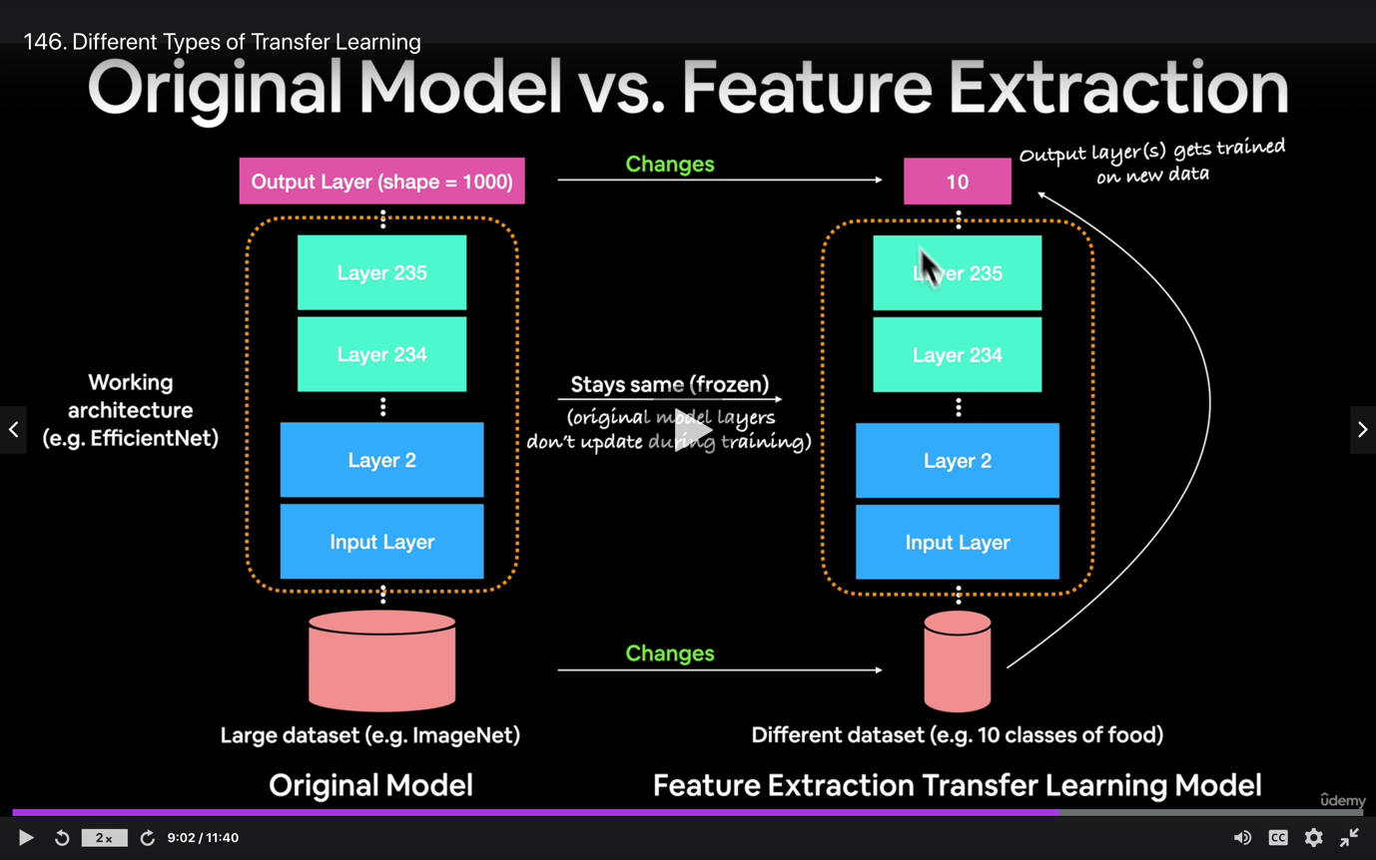

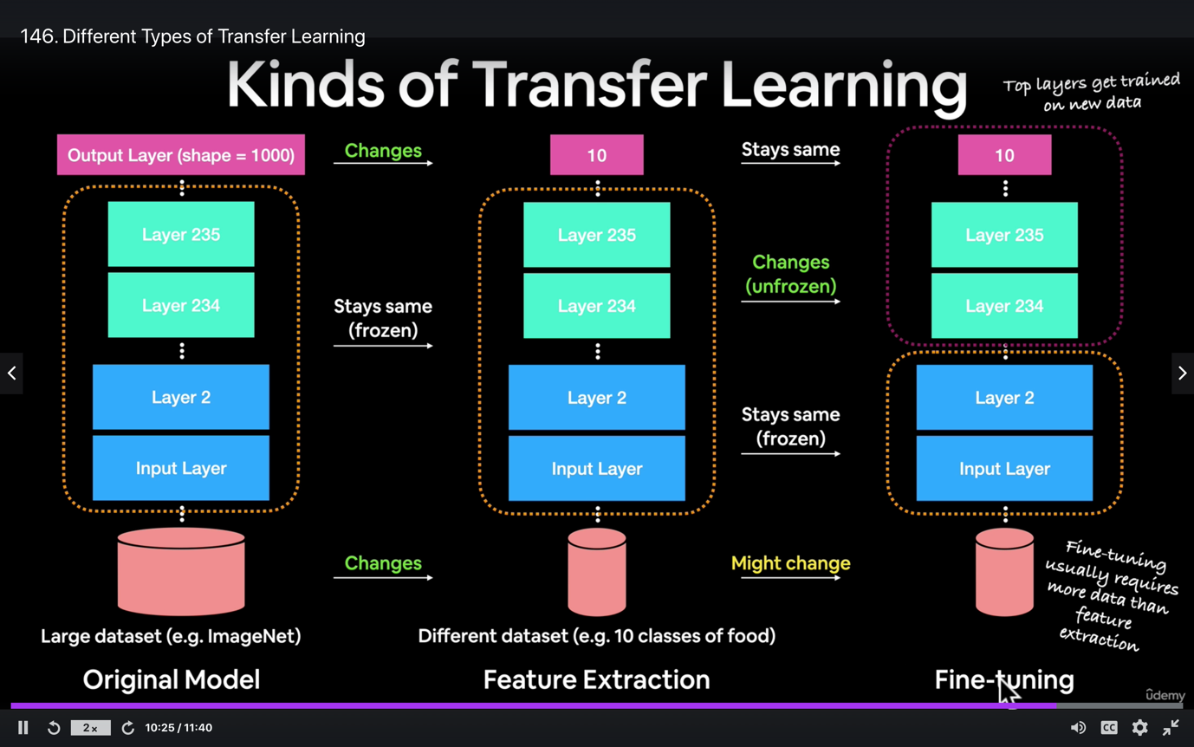

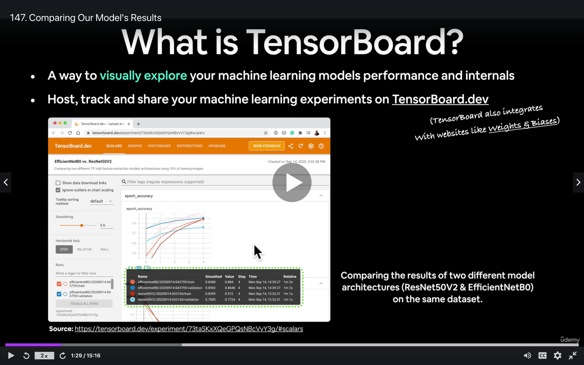

**Section 7: Transfer Learning in TensorFlow Part 2: Fine tuning**

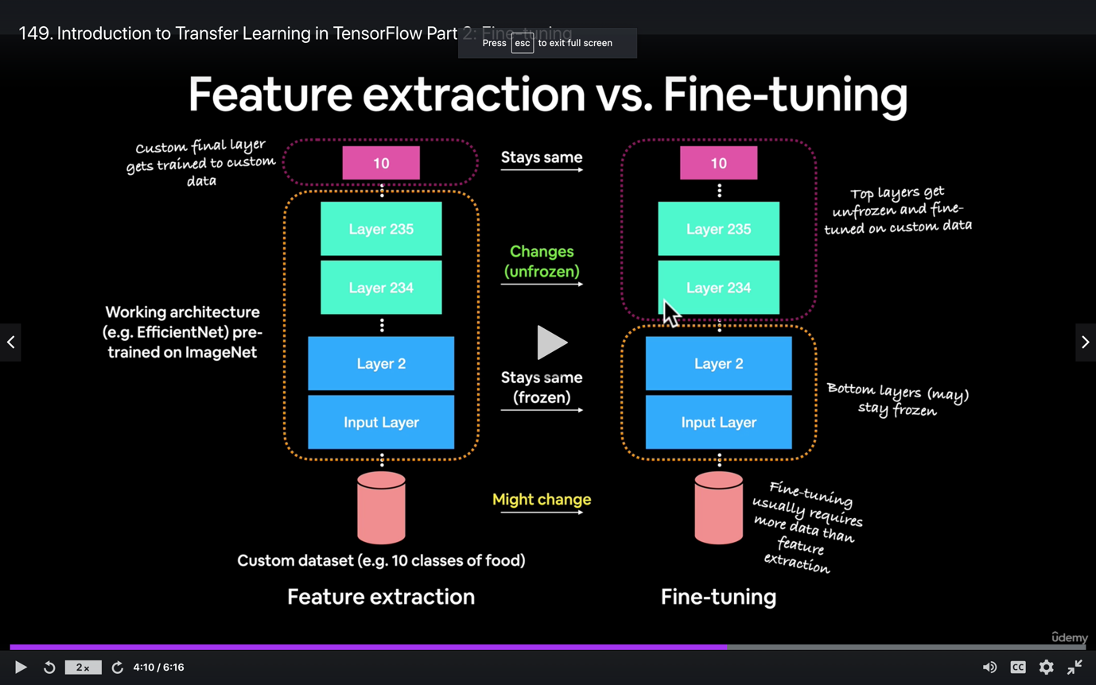

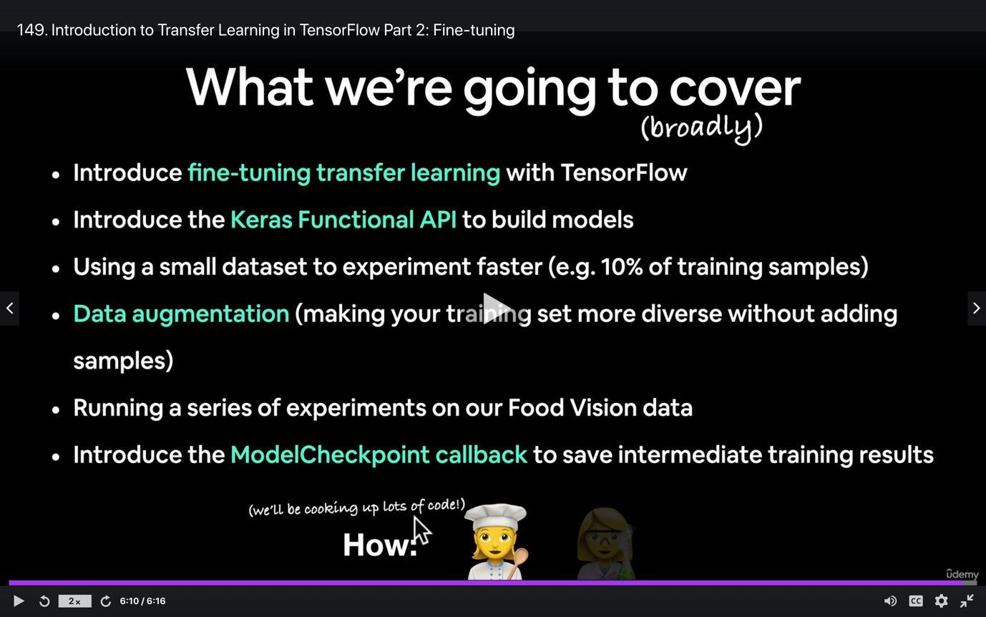

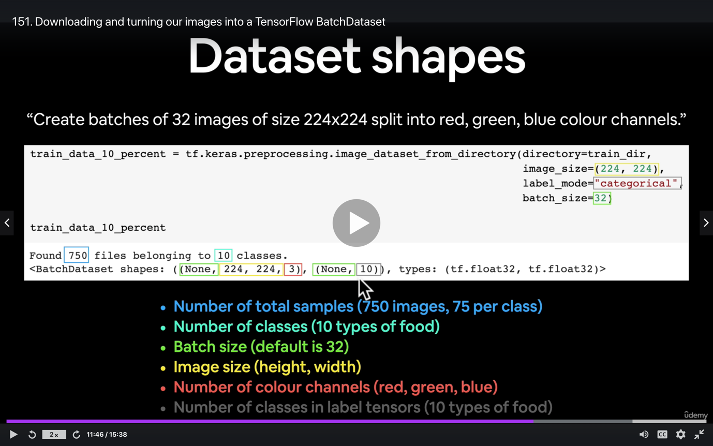

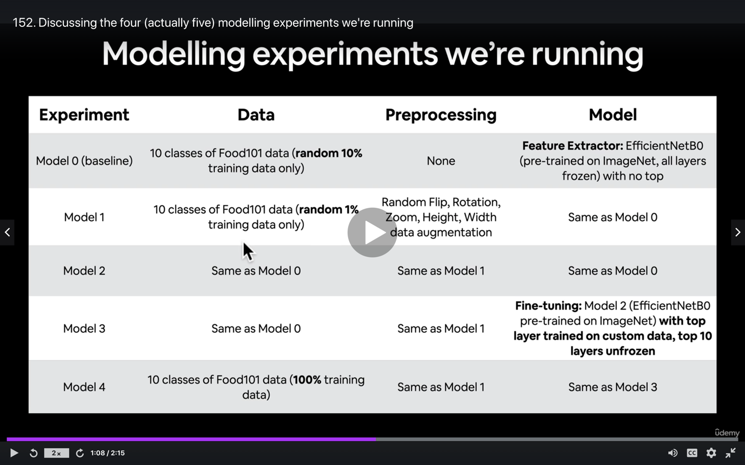

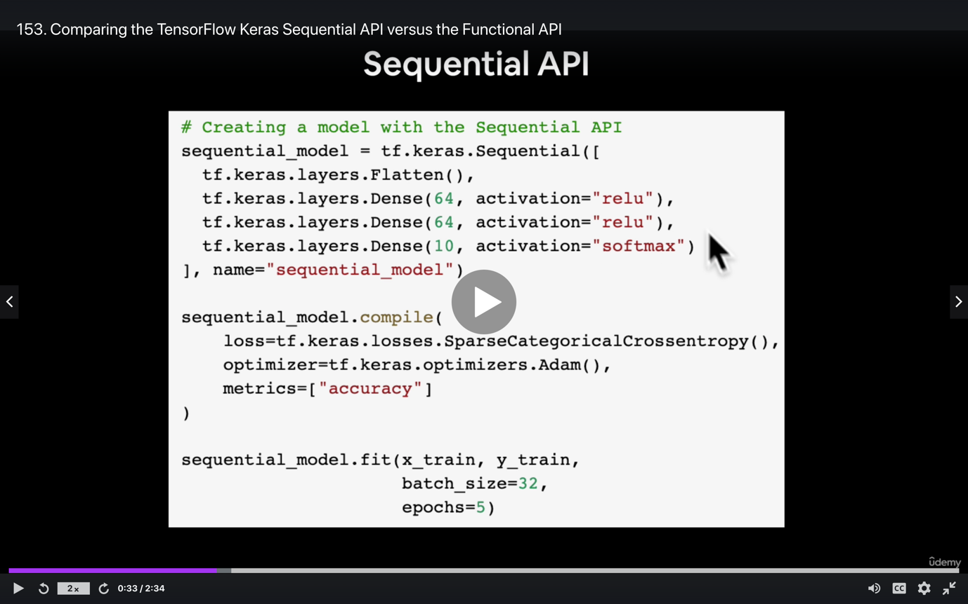

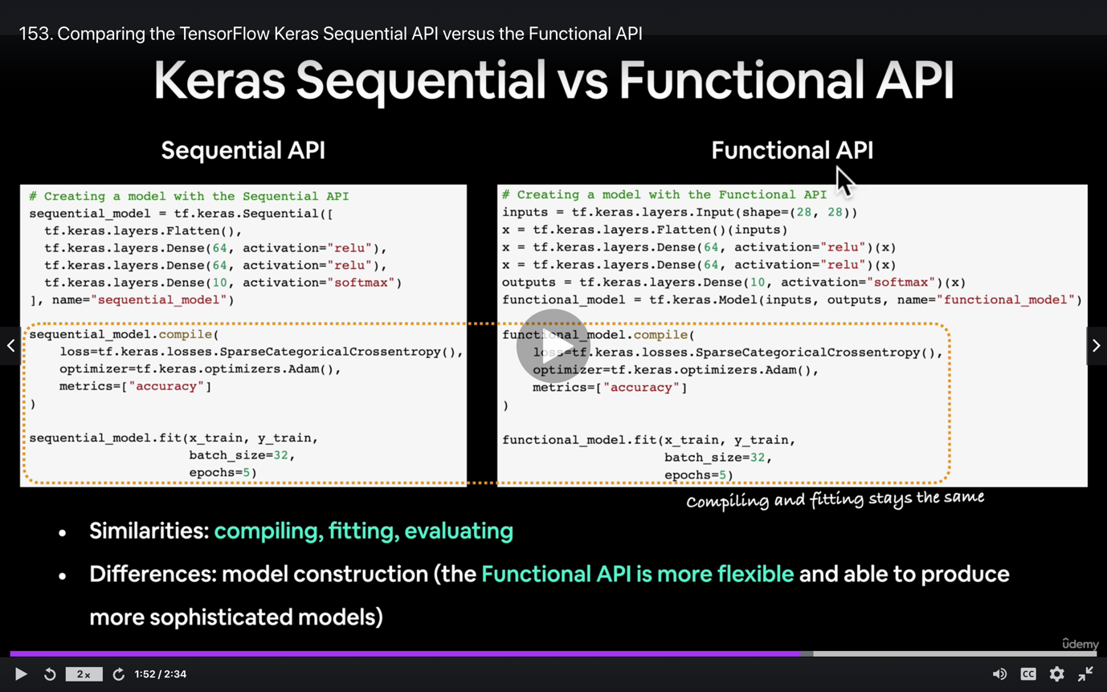

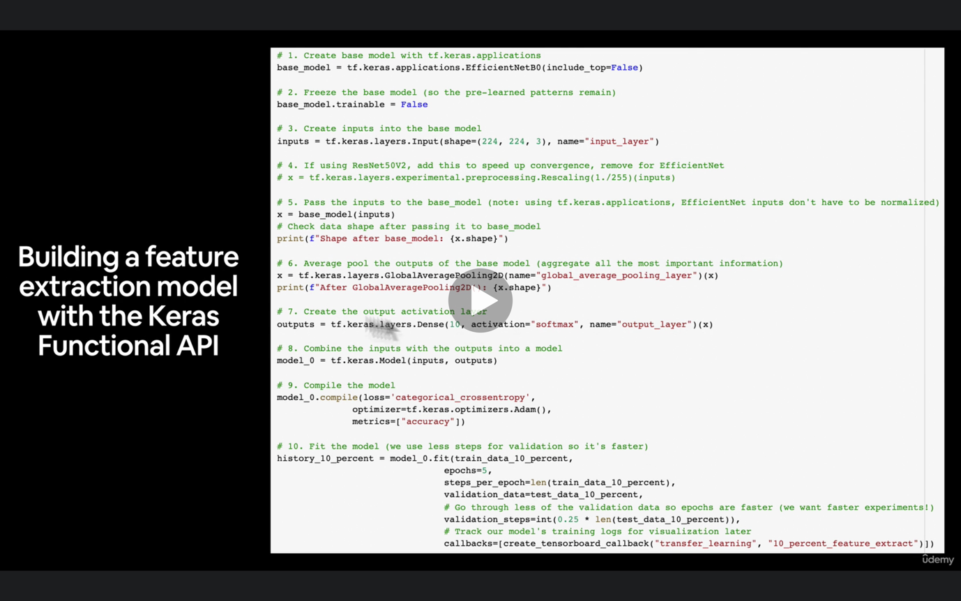

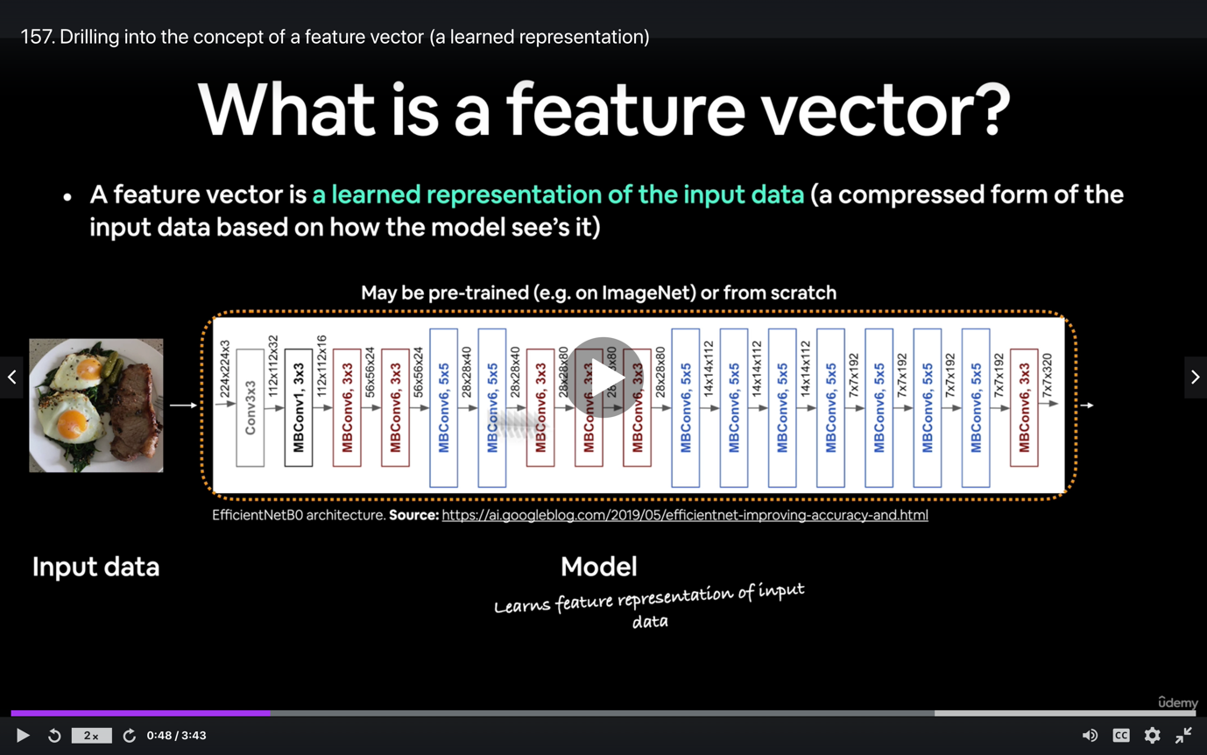

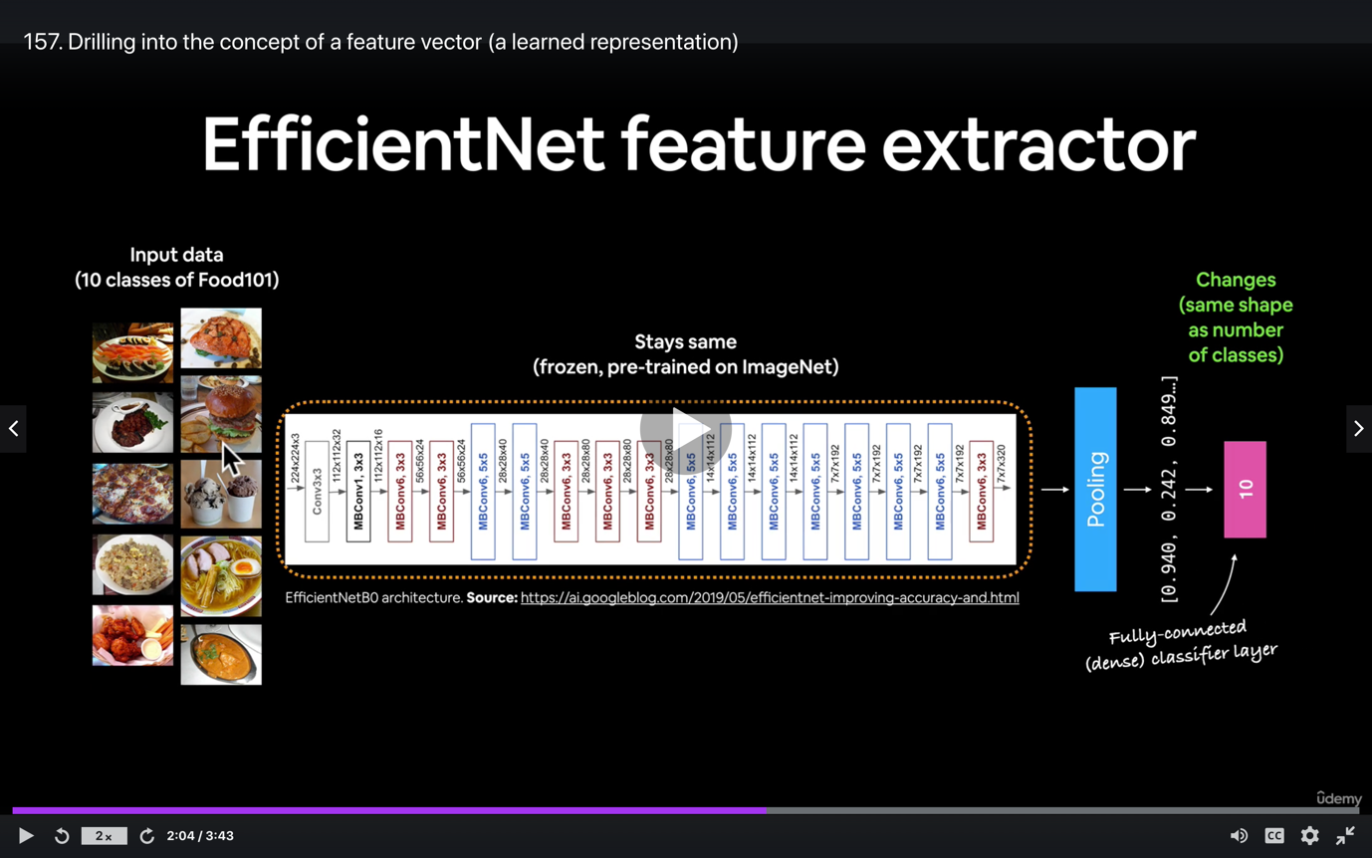

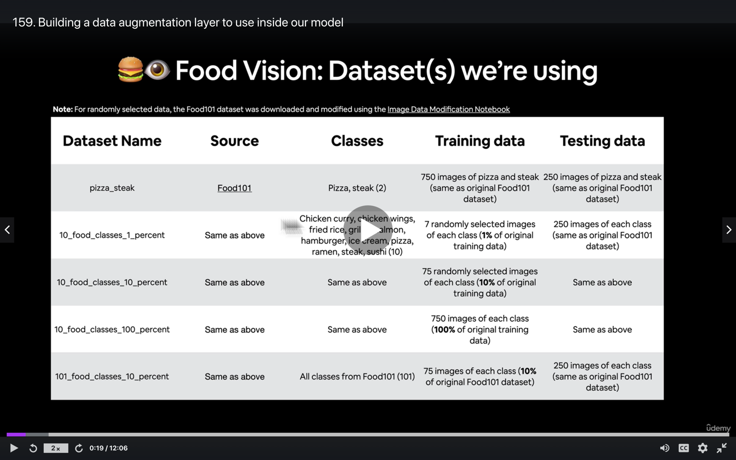

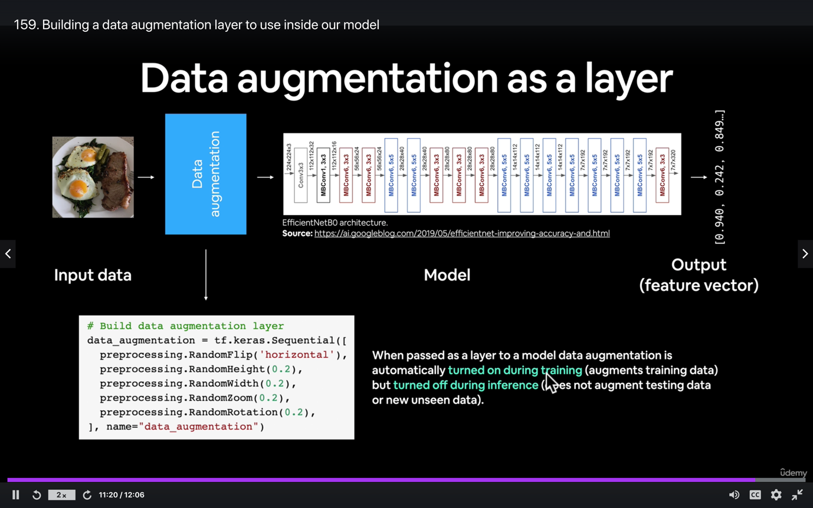

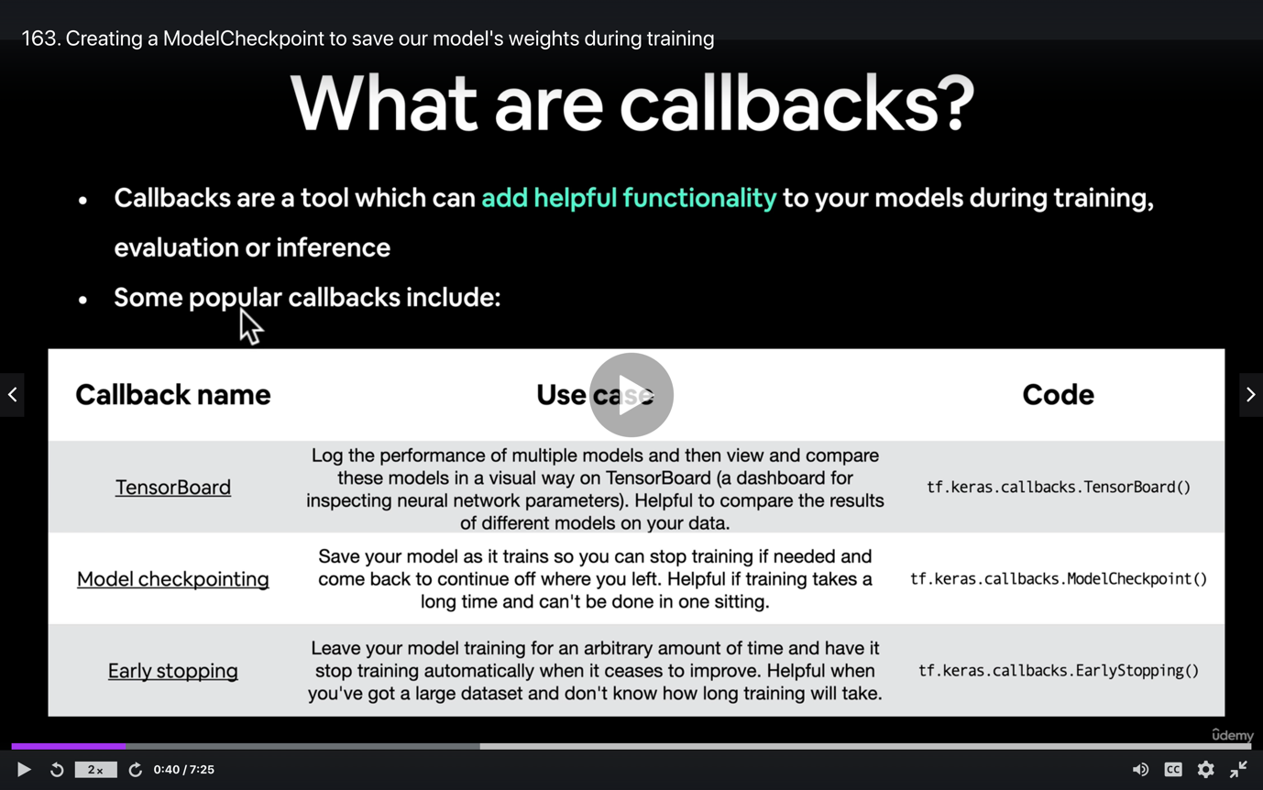

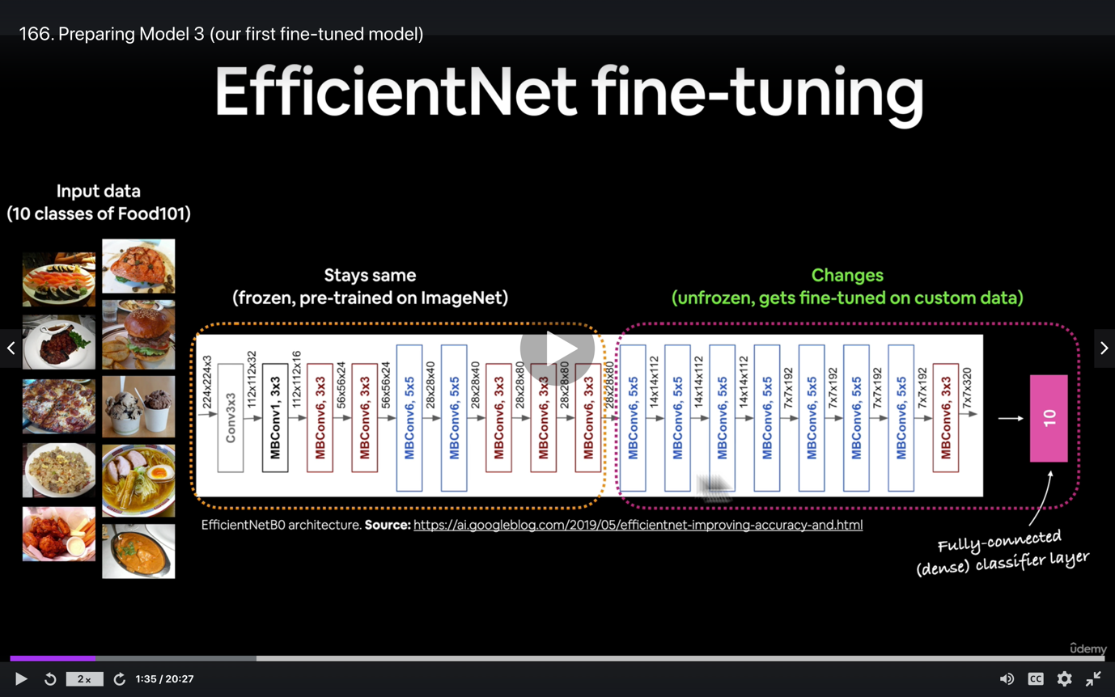

**Section 8: Transfer Learning with TensorFlow Part 3: Scaling Up**

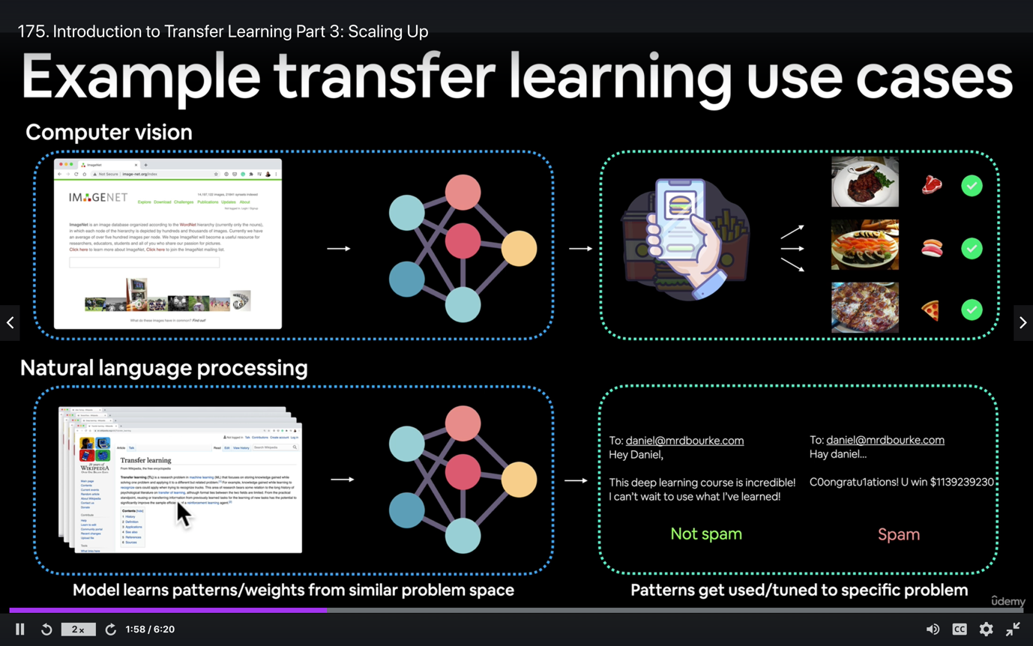

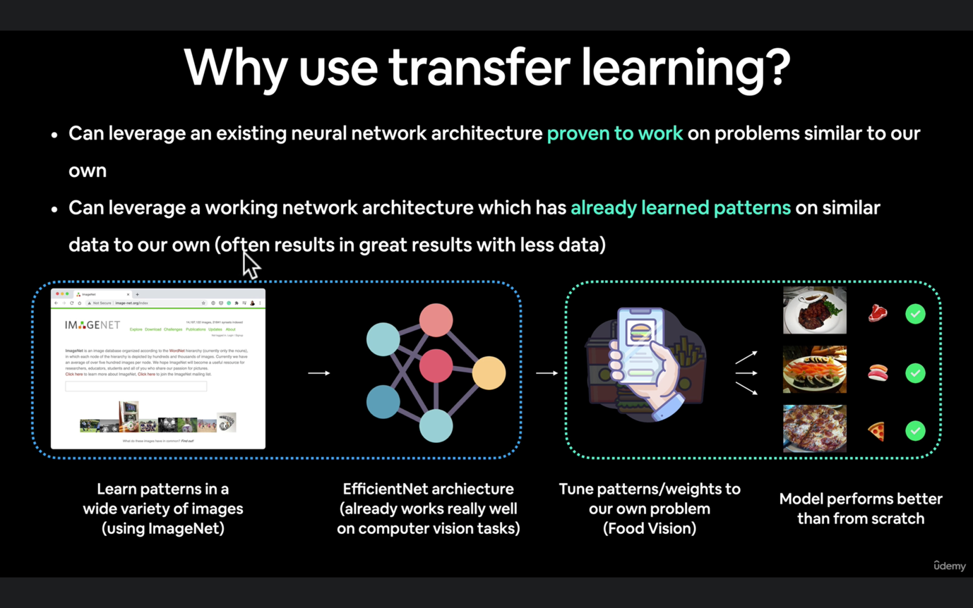

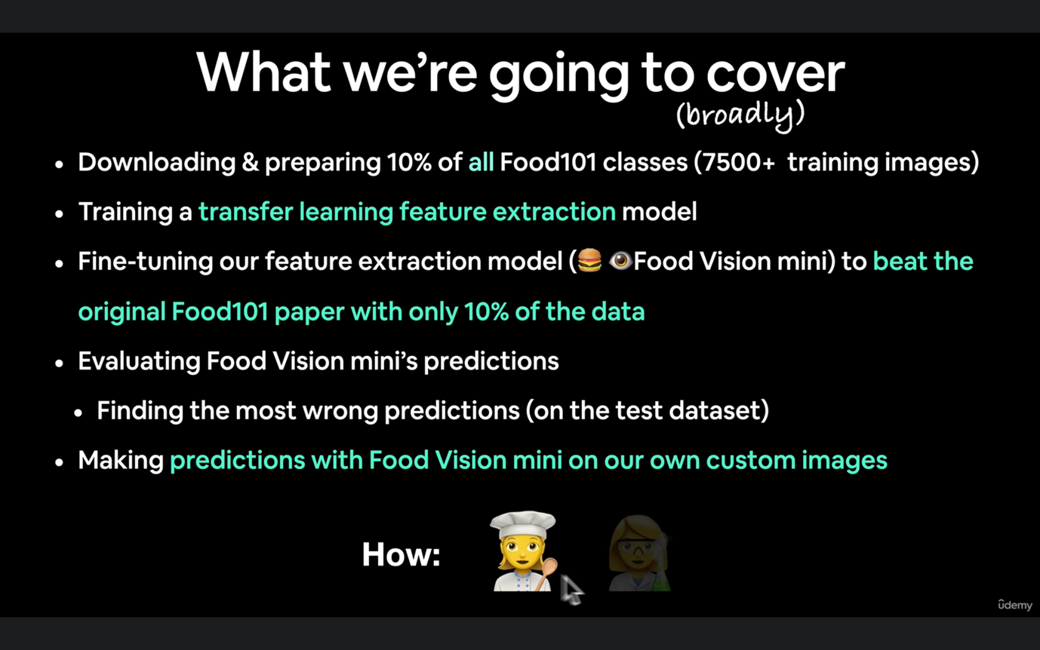

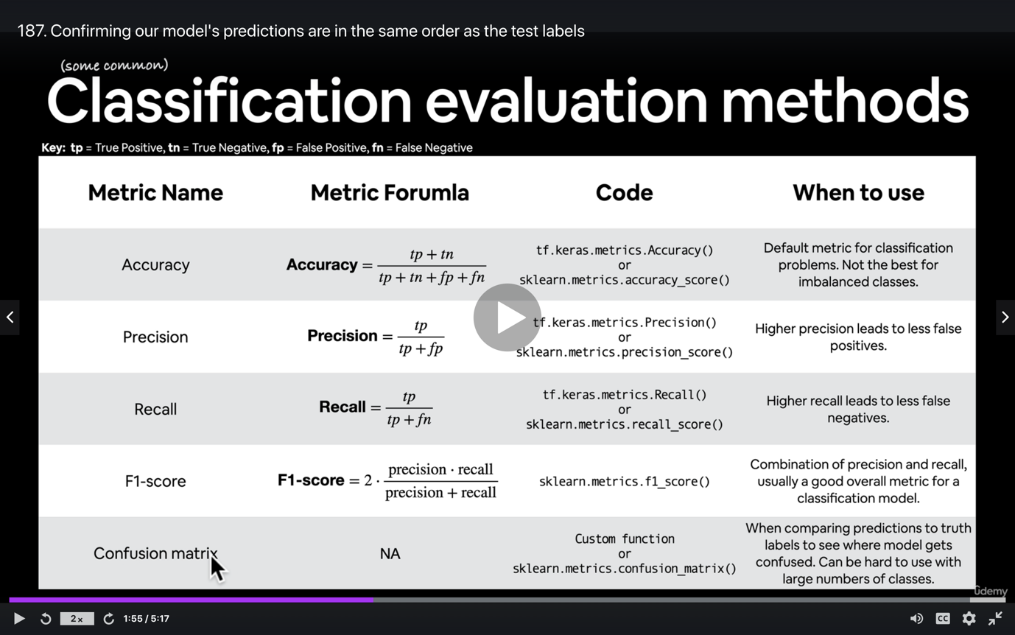

**9: Milestone Project 1: Food Vision Big™**

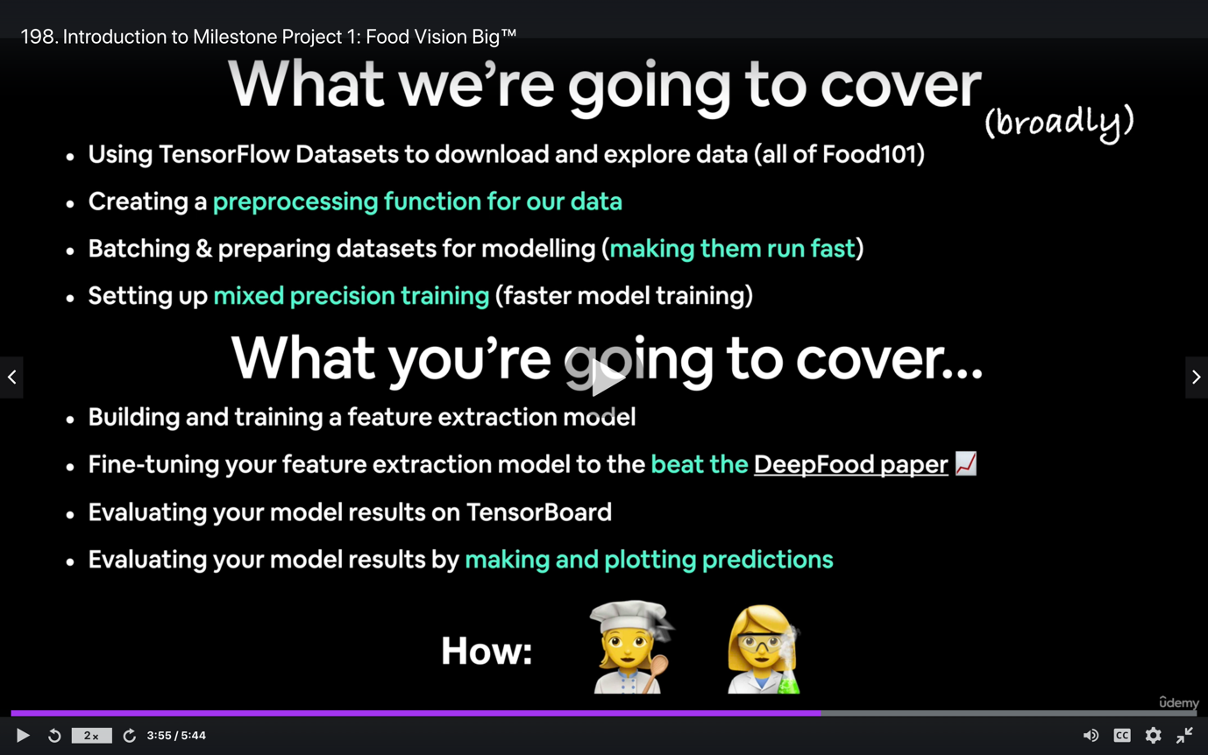

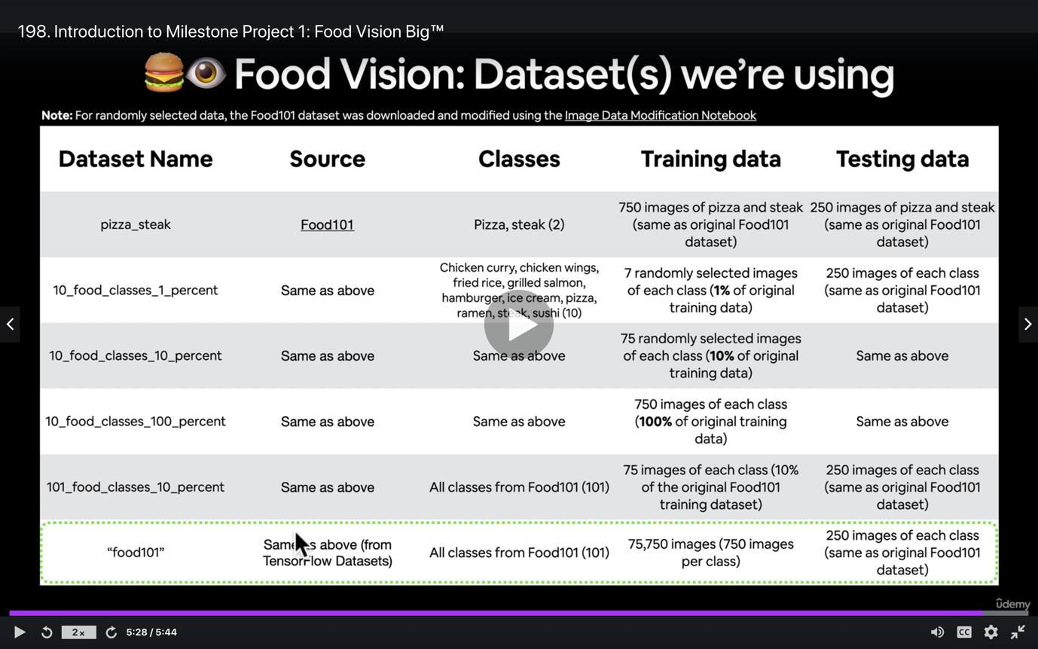

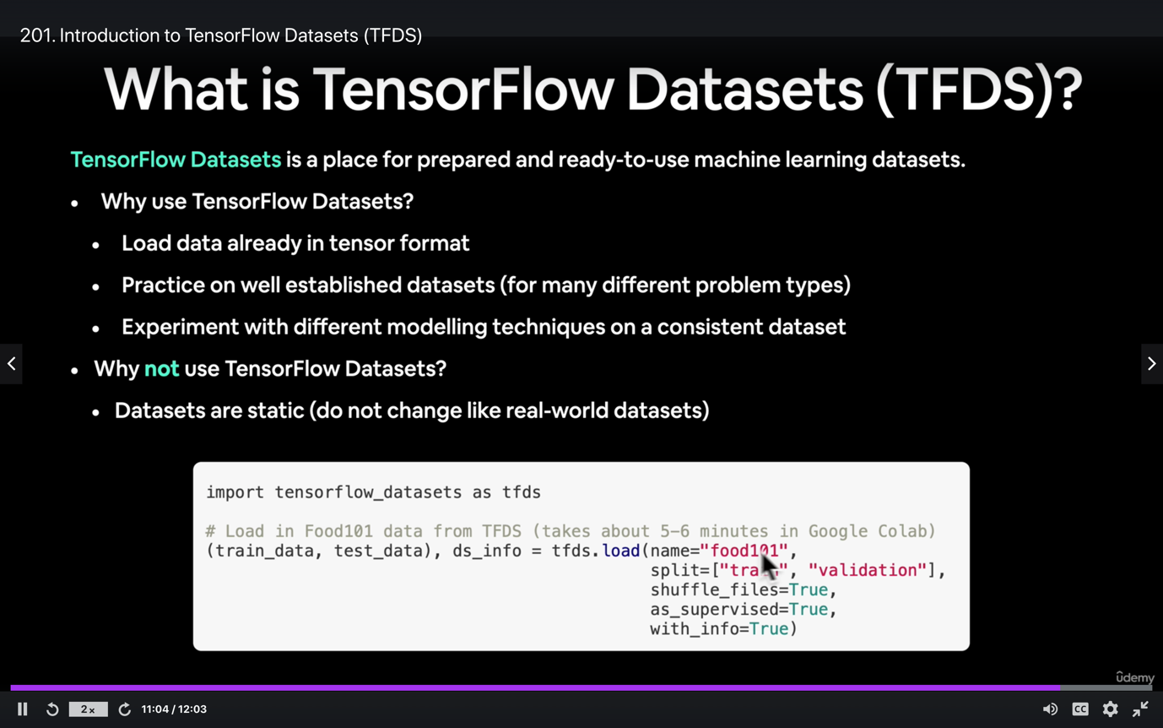

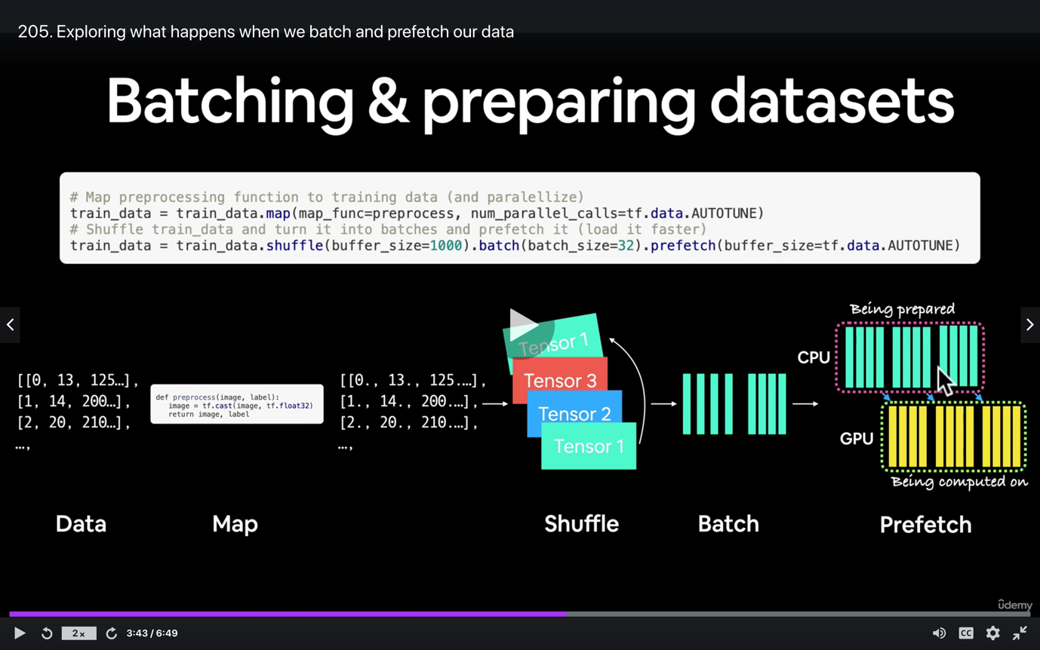

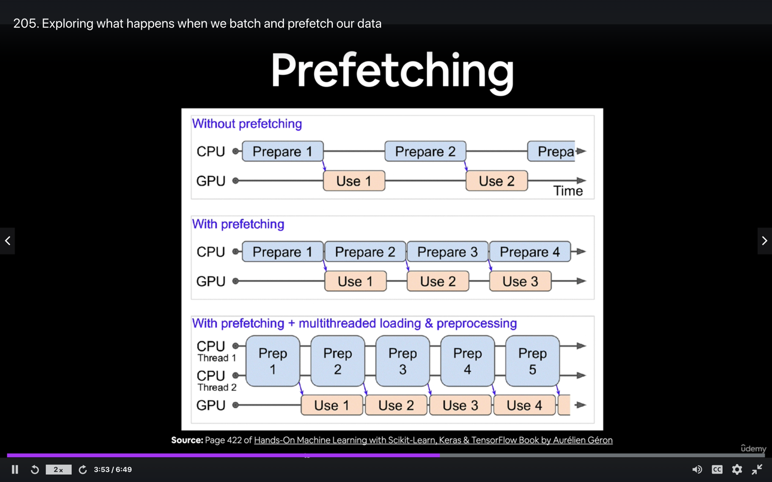

Note: Mixed Precision producing errors for TensorFlow 2.5+

Hey there,

Just putting this note here to let you know that you may face an error in the next video if you're using TensorFlow 2.5+.

**Error**

The error happens when you turn on mixed precision training for EfficientNetBX models (if you're not sure what this is, you'll see it in the next video).

It'll look something like this:

TypeError: Input 'y' of 'Sub' Op has type float16 that does not match type float32 of argument 'x'

As of **29 May 2021**it looks like this is a bug in TensorFlow 2.5+.

There is an issue thread tracking the progress of an update on GitHub: <https://github.com/tensorflow/tensorflow/issues/49725>

**How to fix it**

The current workaround is to downgrade to TensorFlow 2.4.1 (the last version before 2.5).

You can do this in Google Colab by running:

1. # Downgrade Tensorflow Version (run this in Google Colab)
2. !pip install tensorflow==2.4.1

After doing so, you'll have to **restart your runtime** (Runtime -> Restart runtime) to ensure TensorFlow 2.4.1 is active.

1. import tensorflow as tf
2. tf.__version__
4. >>> '2.4.1'

Once TensorFlow 2.4.1 is installed, the code should work as normal.

Ashik has also posted this on the course GitHub discussions: <https://github.com/mrdbourke/tensorflow-deep-learning/discussions/82>

If you have any issues, please post your question/reply there so others can see.

If a fix for this issue comes for TensorFlow 2.5+ (it should), we'll update/remove this post.

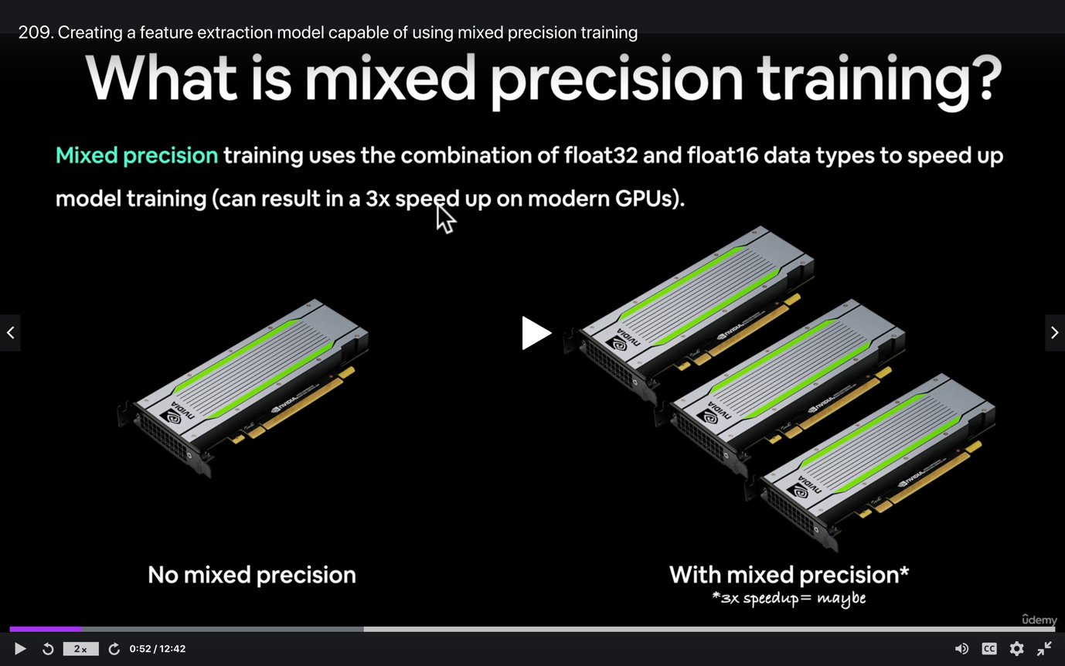

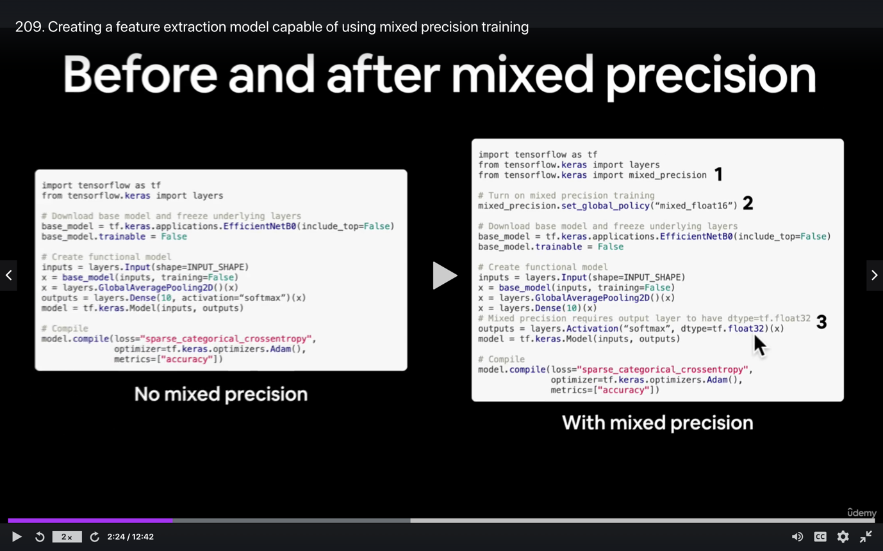

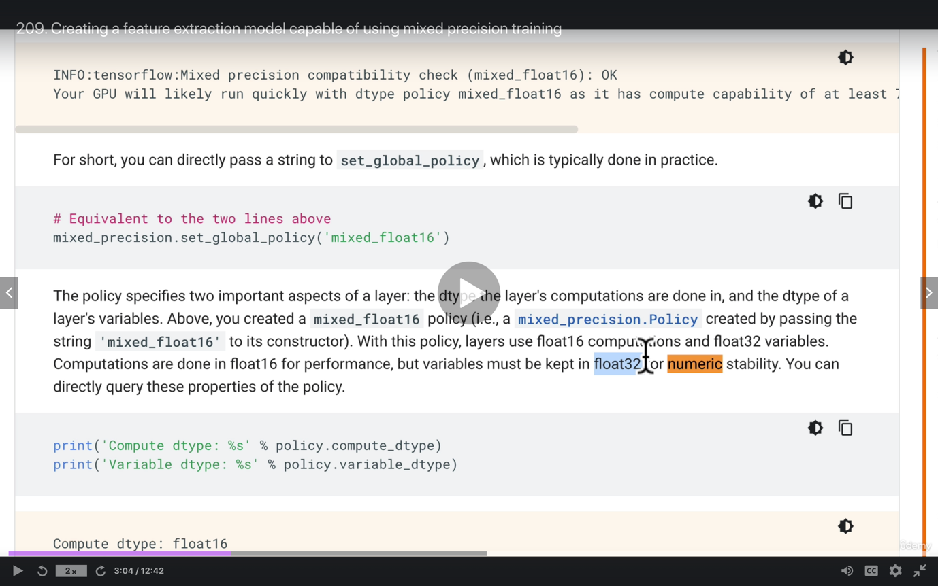

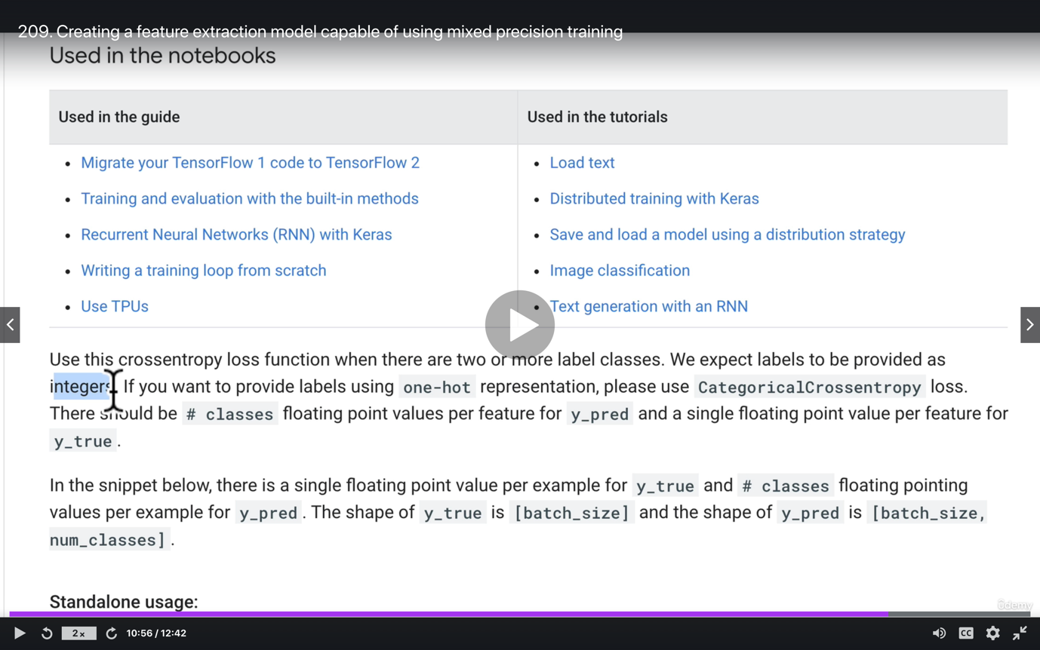

Milestone Project 1: Food Vision Big™, exercises and extra-curriculum

How'd you go?

Did you make it through?

Did you manage to train a model to beat the DeepFood paper?

If you did, congratulations!

Experimenting and figuring things out for yourself is a valuable skill in the world of machine learning (and software development in general).

You should now be able to:

* Use TensorFlow Datasets (TFDS) to download a ready-made (already in tensors) dataset
* Preprocess your data to be used with a model (make sure all the data types are correct)
* Create efficient data pipelines using tf.data API methods like batch() and prefetch()

If you went through the Milestone Project 1 Template, you've already done plenty of practice but if you're up for it (I think you are), there's more.

In the [course GitHub repo](https://github.com/mrdbourke/tensorflow-deep-learning) under “Course materials”, you'll find a series of exercises and extra-curriculum suggestions.

You should go through these **before** moving on to the next section.

See the link below for more.

* [Milestone Project 1: Food Vision Big™ Exercises and Extra-Curriculum](https://github.com/mrdbourke/tensorflow-deep-learning#-07-milestone-project-1--food-vision-big-exercises)

And remember, if you have any questions, be sure to [add them to the discussions page](https://github.com/mrdbourke/tensorflow-deep-learning/discussions).

**Challenge:** Which predictions did your model get most wrong? Why do you think this is?

I'd love to see 3 of your model's most wrong predictions and why you think it got them wrong

Send a message with 3 of your model's most wrong predictions to the #machinelearning-datascience channel on Discord and mention my name (@mrdbourke).

See you in the next module! Time for Natural Language Processing (NLP)!

- Daniel

Web: [www.mrdbourke.com](http://www.mrdbourke.com/)

YouTube: <https://dbourke.link/youtube>